Convert ArrayList containing Integers to primitive int array

* Int[] arr = list.stream().mapToInt(i->i).toArray().

Explicitly call intValue via a method reference, ie.

* int[] arr = list.stream().mapToInt(Integer::intValue).toArray();

Its also worth mentioning that you could get a NullPointerException if you have null reference in the list. This could be easily avoided by adding filtering condition to stream pipeline

//.filter(Objects::nonNull) also works

* int[] arr = list.stream().filter(i -> i != null).mapToInt(i -> i).toArray();

**Remember:**

* If you want to return double something from integer, then divide with double. Int n = 10/ 2.0
* Array is reference type.

Convert list to array

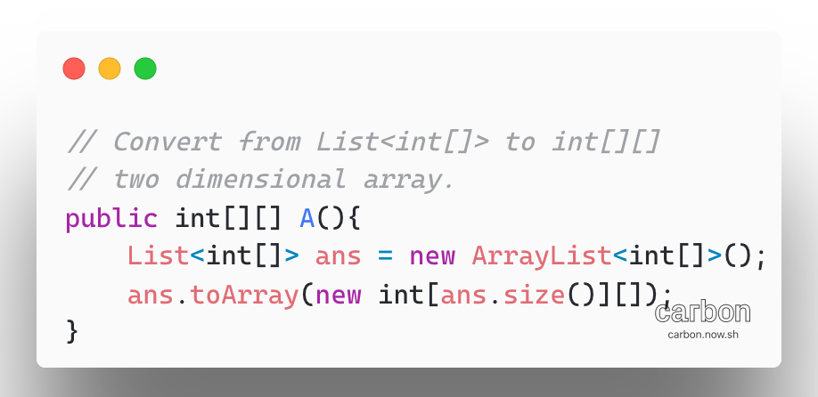

Sort Two dimensional array:

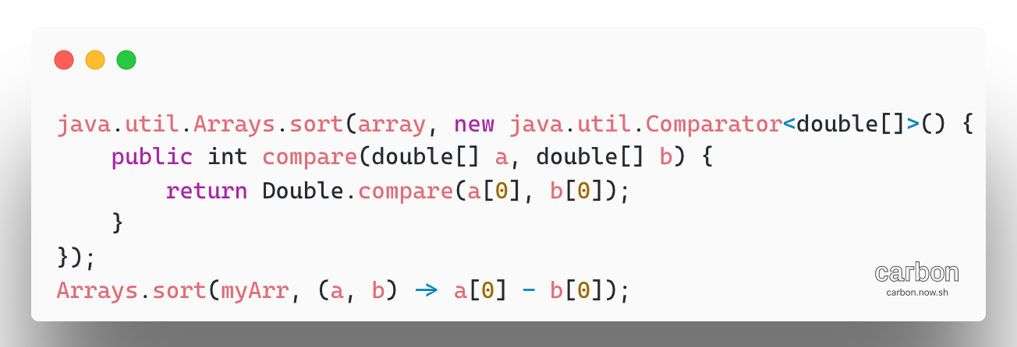

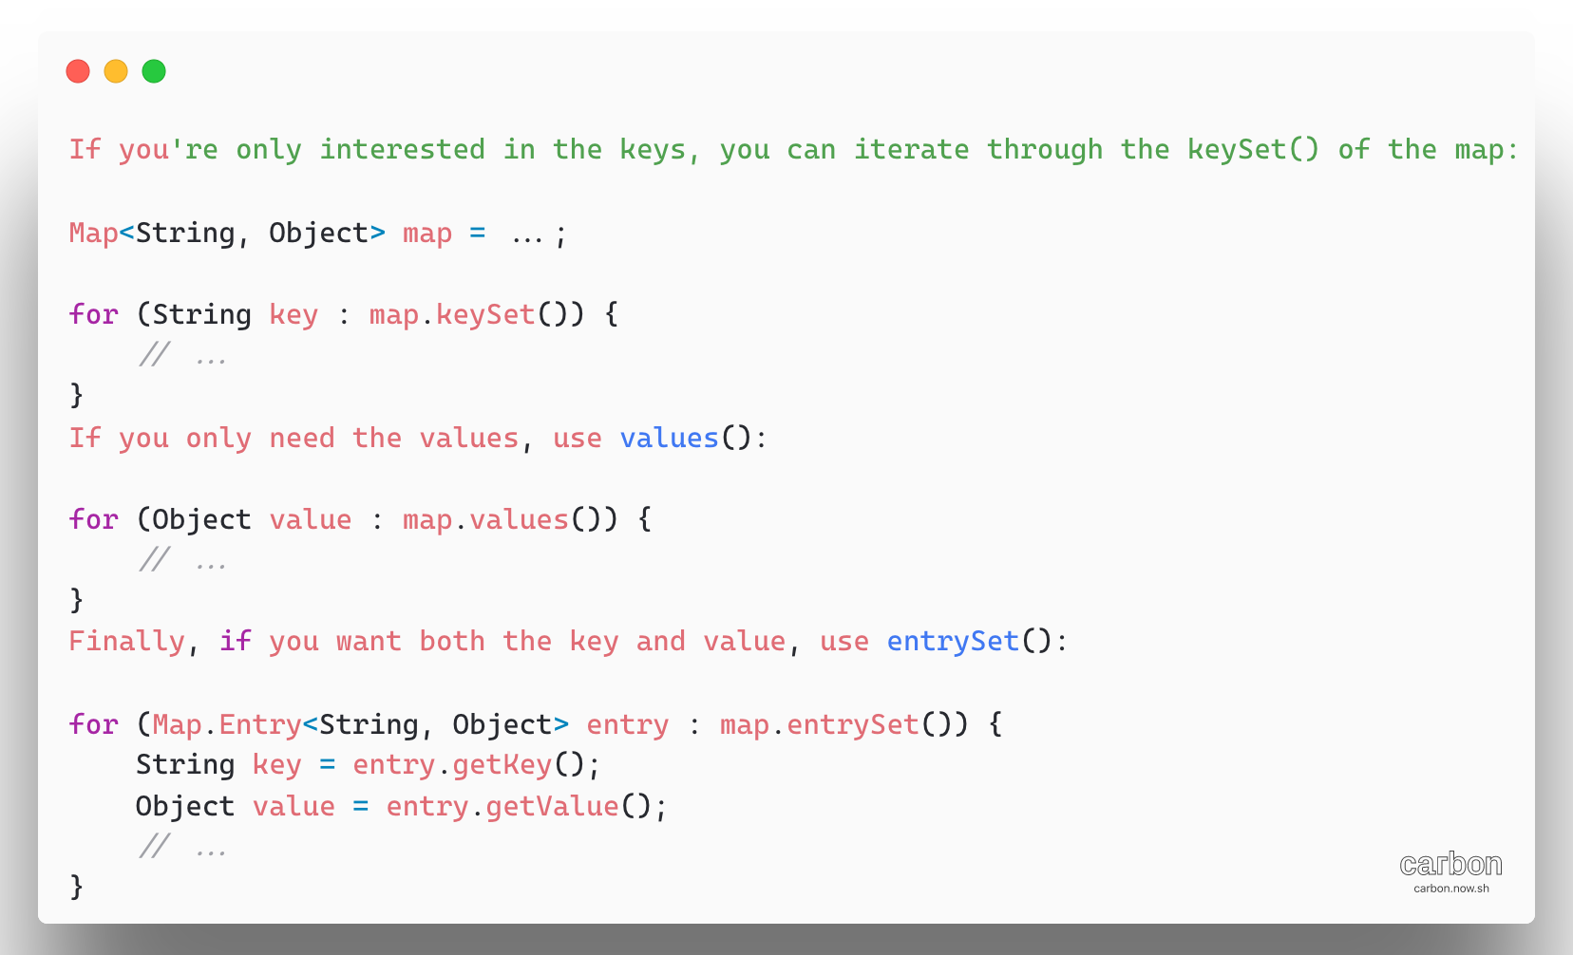

Complexity:

1. Imagine the binary search algorithm: **O(log(n))**
2. For each step of binary search, you iterate the array of N elements
3. The result would be **O(n*log(n))**
4. Which is more work than iterating the array once: **O(n)**

O(1) < O(logn) < O(n) < O(nlogn) holds true.

* + 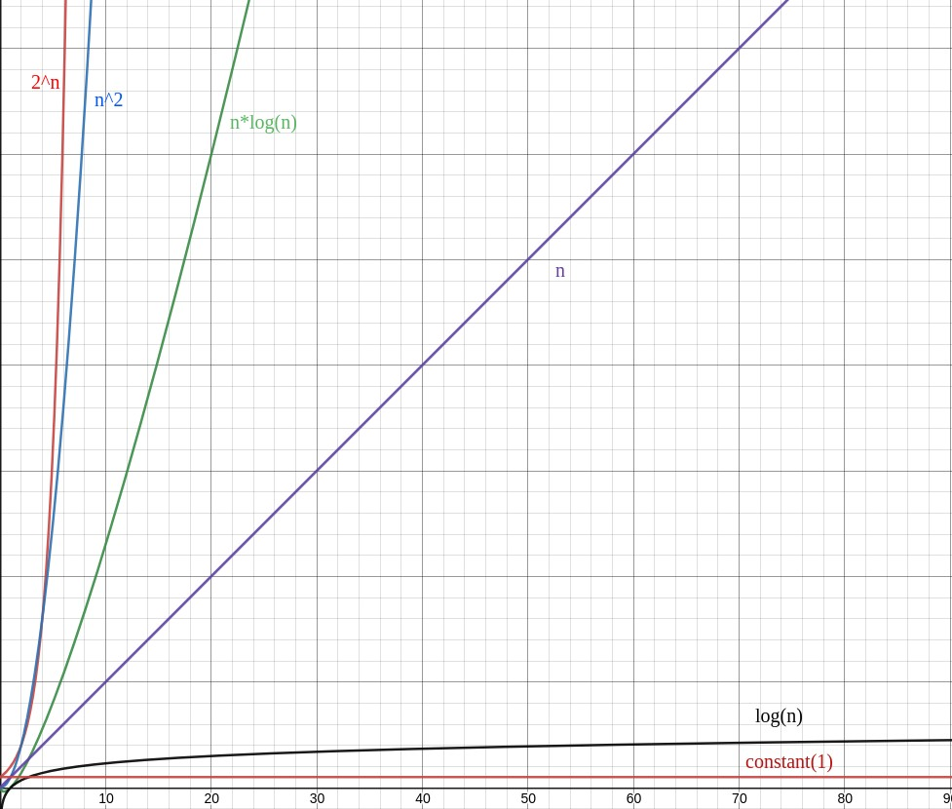

1. [Roman to Integer](https://leetcode.com/problems/roman-to-integer/)

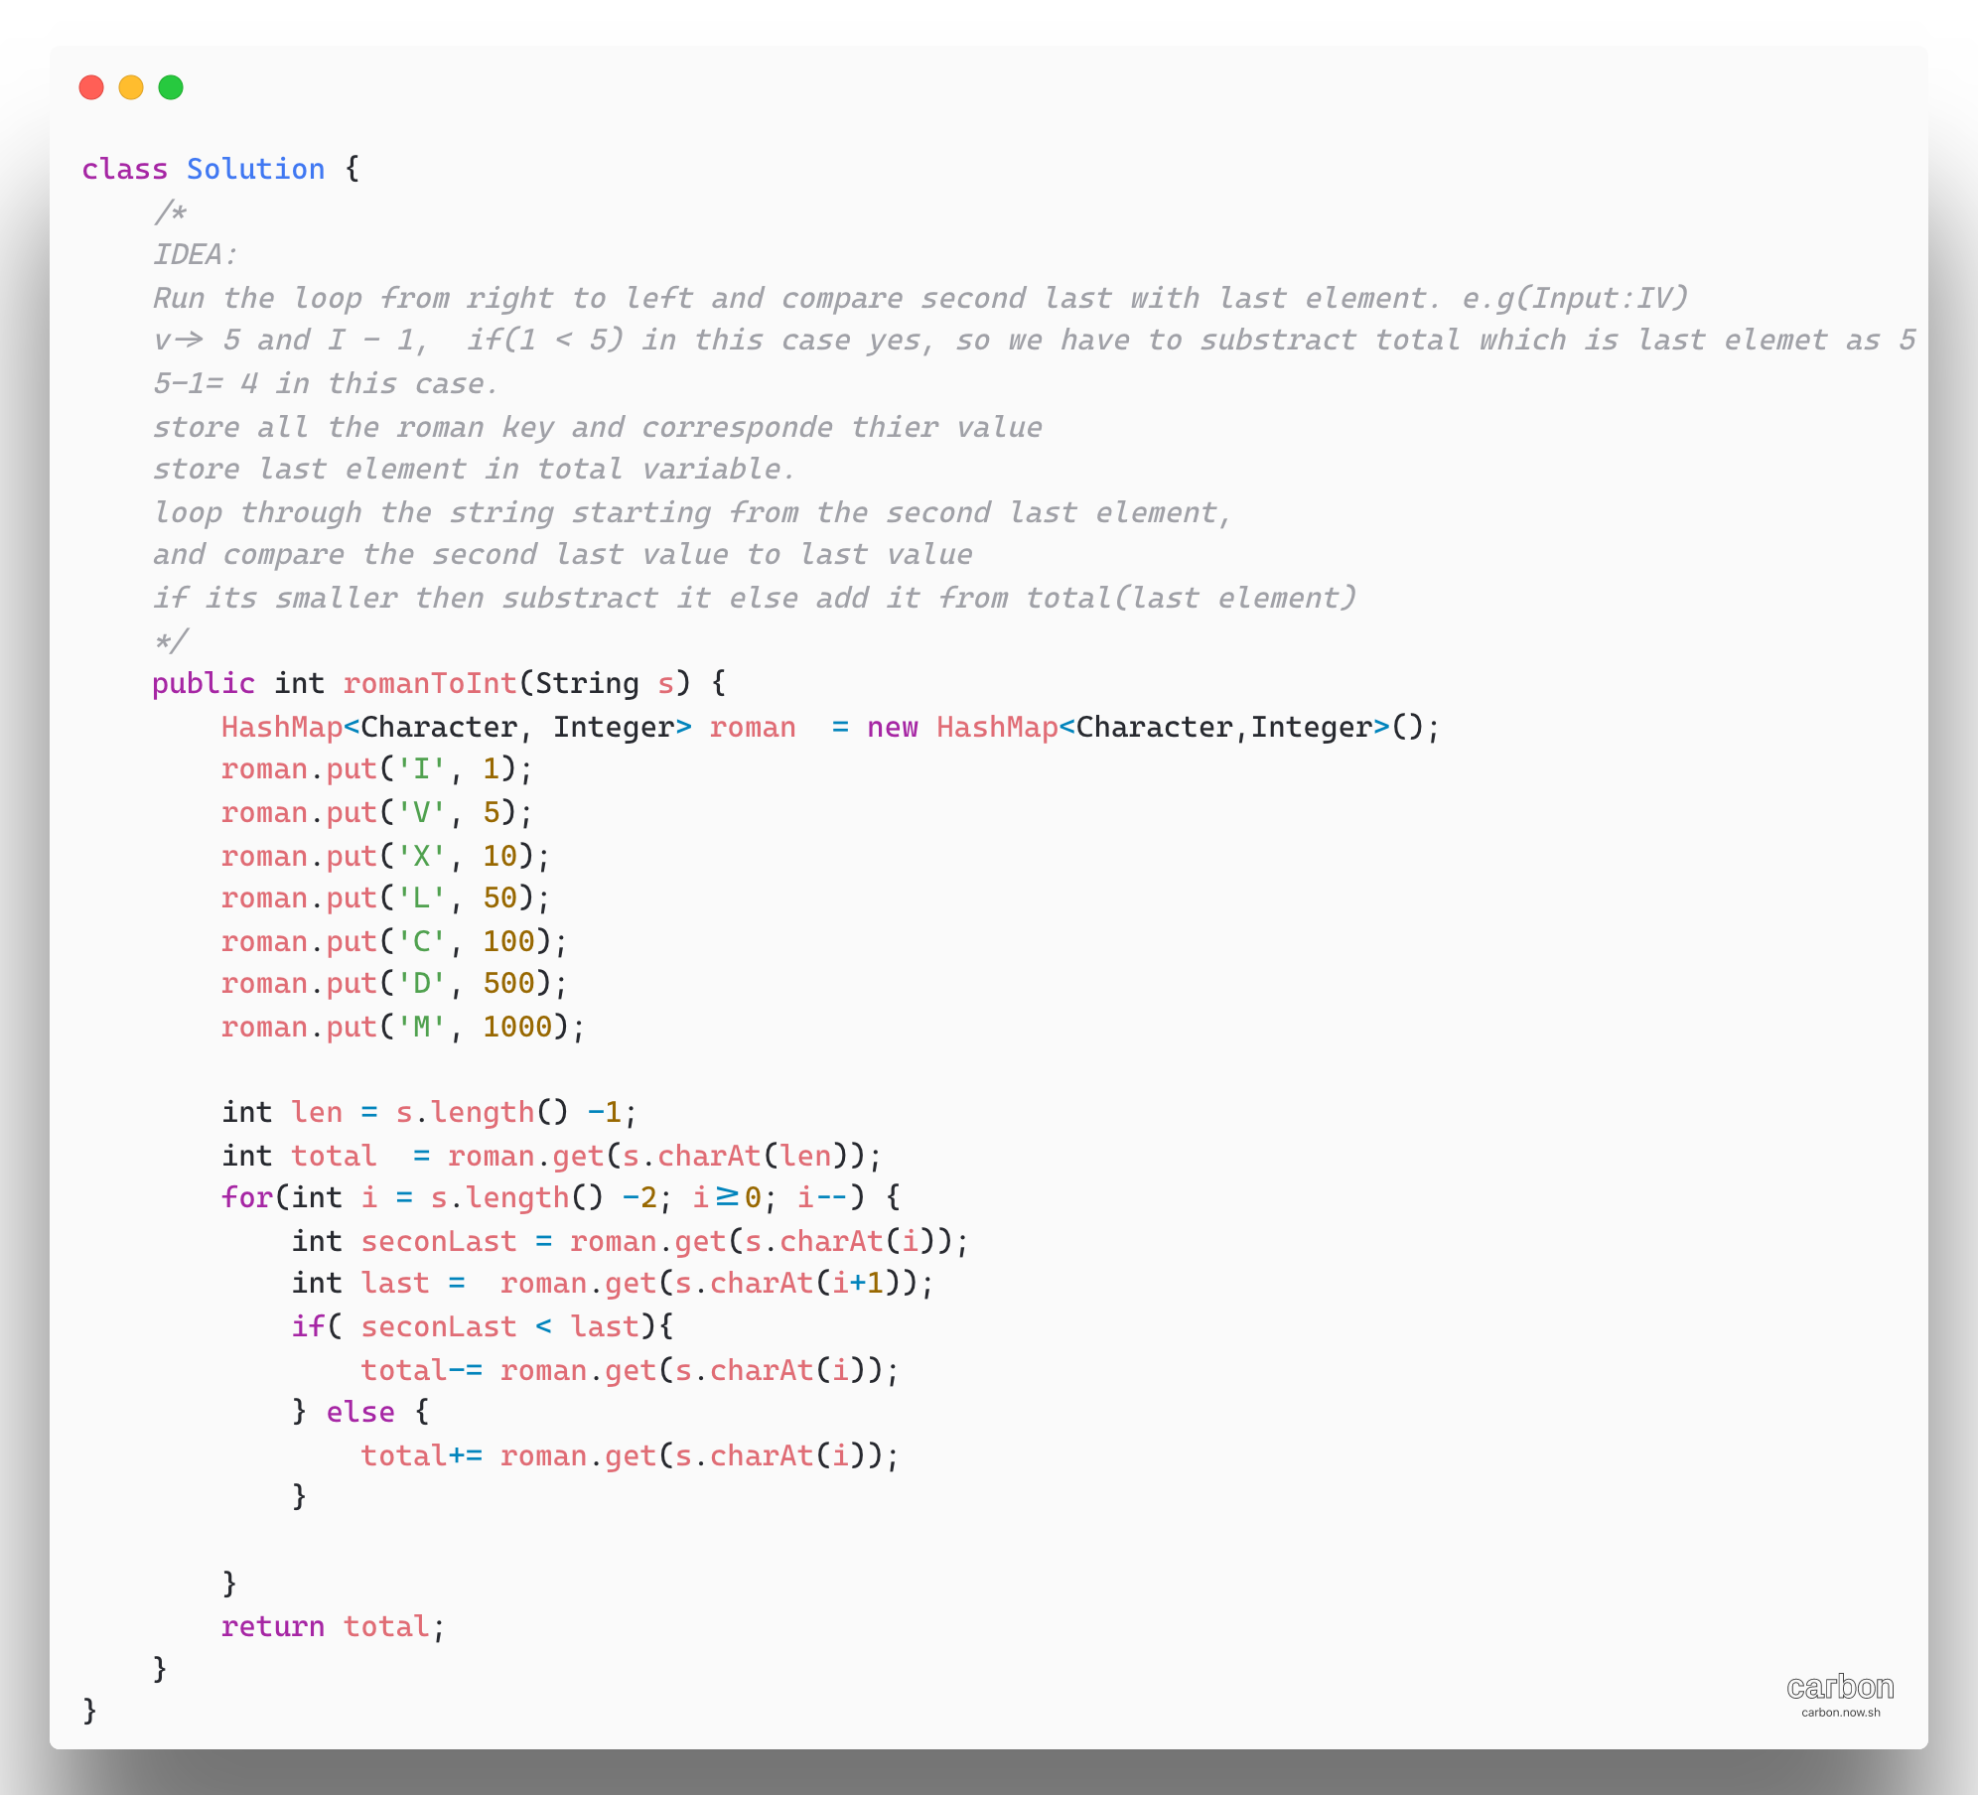

1. Merge Sort Top Down – [Sort an array](https://leetcode.com/problems/sort-an-array/)

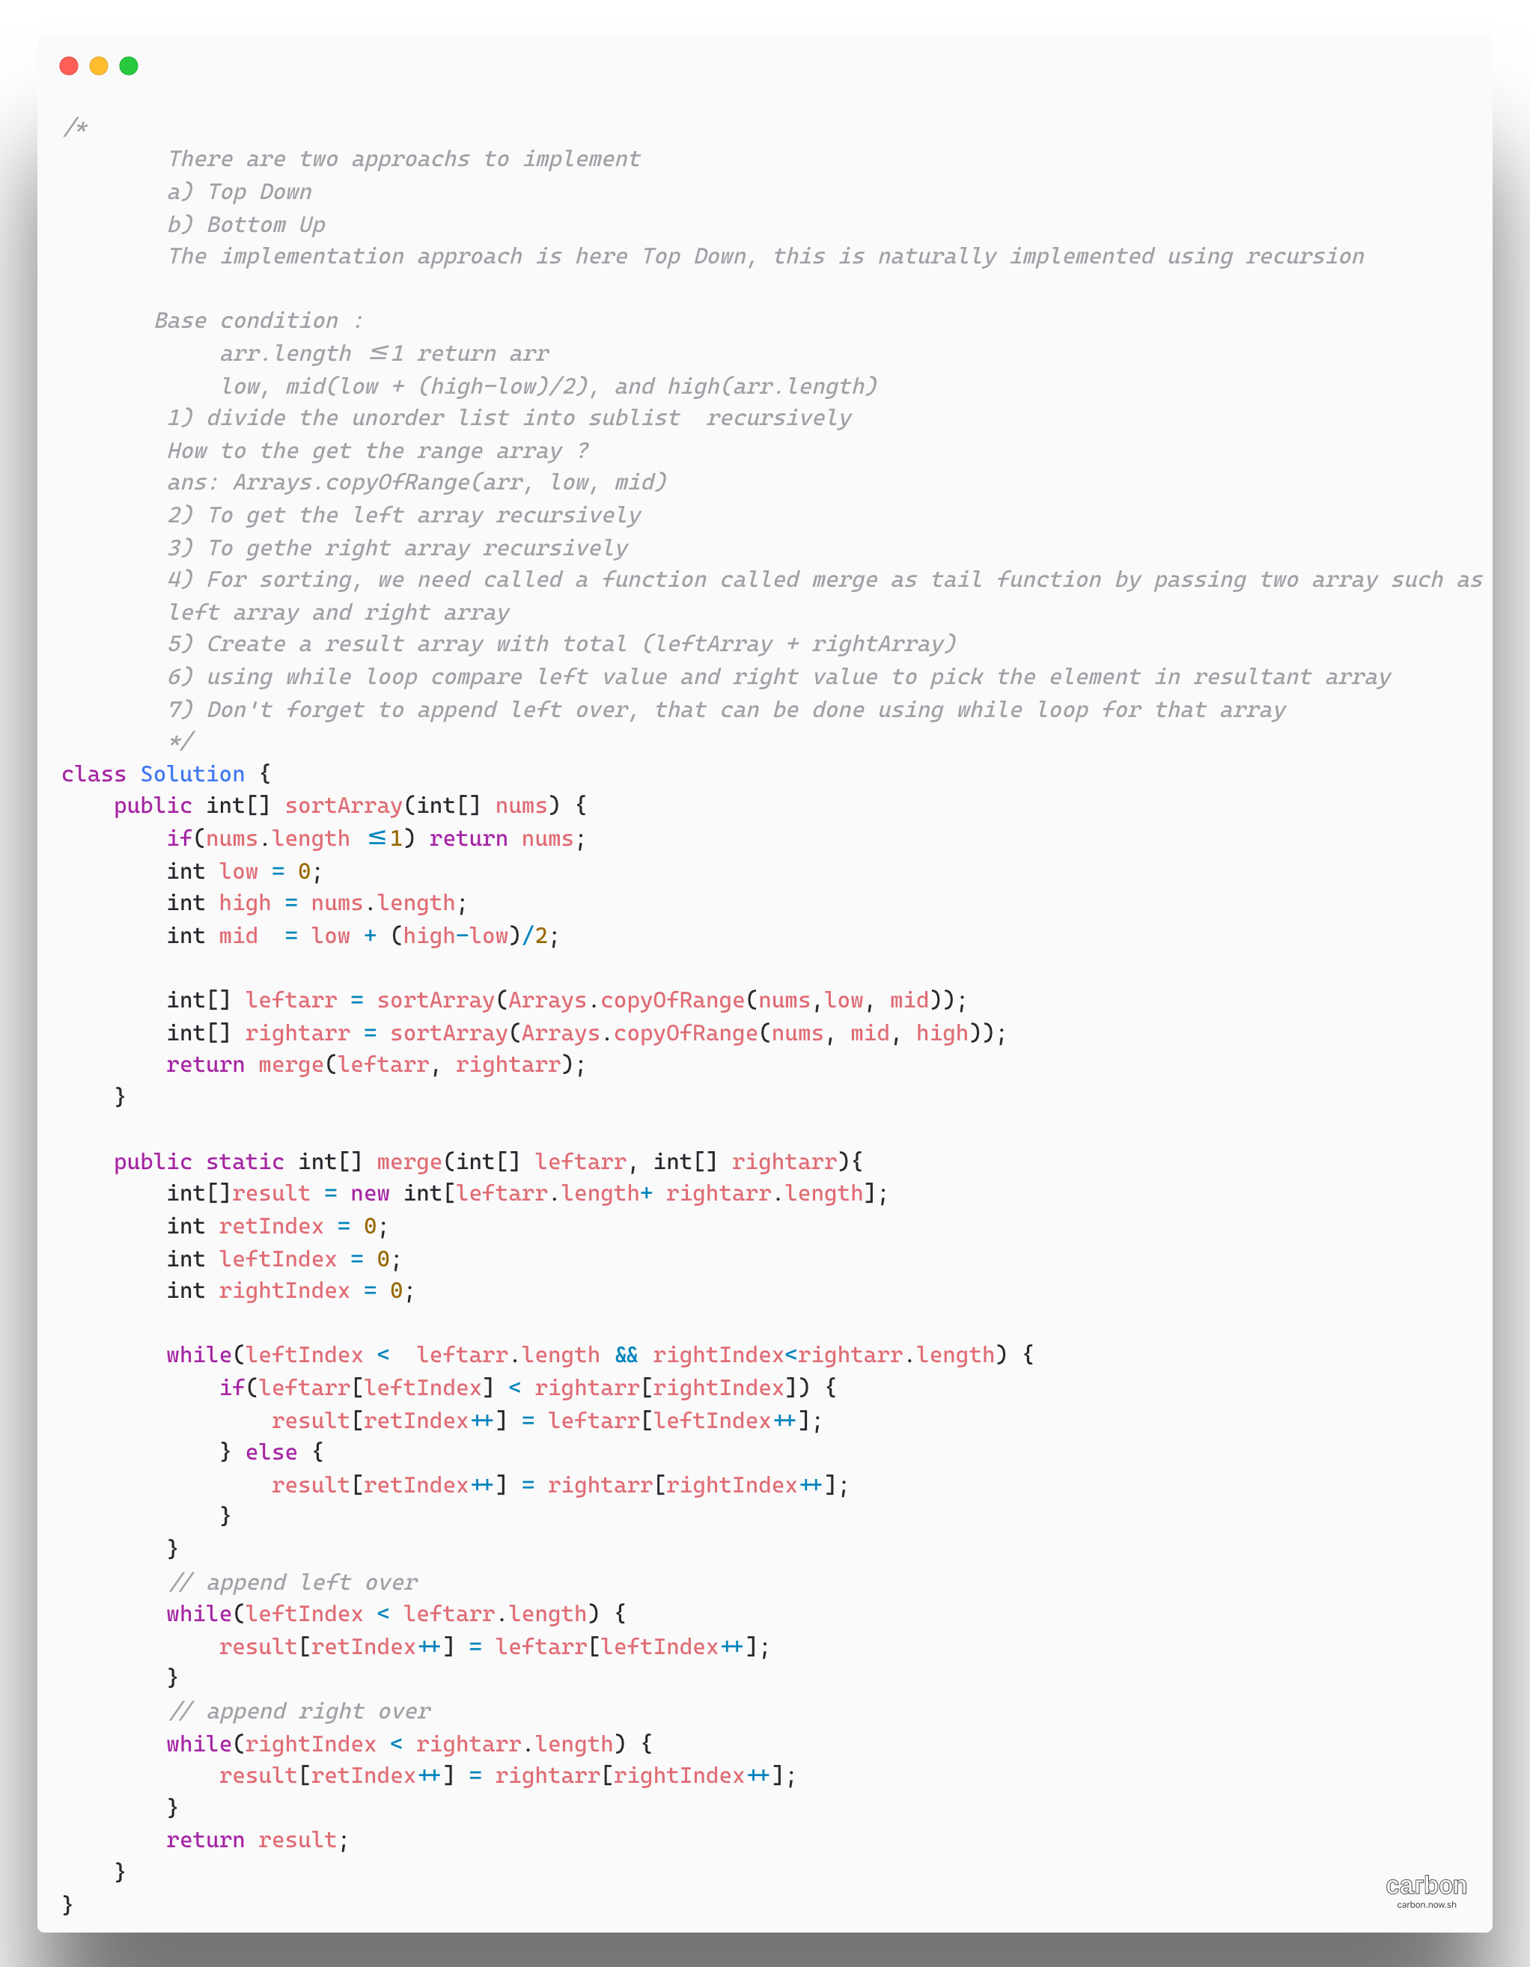

1. [Hamming Distance](https://leetcode.com/problems/hamming-distance/)

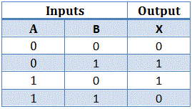

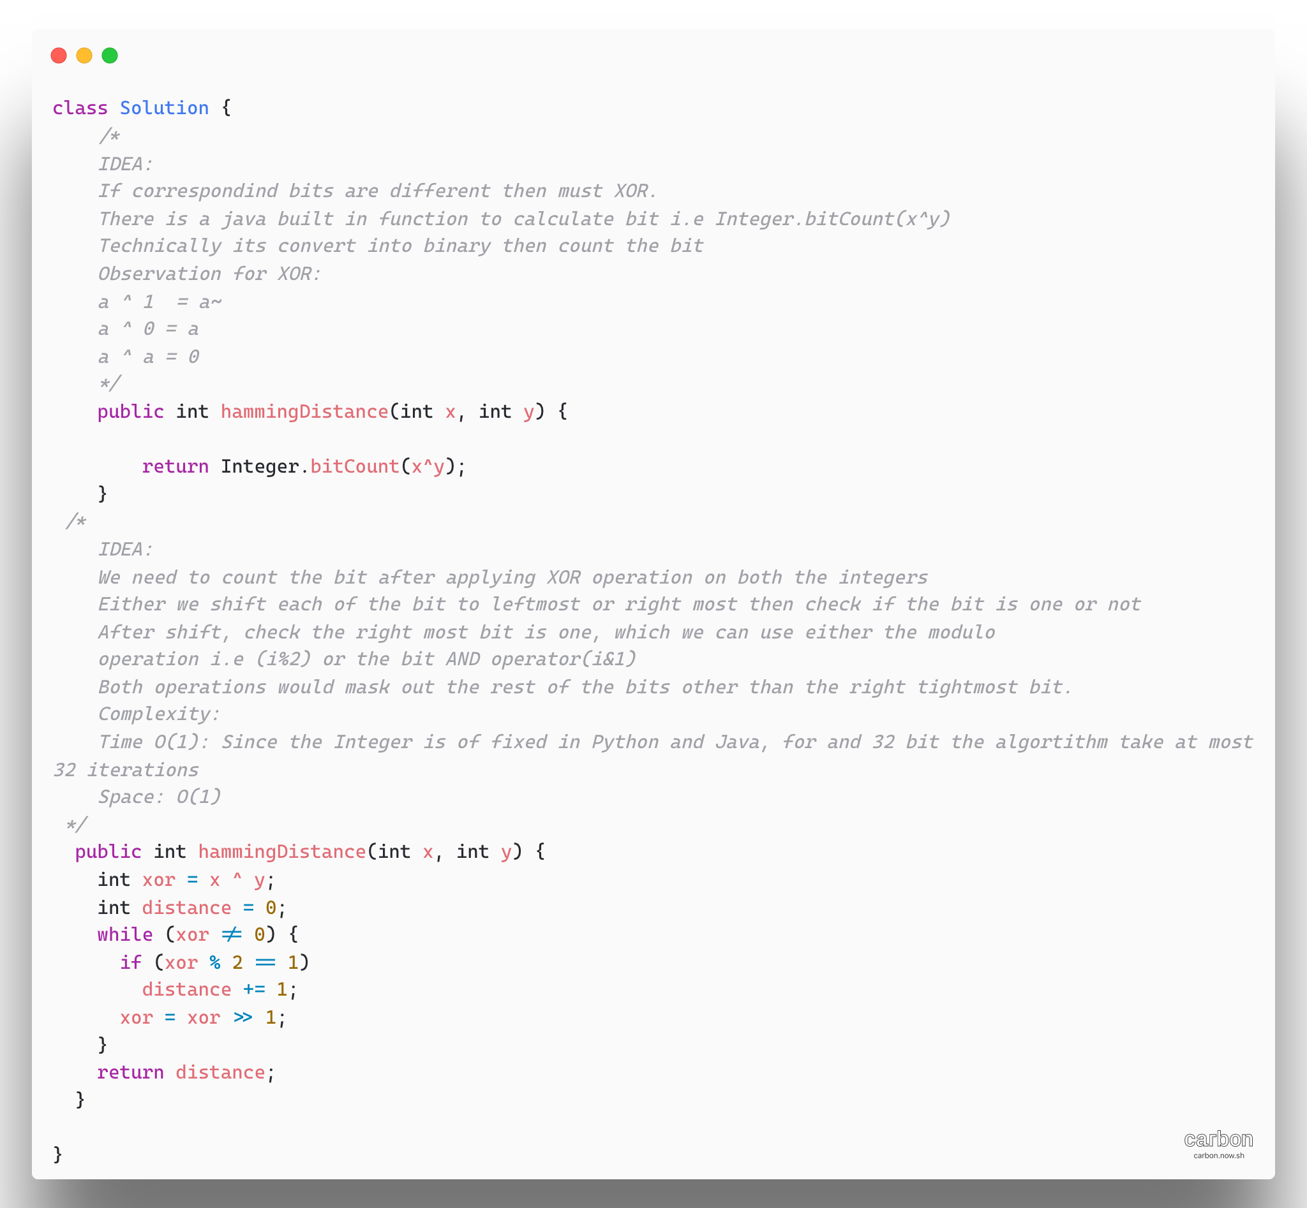

1. [Number of 1 Bits](https://leetcode.com/problems/number-of-1-bits/)

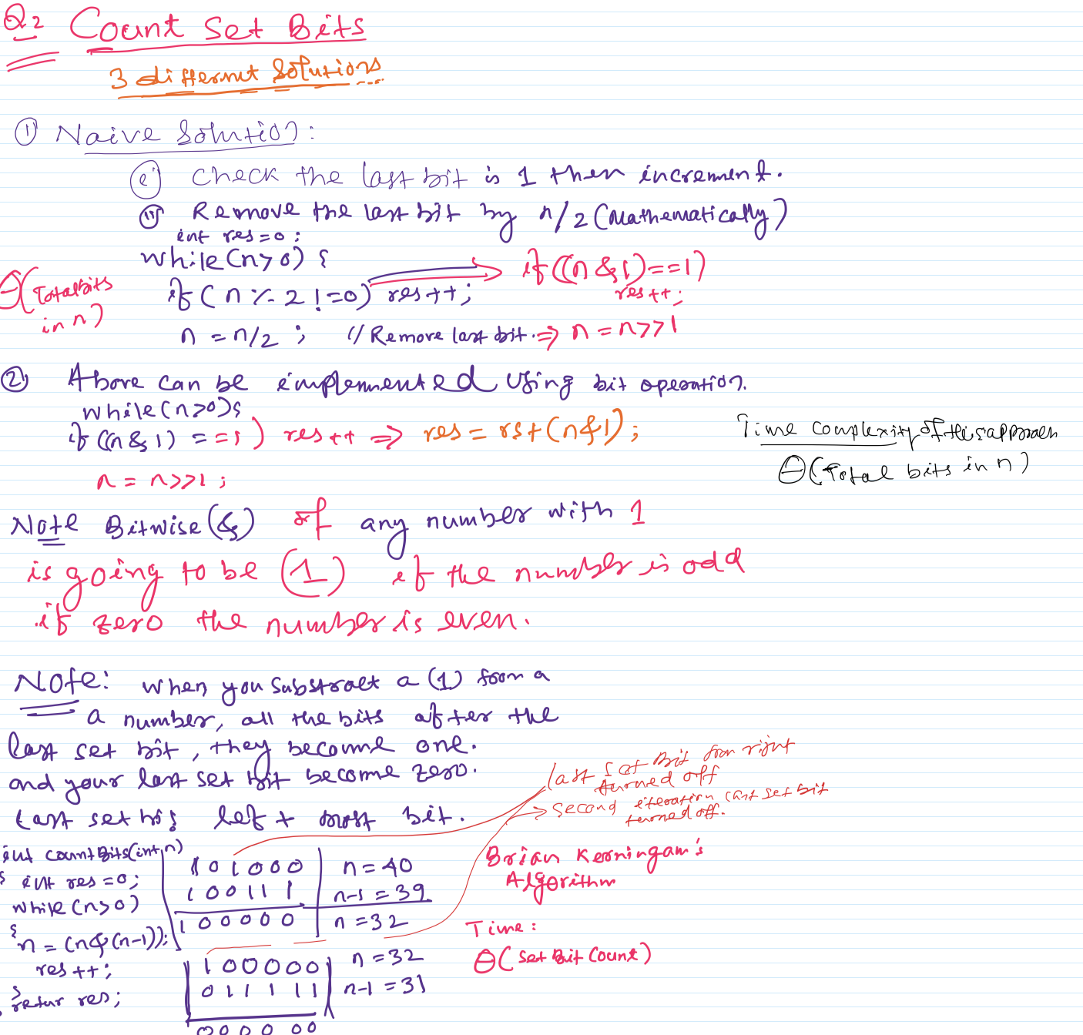

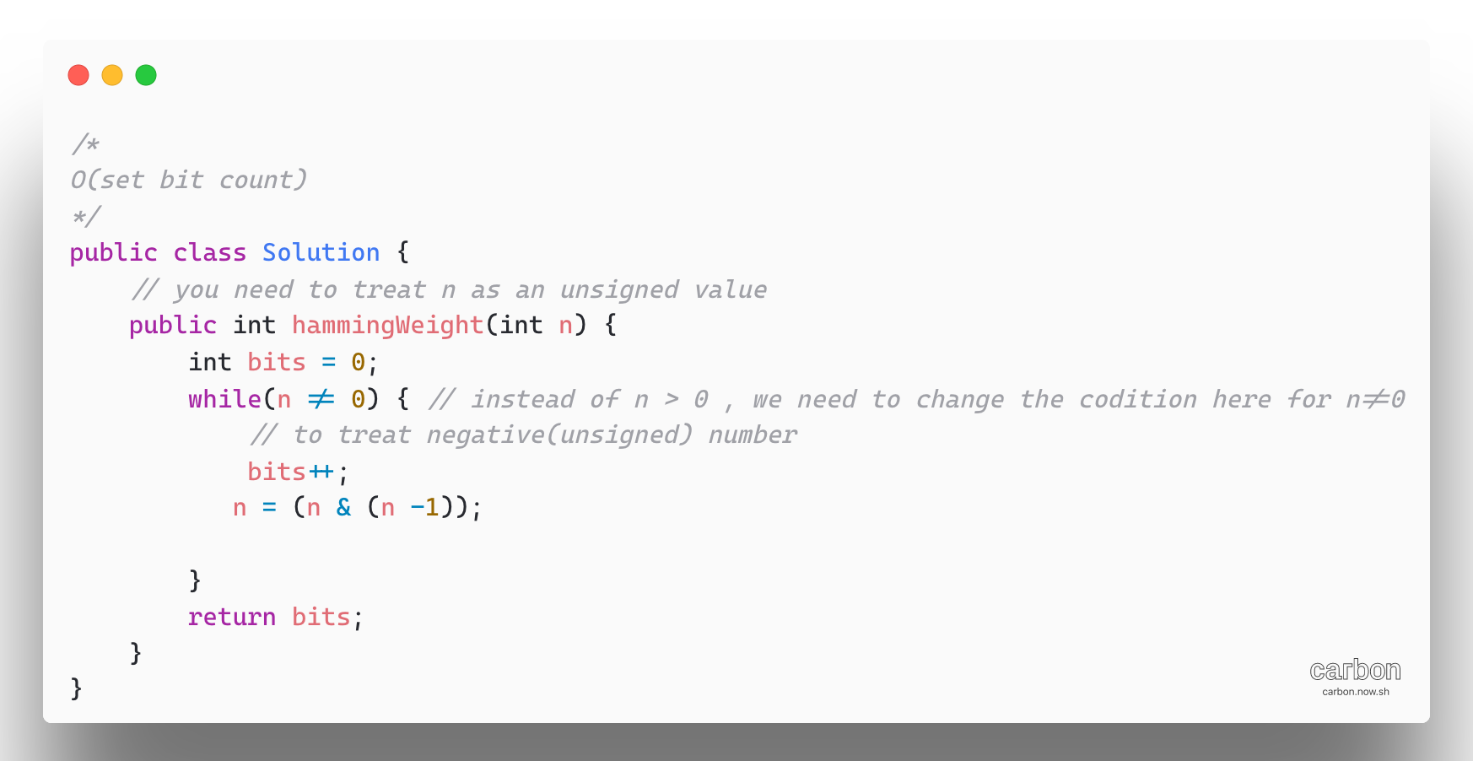

1. [1342. Number of Steps to Reduce a Number to Zero](https://leetcode.com/problems/number-of-steps-to-reduce-a-number-to-zero/)

Approach 1: Simulation

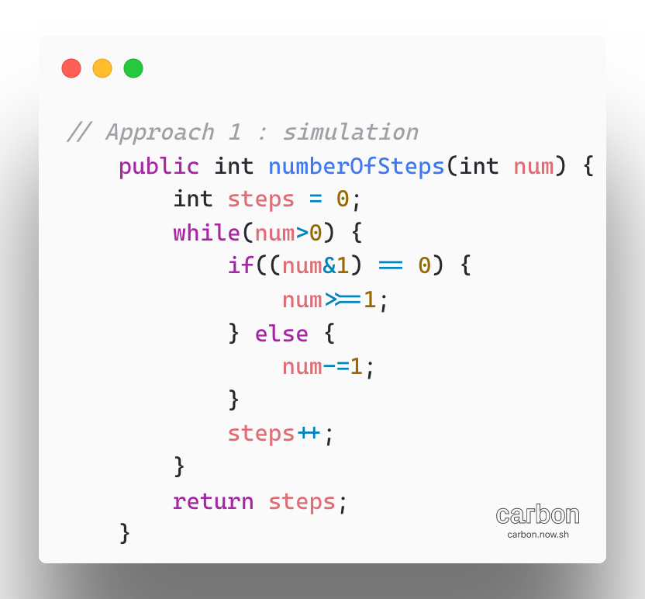

Approach 2: Counting Bits

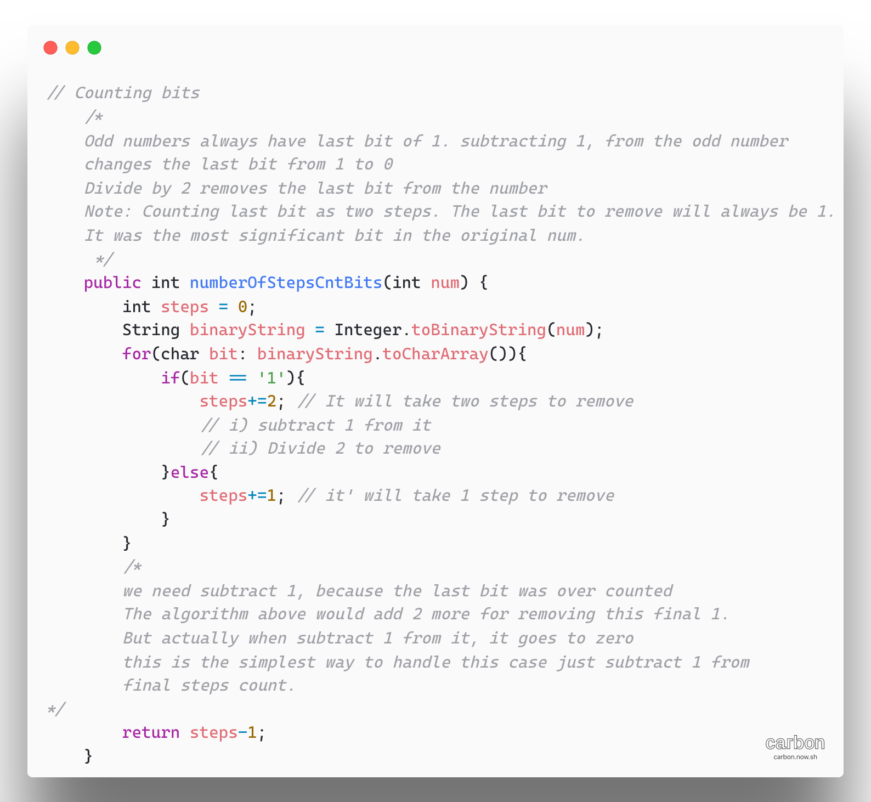

Approach 3: Counting Bits with Bitwise Operators

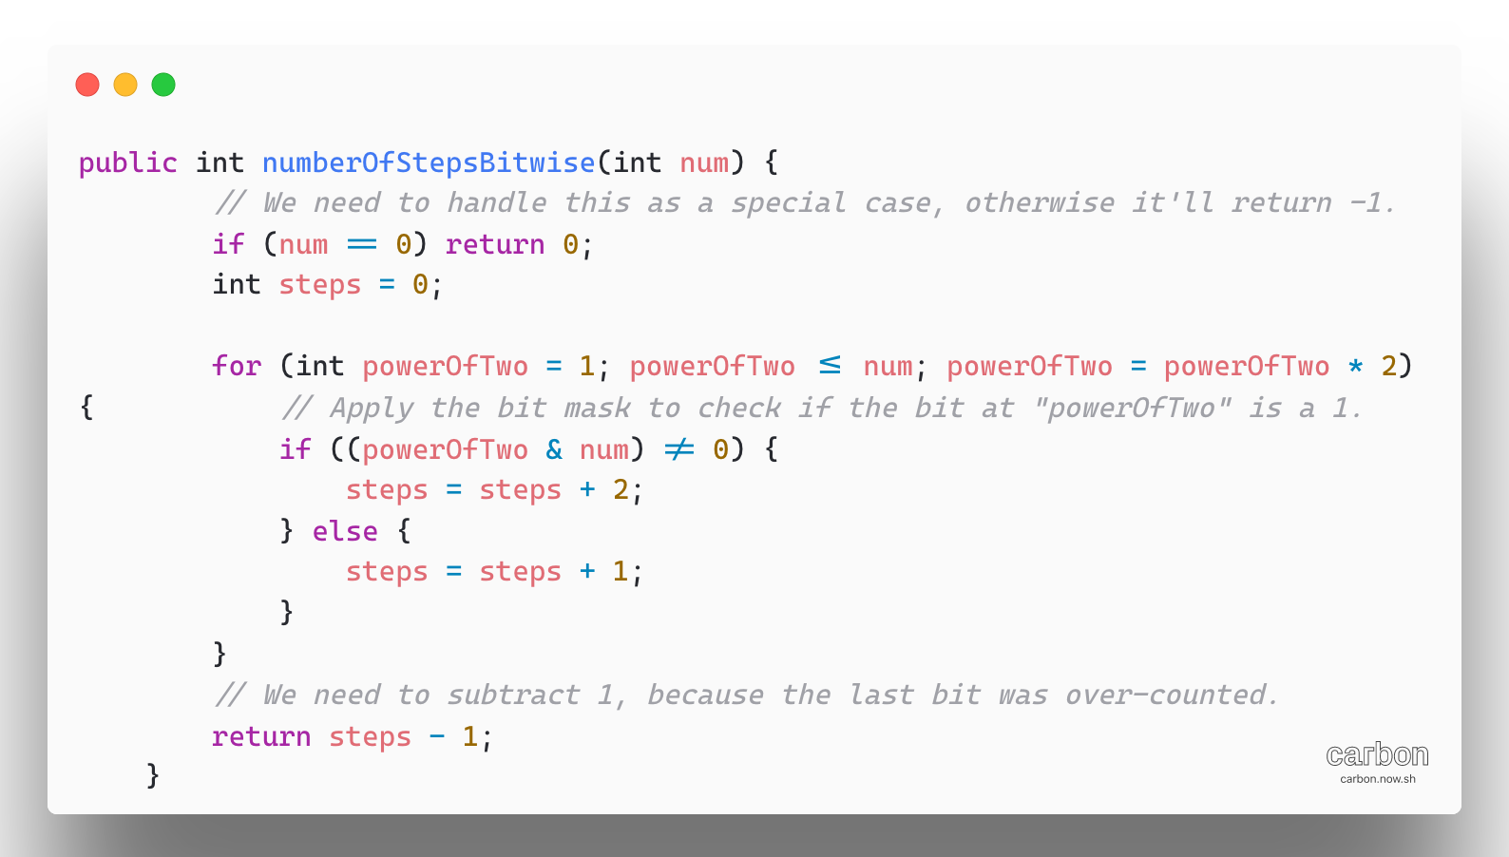

To check bits if they are 1 or 0, we used & operator

The result of a&b looks each bit in both a and b at the same time if both bits are 1 the result to 1.

These numbers of form 1, followed by some number of 0s, are just the powers of two, where the power is the number of 0s after the one.

We can check if a bit is a 1 in a number by doing **(num &(1<<bit))** where bit we want to check (0-indexed from the right).

For example, let’s check if the sixth bit of 109 is a 1

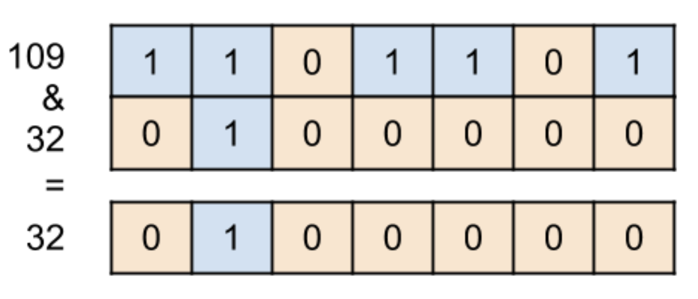

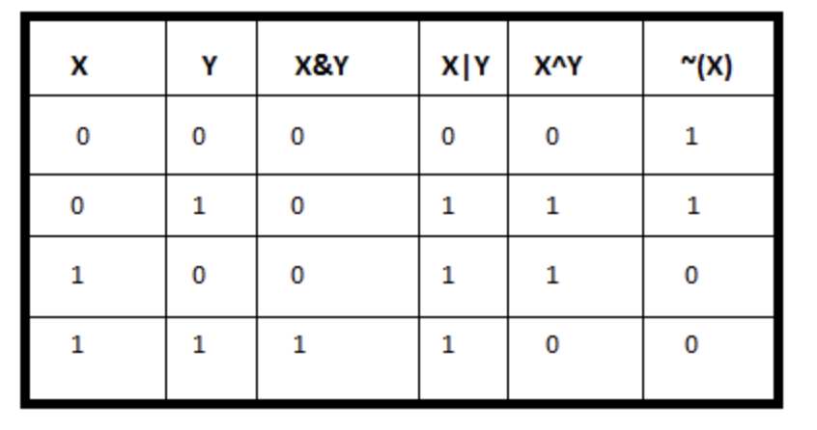

**What is Bit masking?**

A mask defines which bits you want to keep and which bits you want to clear. Masking is

the act of applying a mask to a value.

* + Bitwise ANDing to extract a subset of the bits in the value
  + Bitwise ORing to set a subset of the bits in the value
  + Bitwise XORing to toggle a subset of the bits in the value

1. [Counting Bits](https://leetcode.com/problems/counting-bits/)

Get some idea about DP, may be not the correct implementation but worth to watch

https://www.youtube.com/watch?v=PUSVTRzqEWE

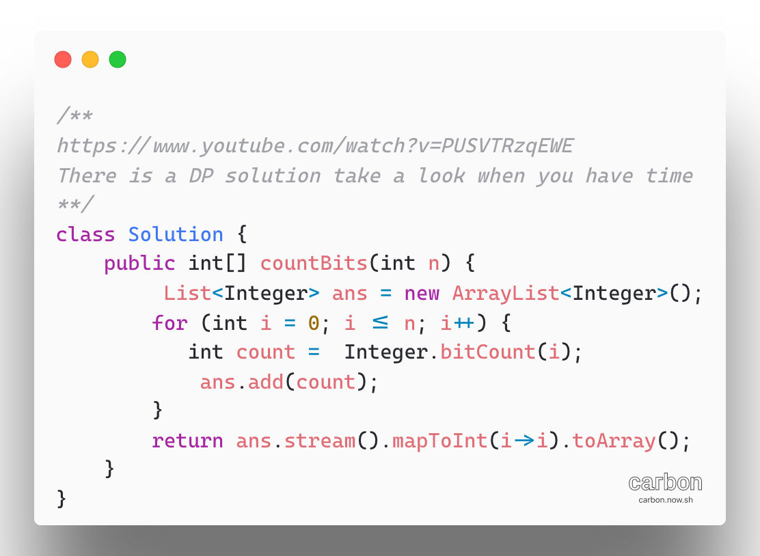

1. [Missing Number](https://leetcode.com/problems/missing-number/)

There are many approaches to solve this problem,

**Approach 1:** Sorting

We check two special cases that can be handled

a) ensuring o is at the beginning

b) and that n is at the end

we get, then missing number is on the range (0, n)

stating from 1,we simply check the previous number plus 1

**Approach 2:** Gauss formula

sum i=0 to n = n(n+1)/2

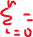

**Approach 3:** Using HashSet

**Approach 4:** Bit Manipulation

initialize an integer to n and XOR it with every index and value, we will be left with the missing number.

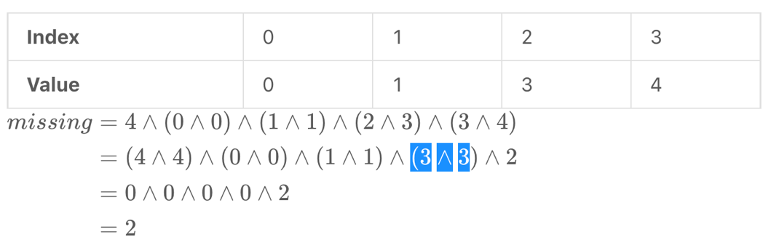

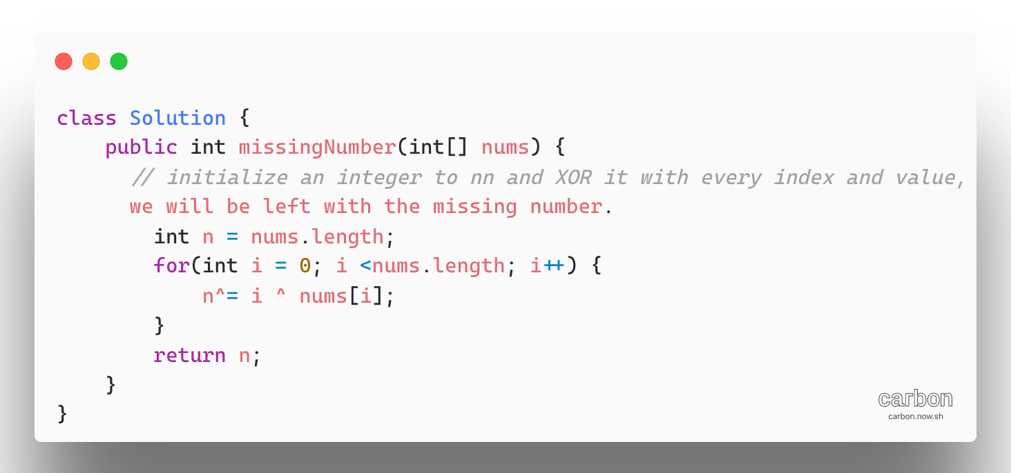

1. [Maximum Product of Word Lengths](https://leetcode.com/problems/maximum-product-of-word-lengths/)

More elegant and fast solution would be to use bitmasks

Words contain only lower-case letters and hence an absence or presence of each letter in a word could be encoded with a bitmask of 26 elements.

Let’s set bit number 0 waul to 1 character a is present so on.

Use standard bitwise trick: n_th_bit = 1<<n

Iterate over the word, letter by letter, compute bit number corresponding to that letter n = ch – ‘a’ and add this n-th_bit = 1<<n into bitmask

Bitmask|=n_th_bit

This way one could compute two bitmaks, character ny character in O(L1 + L2) time. Then the word comparison itself could be done one operation and in a constant time

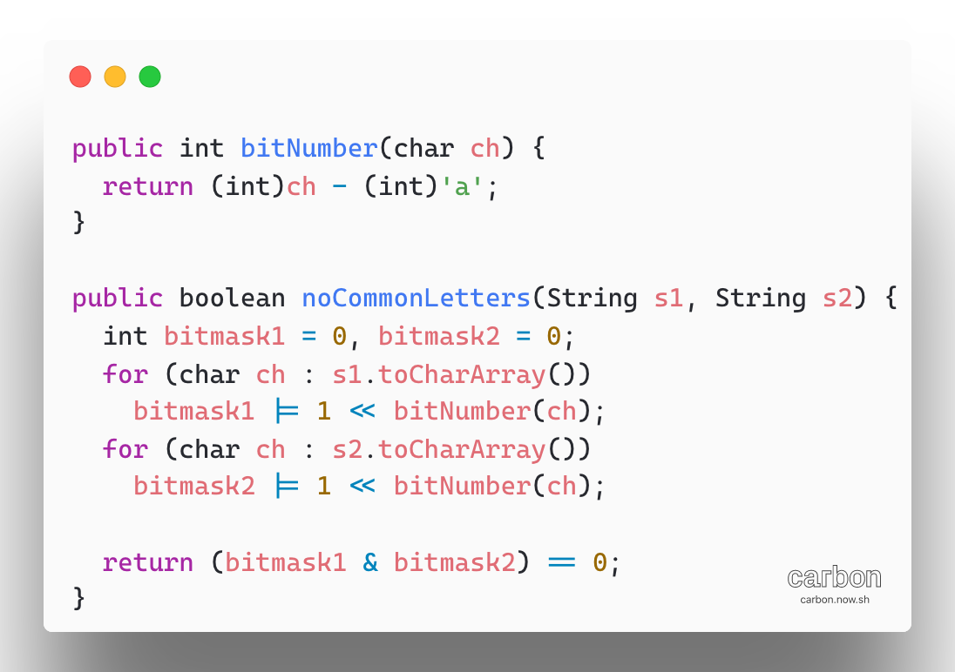

Bitmasks + Precomputation: comparison in O (1) time

In the previous approach computes a bitmask of each word N times. I fact each bitmask could be precomputed just once, memorized, and then used for the runtime comparison in a constant time.

Two integer arrays to store bitmasks and string lengths.

Algorithm:

* Precompute bitmasks for all words and save them in the array masks. Use array lens to keep the lengths for all words.
* Compare each word with all the following words one by one. if two words have no common letters, update the maximum product maxProd.

Perform “no common letters” check in a constant time with help of precomputed masks array: (masks[i] & maks[j]) == 0

* Return maxProd
* Time Complexity: O(N^2 + L) where N is a number of words and L is a total length of all words together. The precomputed takes O(L) time because we iterate over all characters in all words. The runtime word comparison take O(N^2) time. In total that results in O(n^2 + L) time complexity
* Space Complexity: O(N) to keep two arrays of N elements

1. [Check If a String Contains All Binary Codes of Size K](https://leetcode.com/problems/check-if-a-string-contains-all-binary-codes-of-size-k/)

We just need to check every substring with length K until we get all possible binary codes. Since there are two possible chars for each place: 0 or 1, there will be 2^k possible binary code.

We can continue until we count to 2^k. we will return false if did not get 2^k counts after iteration. To prevent repeated counting, a set can be used to store the result we previously counted.

Note: 1<<k is the same as 2^k, and we use previous one here.

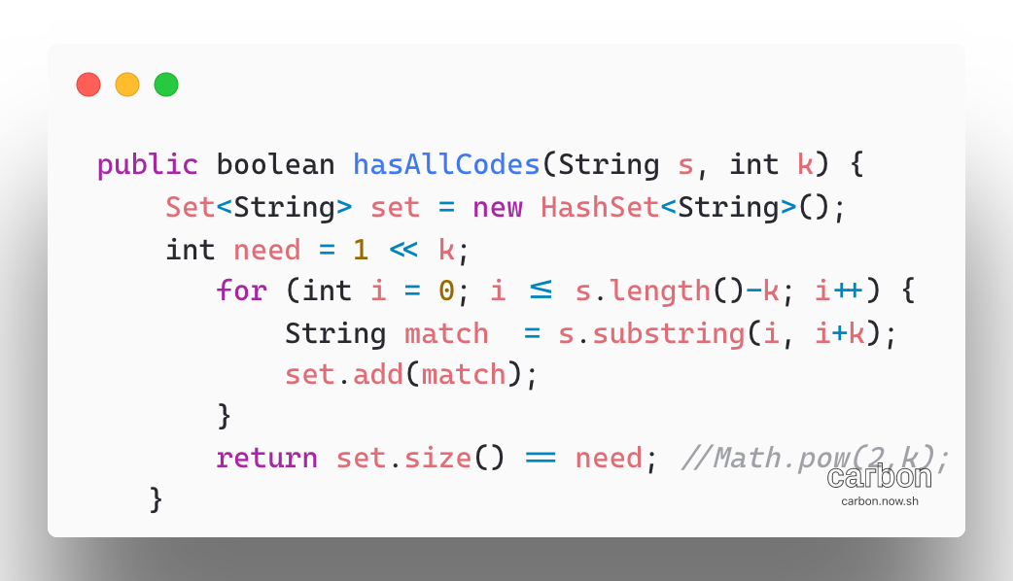

1. [Kth Smallest Element in a Sorted Matrix](https://leetcode.com/problems/kth-smallest-element-in-a-sorted-matrix/)

**Note: Look for binary search for optimal solution**

Time Complexity:

Let X = min (K, N); X+ K log(X)

* Well, the heap construction takes O(X) time
* After that, we perform K iterations and each iterations has two operations

We extract the minimum element from a heap containing X elements. Then we add a new element to this heap. Both the operations will take O(lg(x)) time.

Thus, the total time complexity for this algorithm comes down to be O(x_K log(x)) where X is min(K,N)

* Space Complexity: O(X) which is occupied by the heap

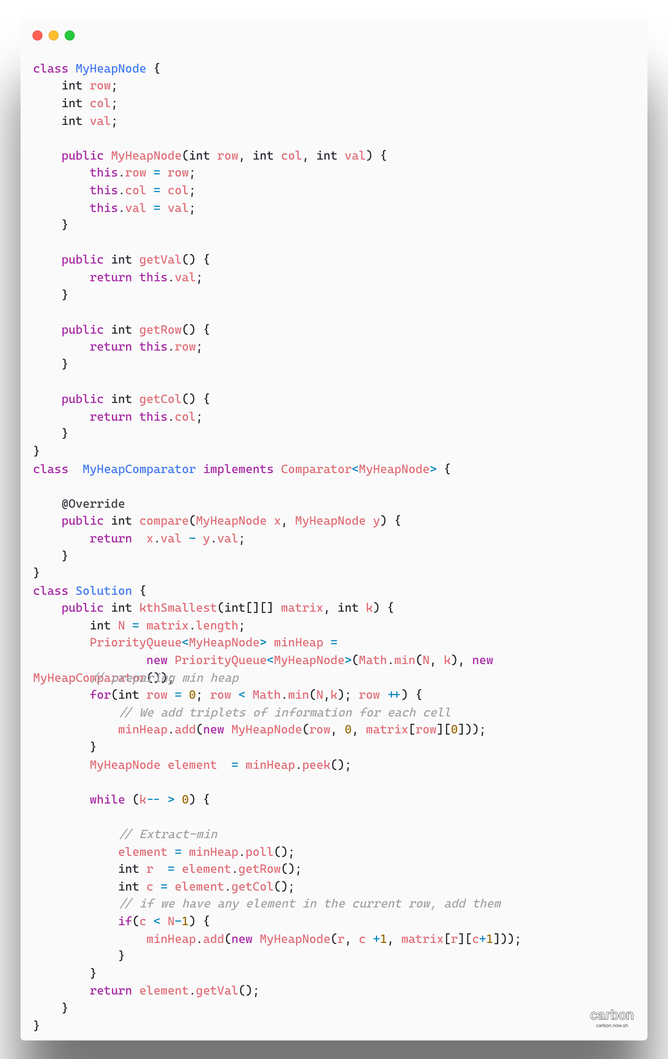

1. [Delete Node in BST](https://leetcode.com/problems/delete-node-in-a-bst/)

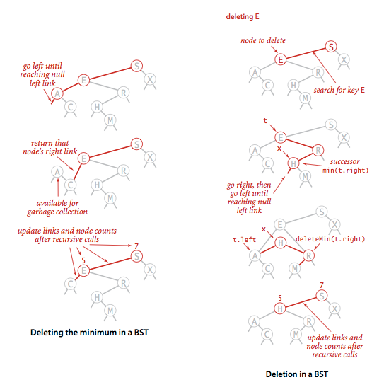

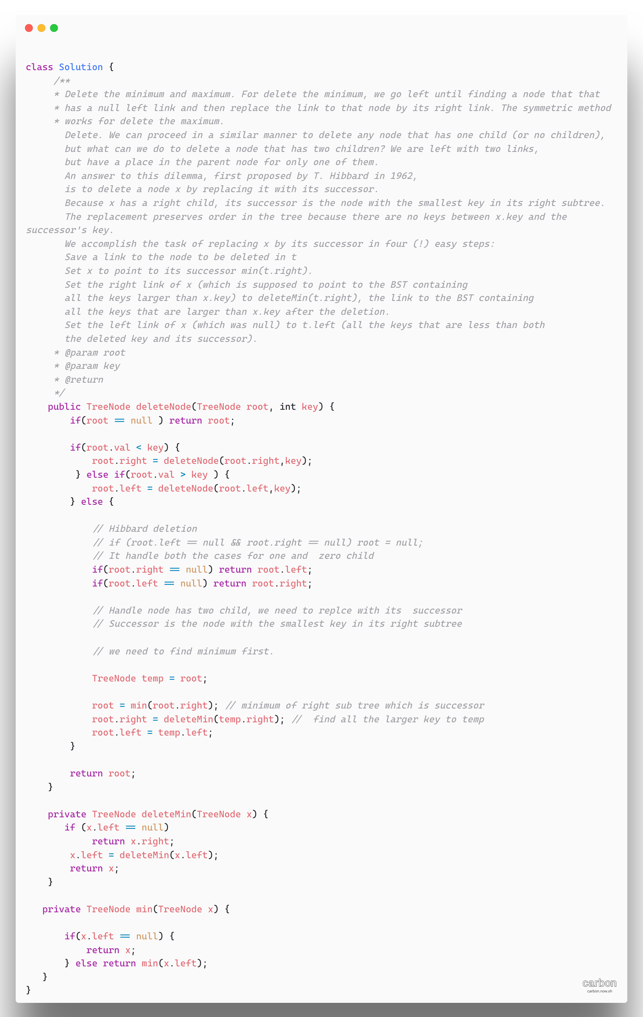

1. [Container with Most Water](https://leetcode.com/problems/container-with-most-water/)

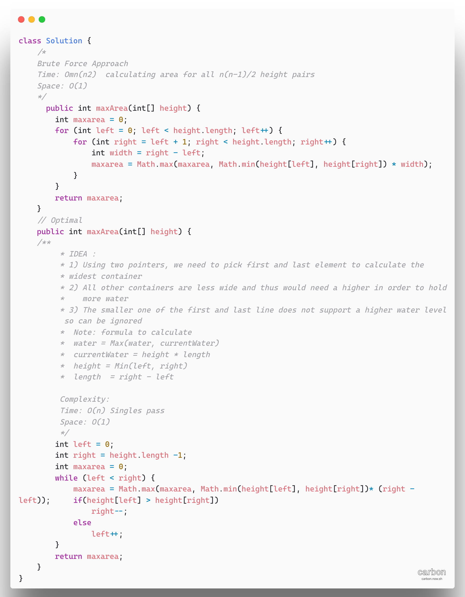

1. [Squares of a sorted Array](https://leetcode.com/problems/squares-of-a-sorted-array/)

IDEA: Two Pointers since the array is sorted, loosely speaking it has some negative elements with squares in decreasing order, then some non-negative elements with squares in increasing order. Using Math.abs() we can compare and merge array accordingly.

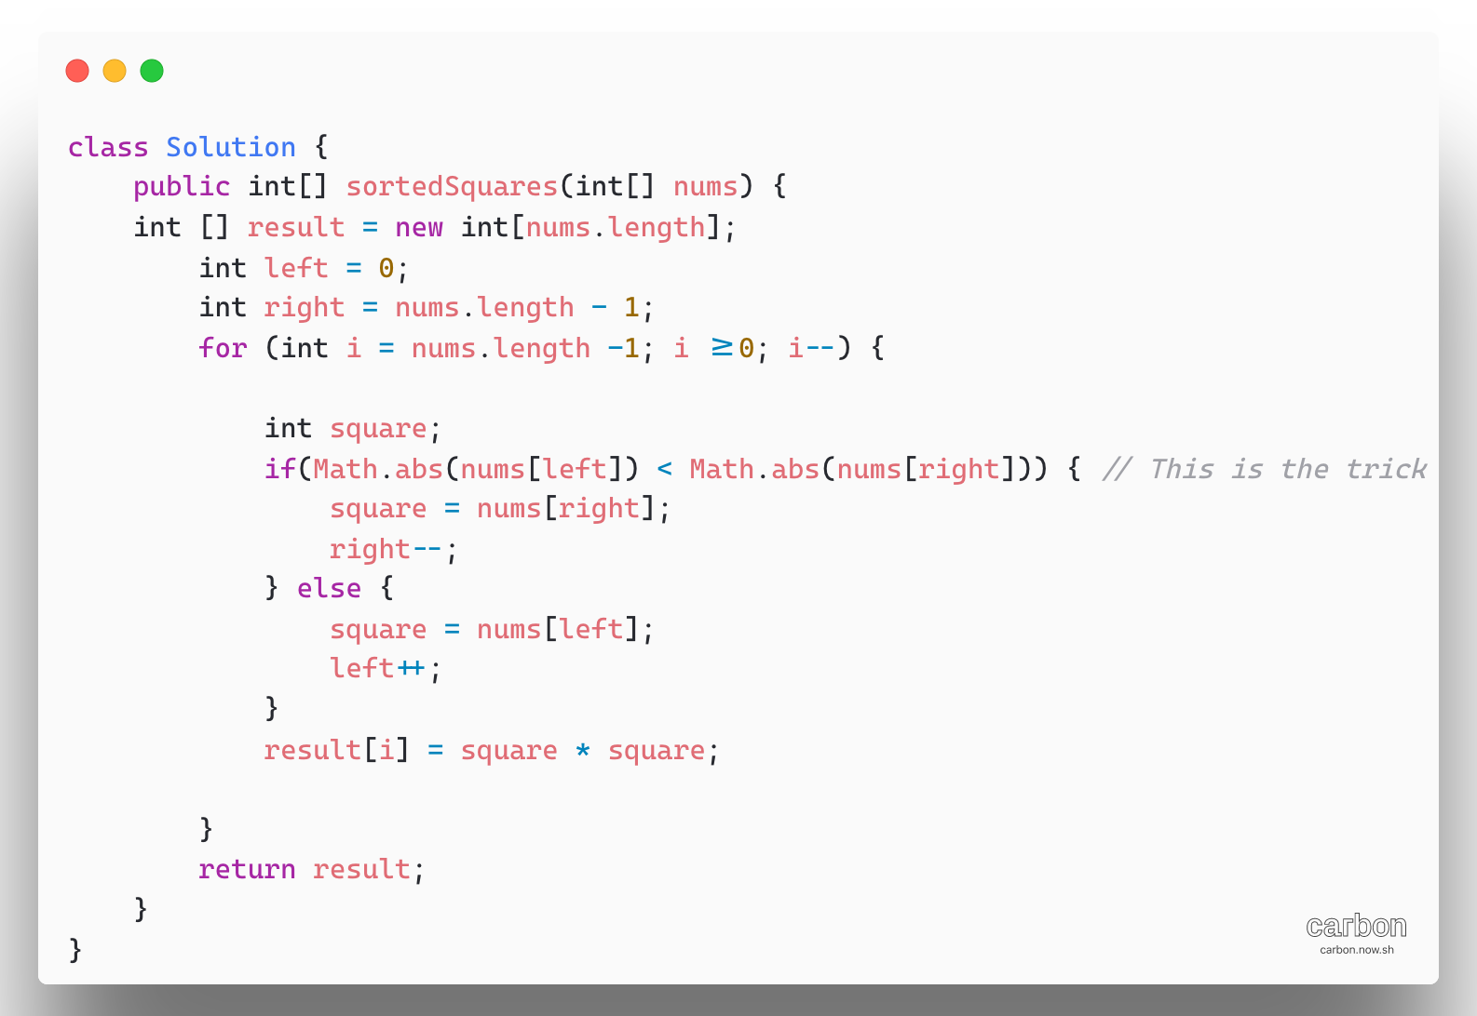

1. [Merge Sorted Array](https://leetcode.com/problems/merge-sorted-array/)

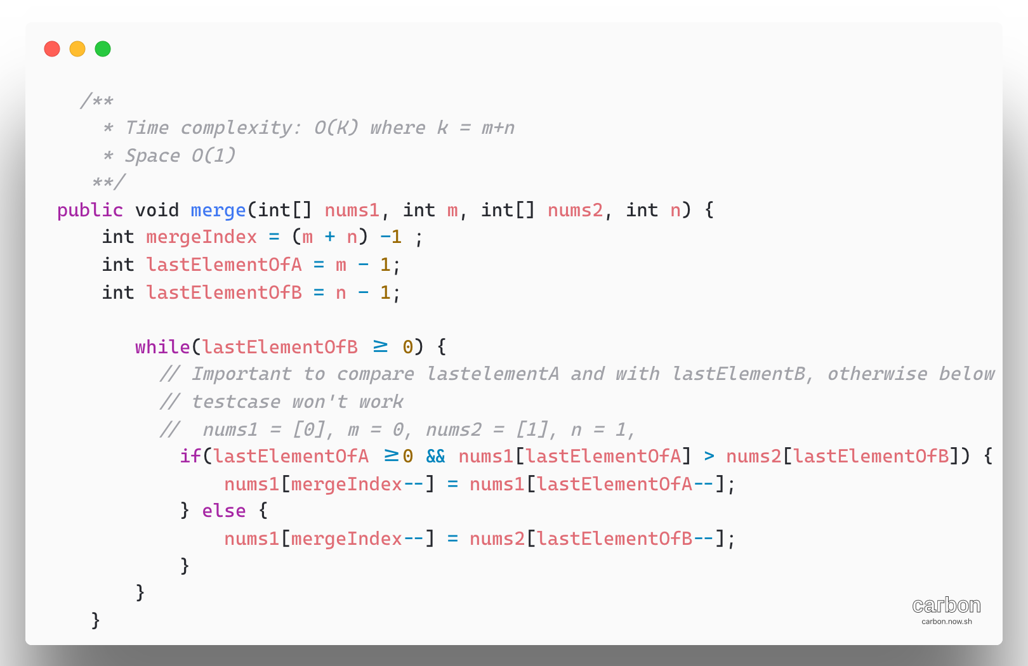

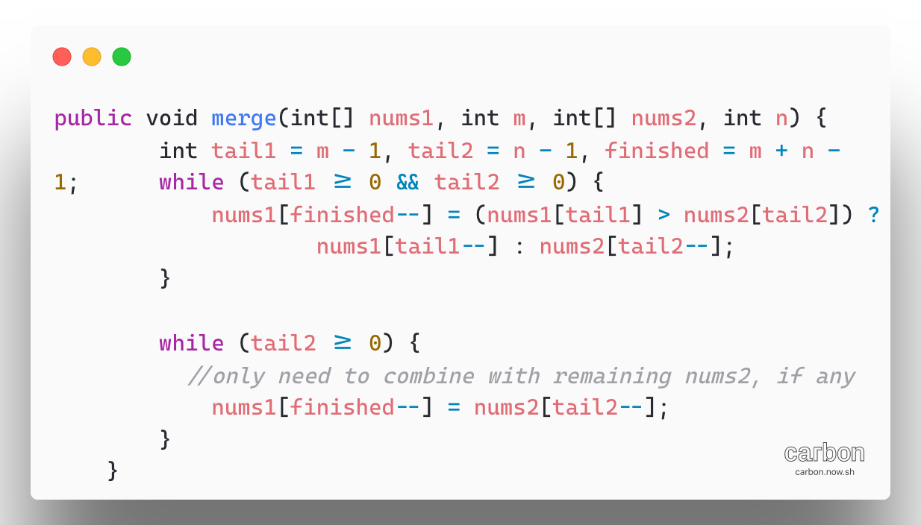

1. [Merge Two Sorted Lists](https://leetcode.com/problems/merge-two-sorted-lists/)

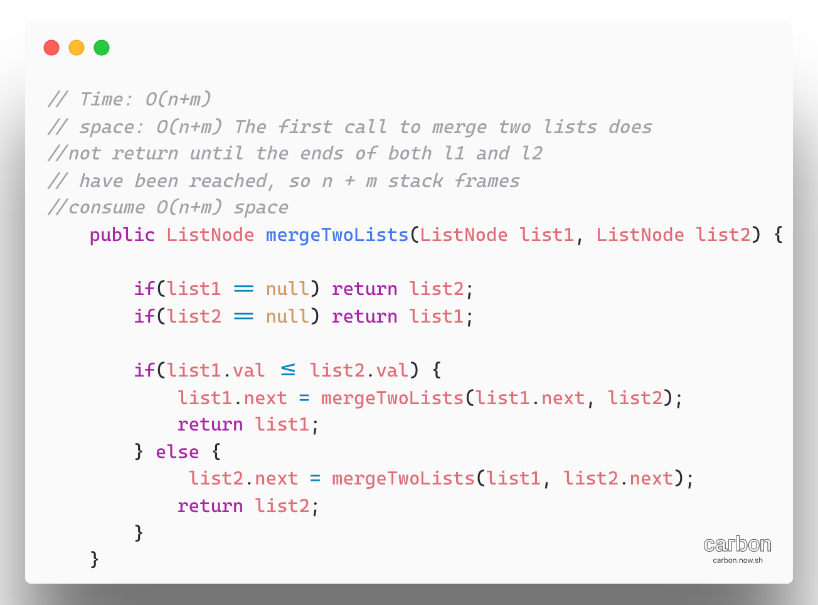

Iteration Approach: Time O(n+m)- Exactly one of l1 and l2 incremented on each loop iteration, the while loop runs for number of iteration equal to the sum of the length of two lists. All other work is constant, so the overall complexity is leaner

Space Complexity : O(1)

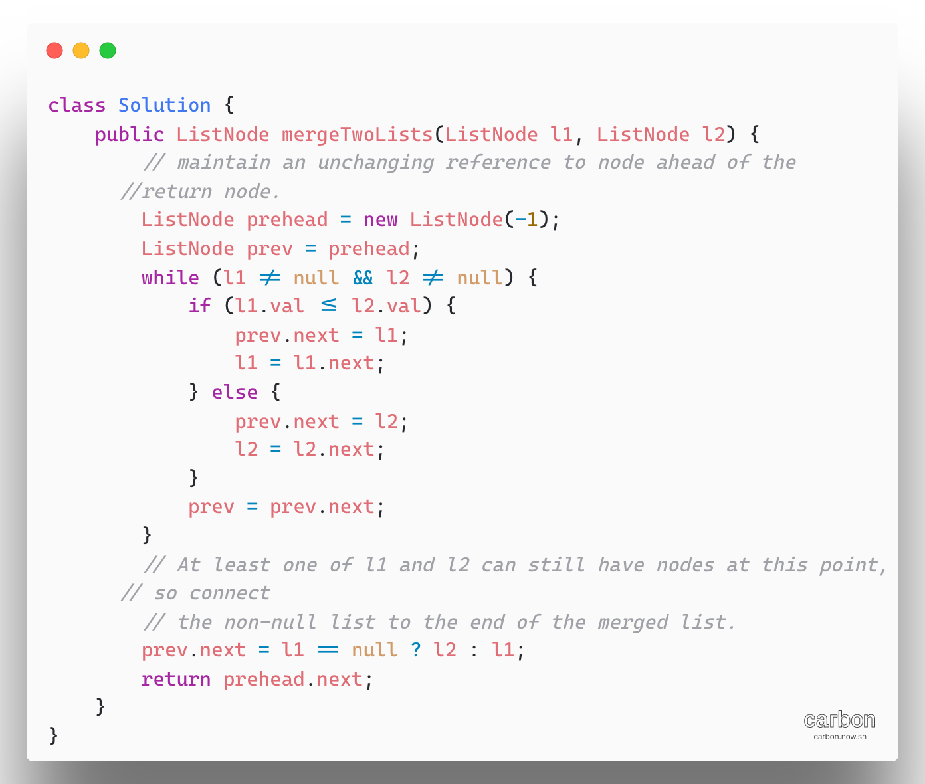

1. [Interval List Intersectio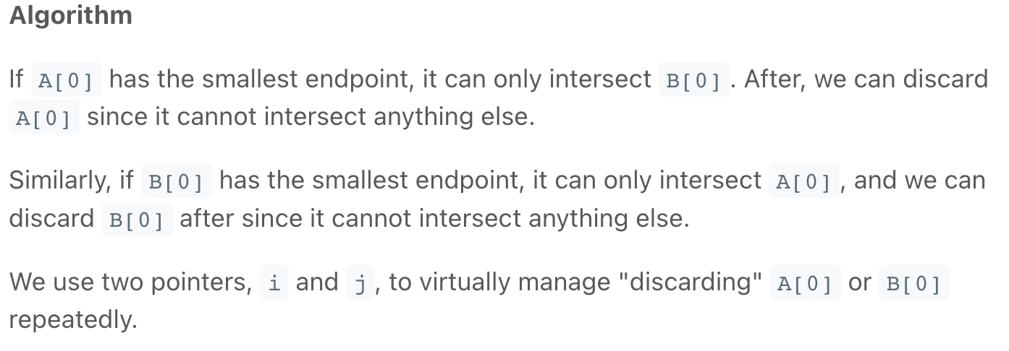ns](https://leetcode.com/problems/interval-list-intersections/)

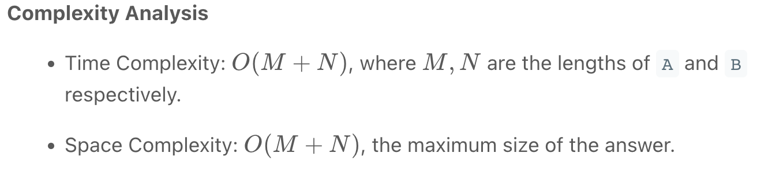

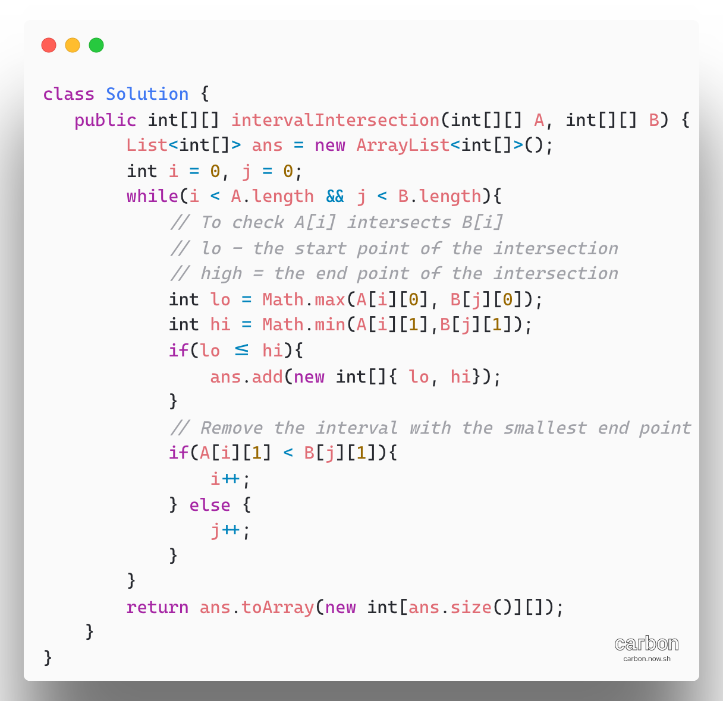

1. [**56. Merge Intervals**](https://leetcode.com/problems/merge-intervals/)

**Algorithm**

First, we sort the intervals by their start value. Then, we insert the first interval into our merged LinkedList (LinkedList is better) and continue considering each interval in turn as follows

If the current interval begins after the previous interval ends, then they do not overlap, and we can add the current interval to merged resultant list. Otherwise, they do overlap, and we merge them by updating the end of the previous interval if it is less than the end of the current interval

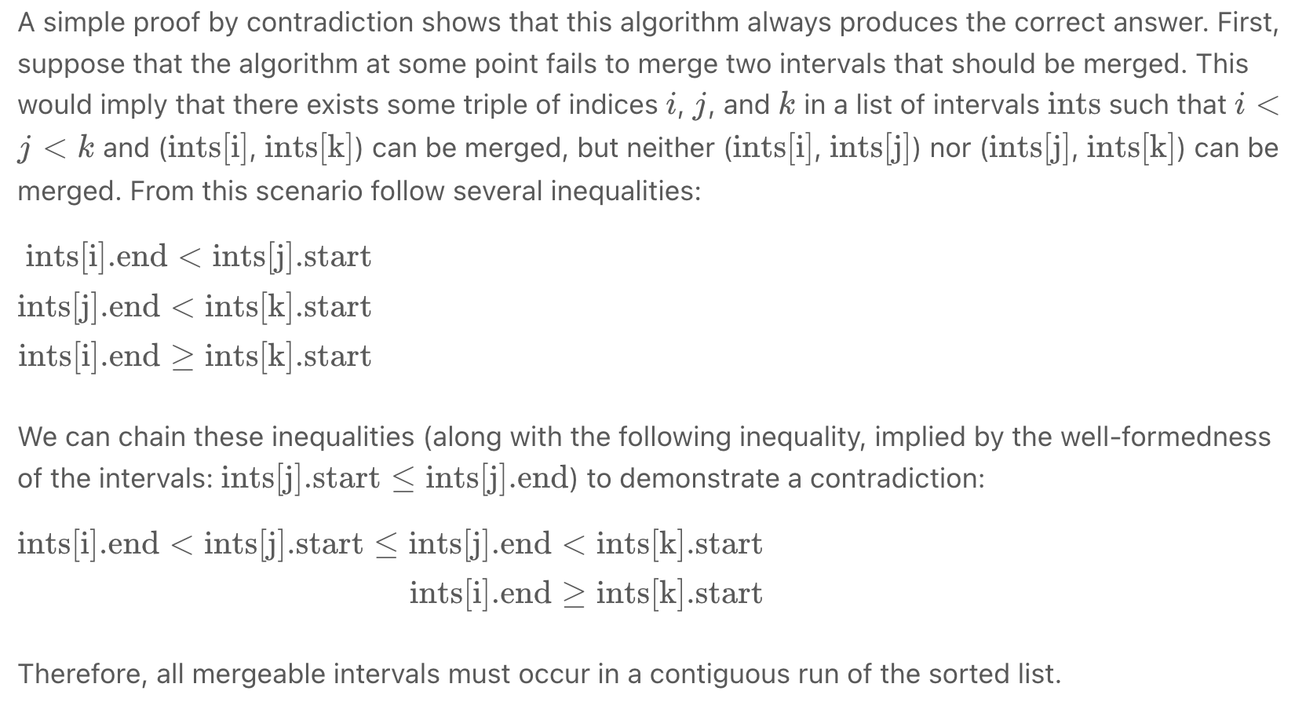

Complexity Analysis:

**Time complexity: O(nlogn)**

Other than the sort invocation, we do a simple linear scan of the list, so the runtime is dominated by O(nlogn) complexity of sorting.

**Space Complexity:** O(logN)(or O(n)), if we can sort intervals in place, we do not need more than constant additional space, although the sorting itself takes O(long) space.

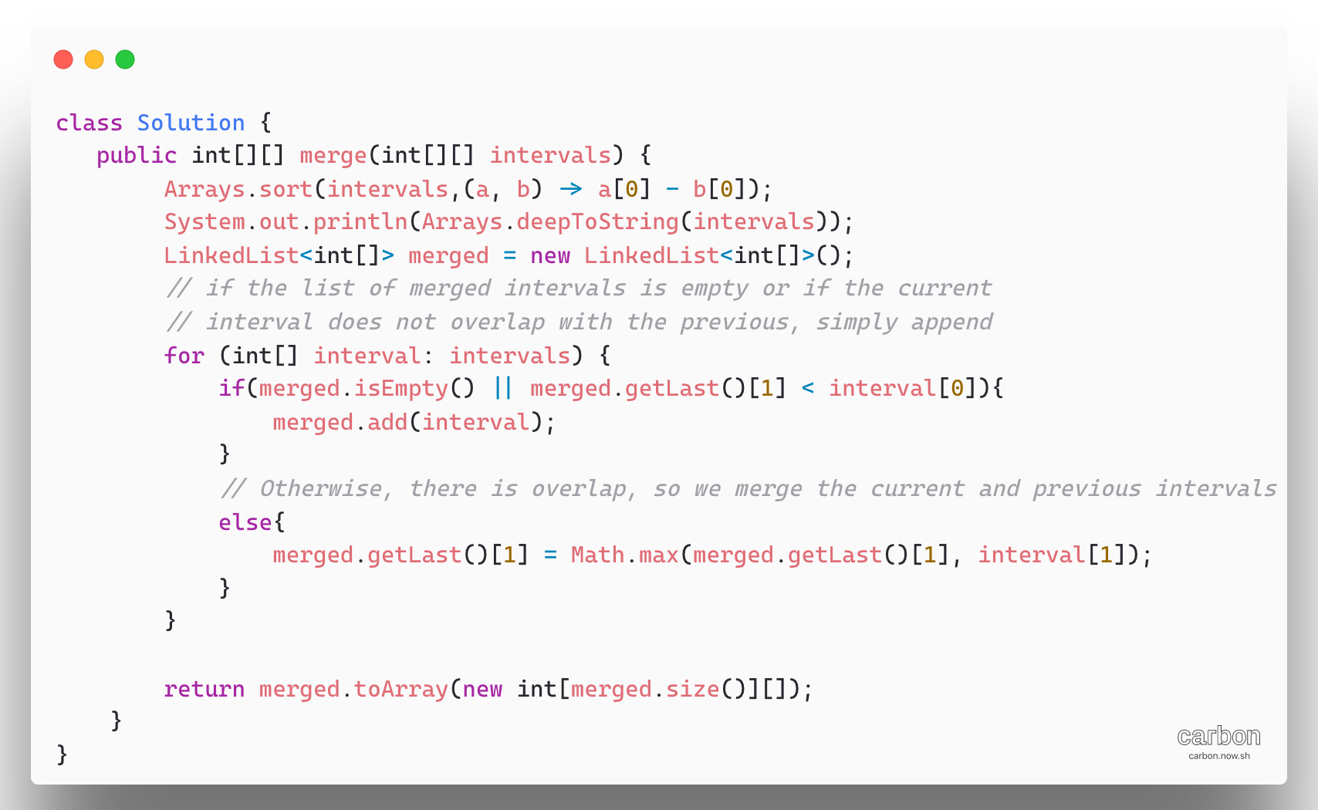

1. [**1332. Remove Palindromic Subsequences**](https://leetcode.com/problems/remove-palindromic-subsequences/)

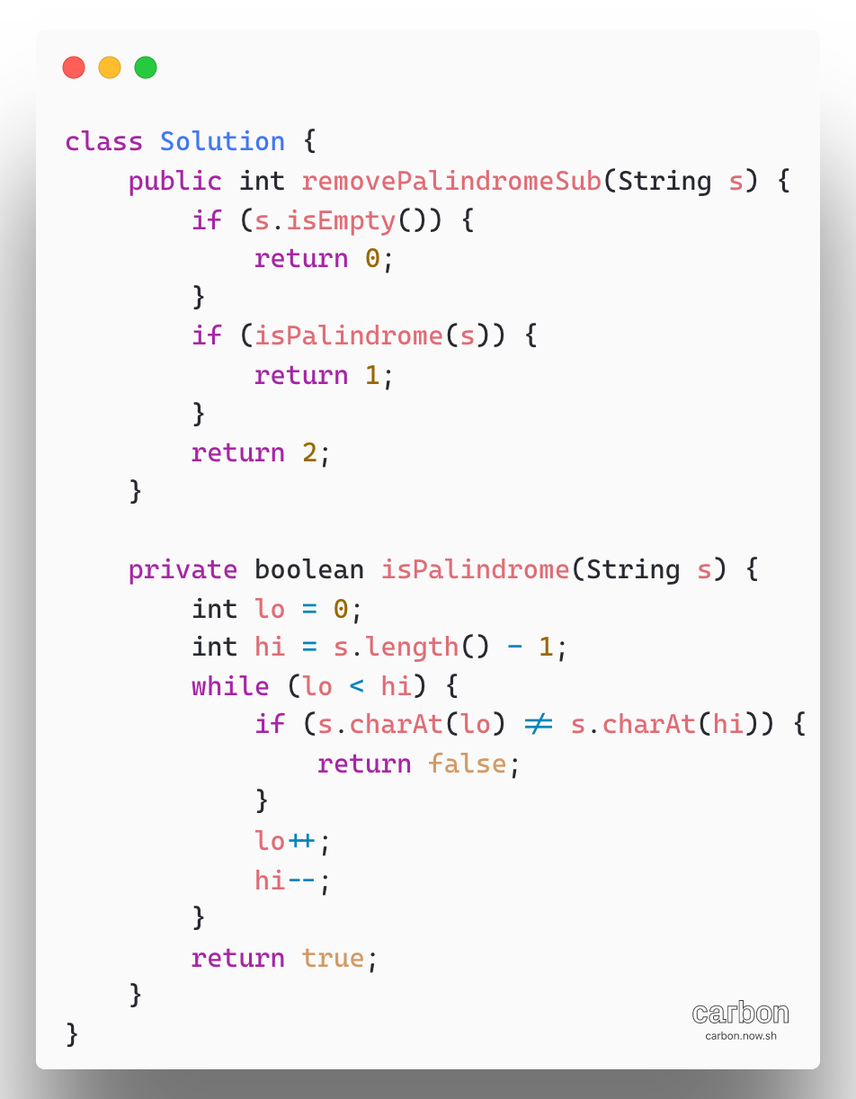

1. [**1362. Closest Divisors**](https://leetcode.com/problems/closest-divisors/)

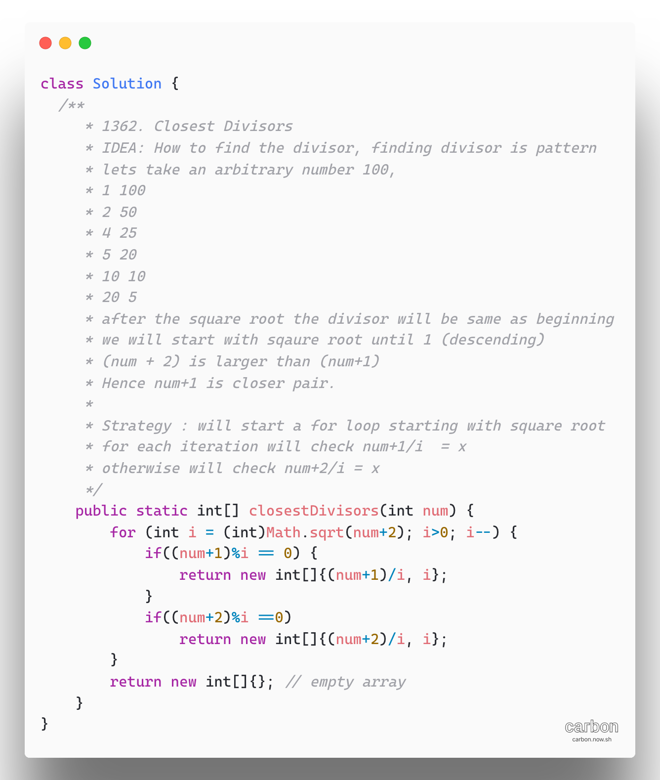

1. [**98. Validate Binary Search Tree**](https://leetcode.com/problems/validate-binary-search-tree/)

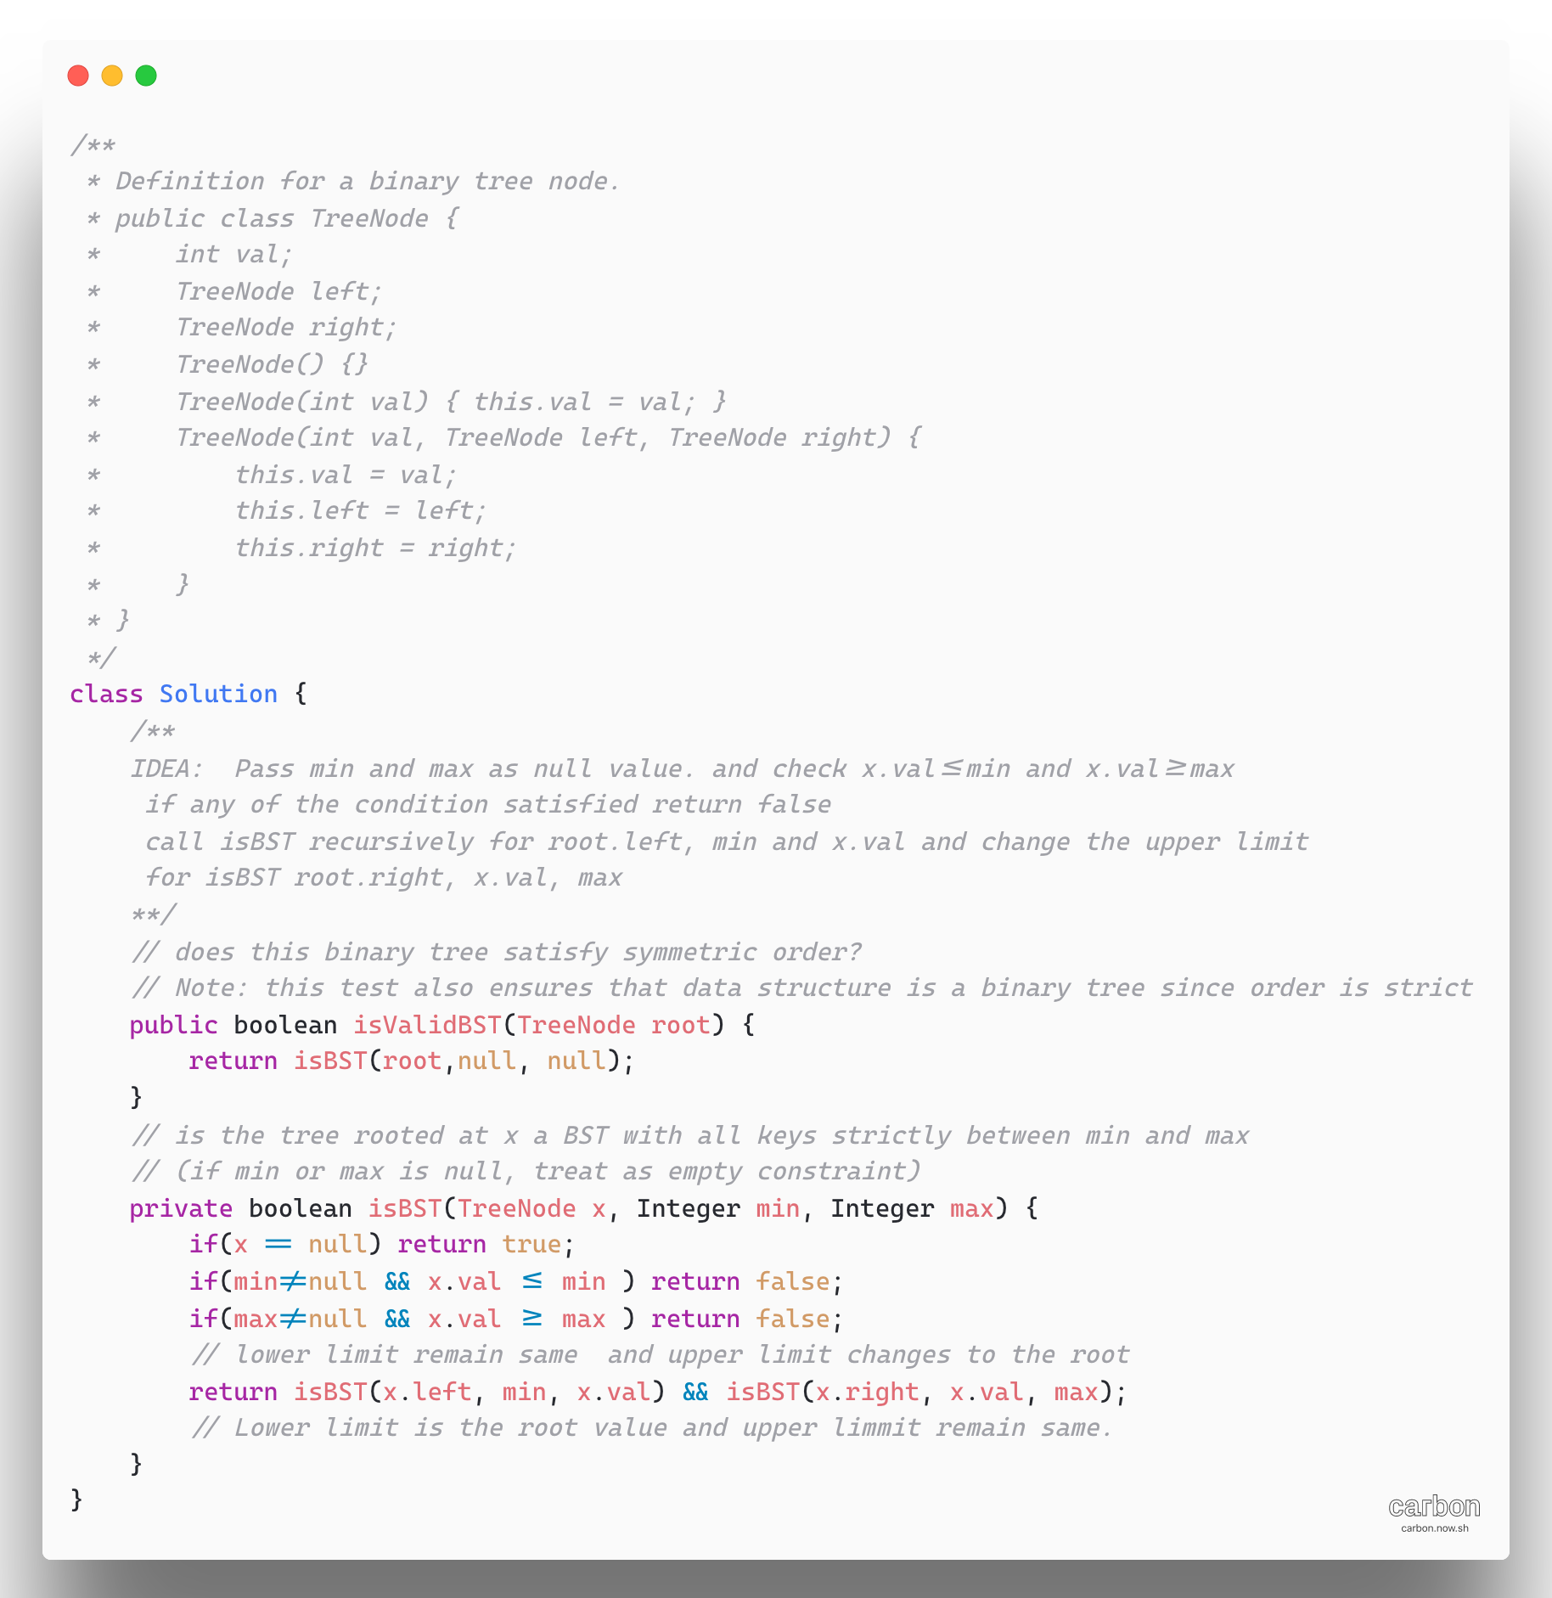

1. [Remove Sub folder from the file System](https://leetcode.com/problems/remove-sub-folders-from-the-filesystem/)

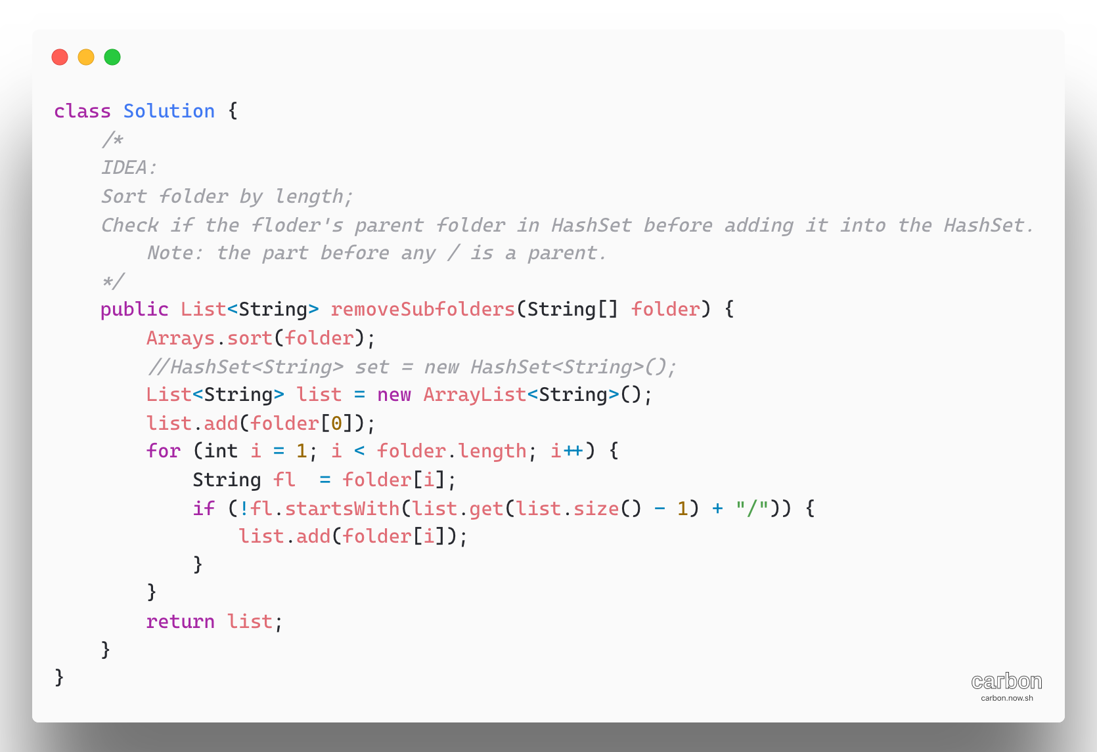

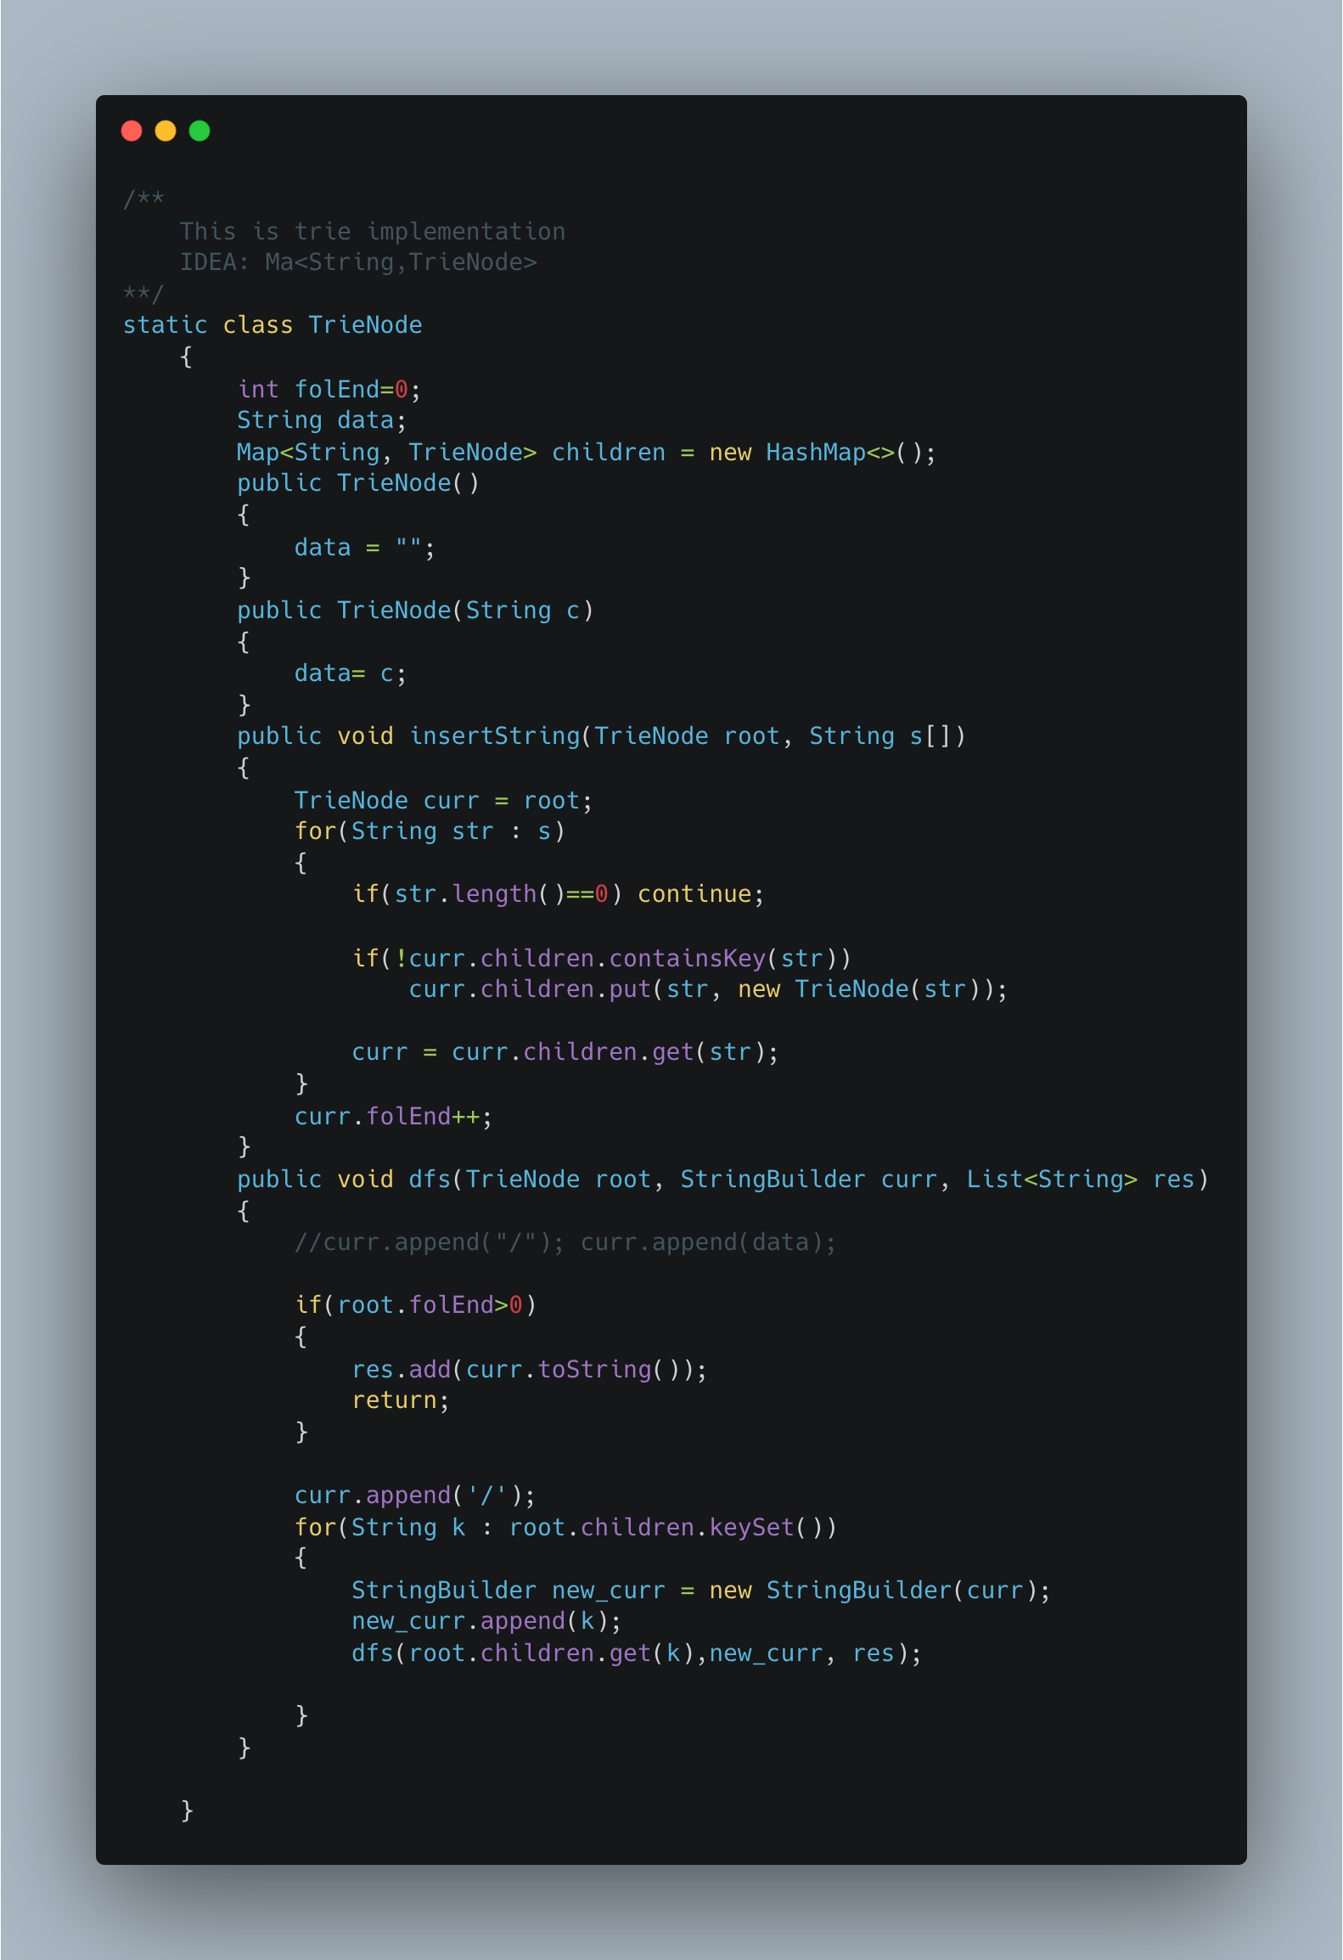

**Arrays**

1. [Second largest element in an array](https://www.geeksforgeeks.org/find-second-largest-element-array/)

**Approach 1:** The idea is to sort the array in descending order then return the second element which is not equal to the largest element from the sorted array.

O(nlogn)

Approach 2: The approach is to traverse the array twice, In the first traversal find the maximum element. In the second traversal find the greatest element in the remaining excluding the previous greatest.

O(n) Two traversals of the array is needed

**Approch 3: Efficient,**

a. Initialiaze the first as 0 ( i.e index of arr[0] element)

b. Start traversing the array from arr[1]

i) if the current element in array say arr[i] is greater than first

then update first and second as,

second = first

first = arr[i]

ii) If the current element is in between first and second, then update second to store the value of current variable as

second = arr[i]

c. return the value stored in second

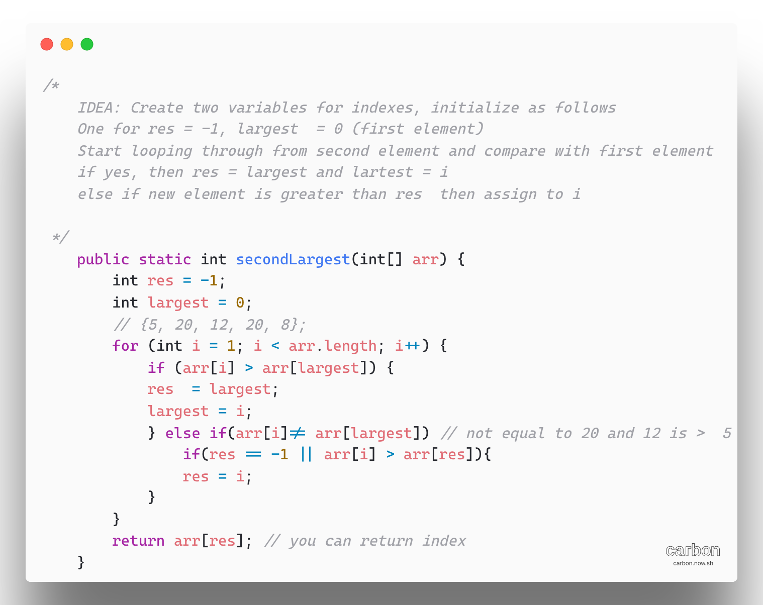

1. [Running Sum of 1d Array](https://leetcode.com/problems/running-sum-of-1d-array/)

**Approach 1:** Using separate space

We start building output array at index 0, at each index i we have already calculated the sum of all numbers up to and including i -1. Thus, instead of recalculating the sum, we can get the result for index i by simple adding element at index i to the previously calculated running sum for index i -1.

Algorithm:

* Define an array result
* Initialize the first element of result with the first element of input array
* At index i append sum of the element nums[i] and previously running sum result[i -1] to the result array.
* We repeat step 3 for all indices from 1 to n-1

Time complexity : O(n)

Space O(1) Because we don’t use additional space to find the running sum. Note that we do not take into consideration the space occupied by resulting output array.

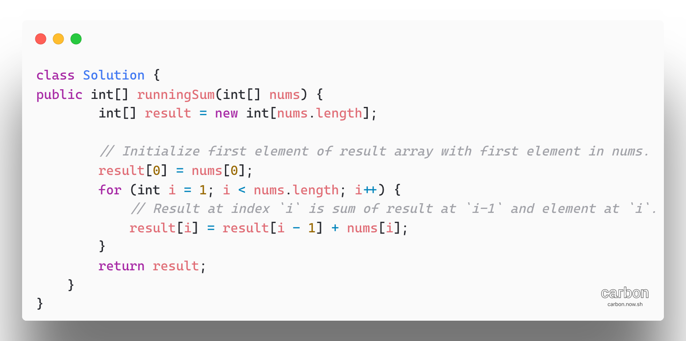

**Approach 2:**

We do not actually need to do so. We can obtain the same result without using extra space by performing the same operations on the input array instead.

Algorithm:

* Increase nums[i] by previous index’s running sum. The previous index’s running sum stored at index i-1 in the input array.
* We repeat step 1 for all indices from 1 to n-1

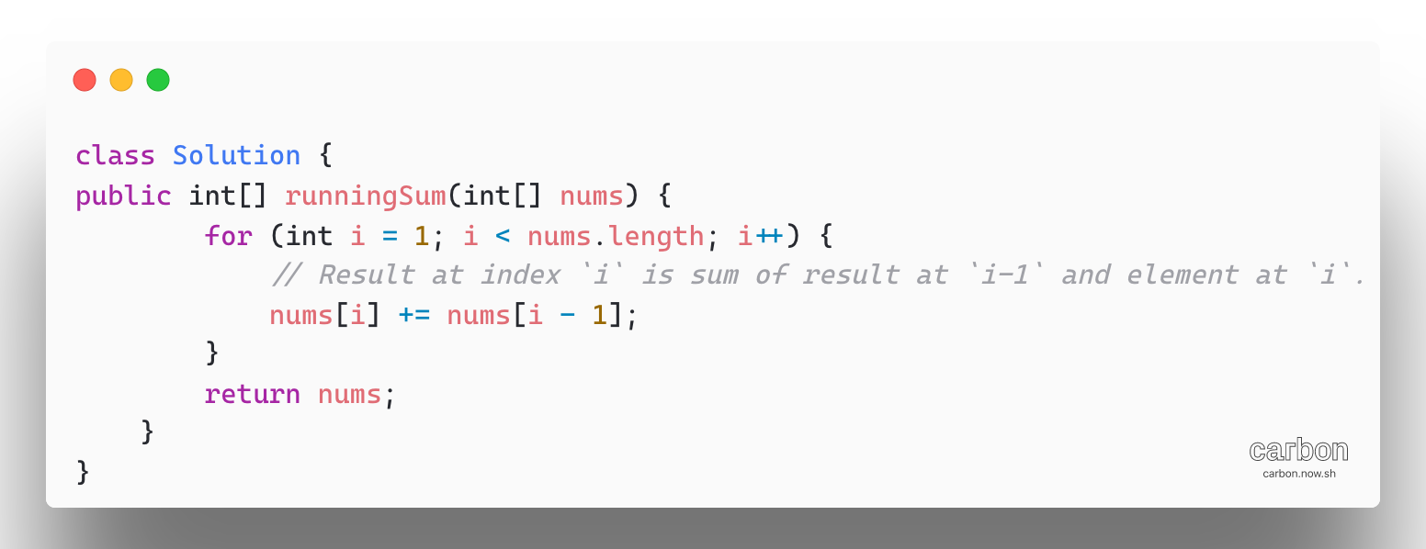

1. [Transpose Matrix](https://leetcode.com/problems/transpose-matrix/)

Transpose of a matrix A with dimensions RXC is a matrix ans with dimensions CXR for which ans[c][r] = A[r][c]

Complexity:

O(R*C) where R and C are the number of rows and columns in the given matrix A.

O(R*C) the space used by the answer

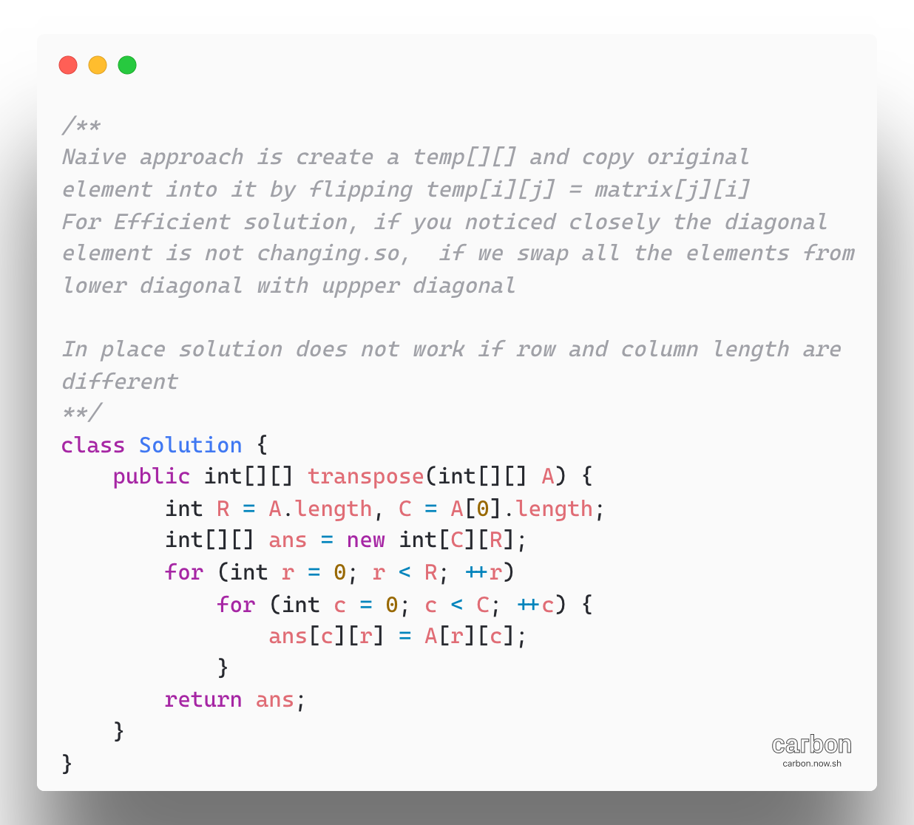

1. [**303. Range Sum Query - Immutable**](https://leetcode.com/problems/range-sum-query-immutable/)**-1D**

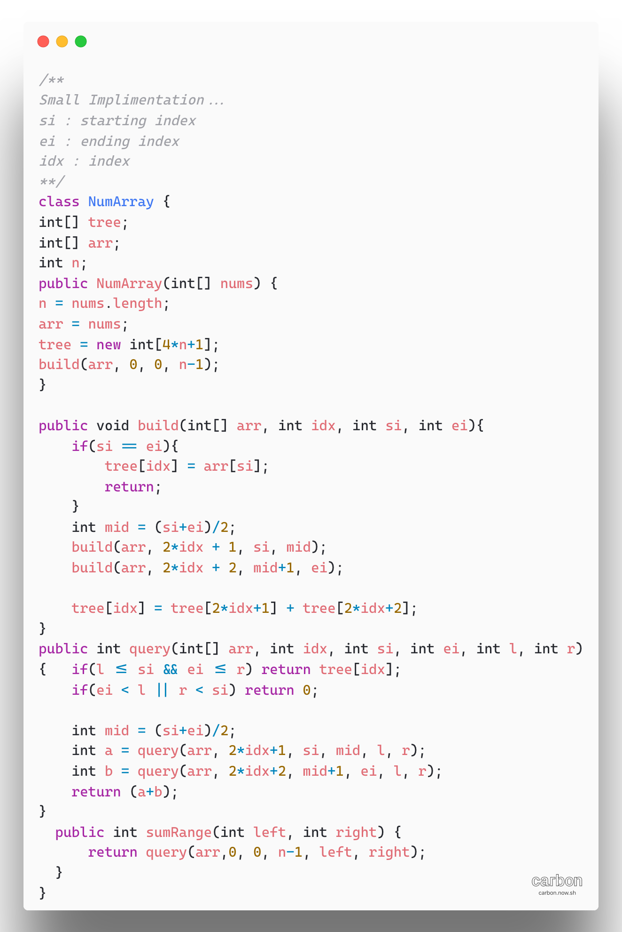

1. [Range Sum Query 2D – Immutable](https://leetcode.com/problems/range-sum-query-2d-immutable/)

We used a cumulative sum array, in the 1D version, we noticed that cumulative sum is computed with respect to the origin at index 0. Extending this analogy to the 2D case, we would pre-compute a cumulative region sums with respect to the origin at (0,0)

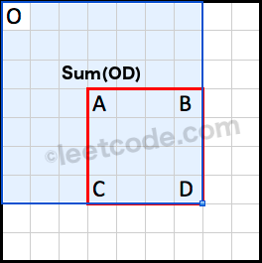 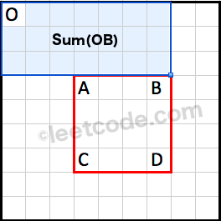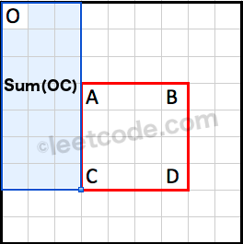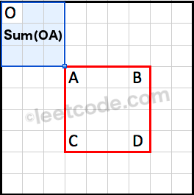

Note that the region Sum (OA) is covered twice by both Sum (OB) and Sum (OC). We could use the principle of inclusion-exclusion to calculate Sum (ABCD) as following:

Sum (ABCD) = Sum (OD) - Sum (OB) - Sum (OC) + Sum(OA)

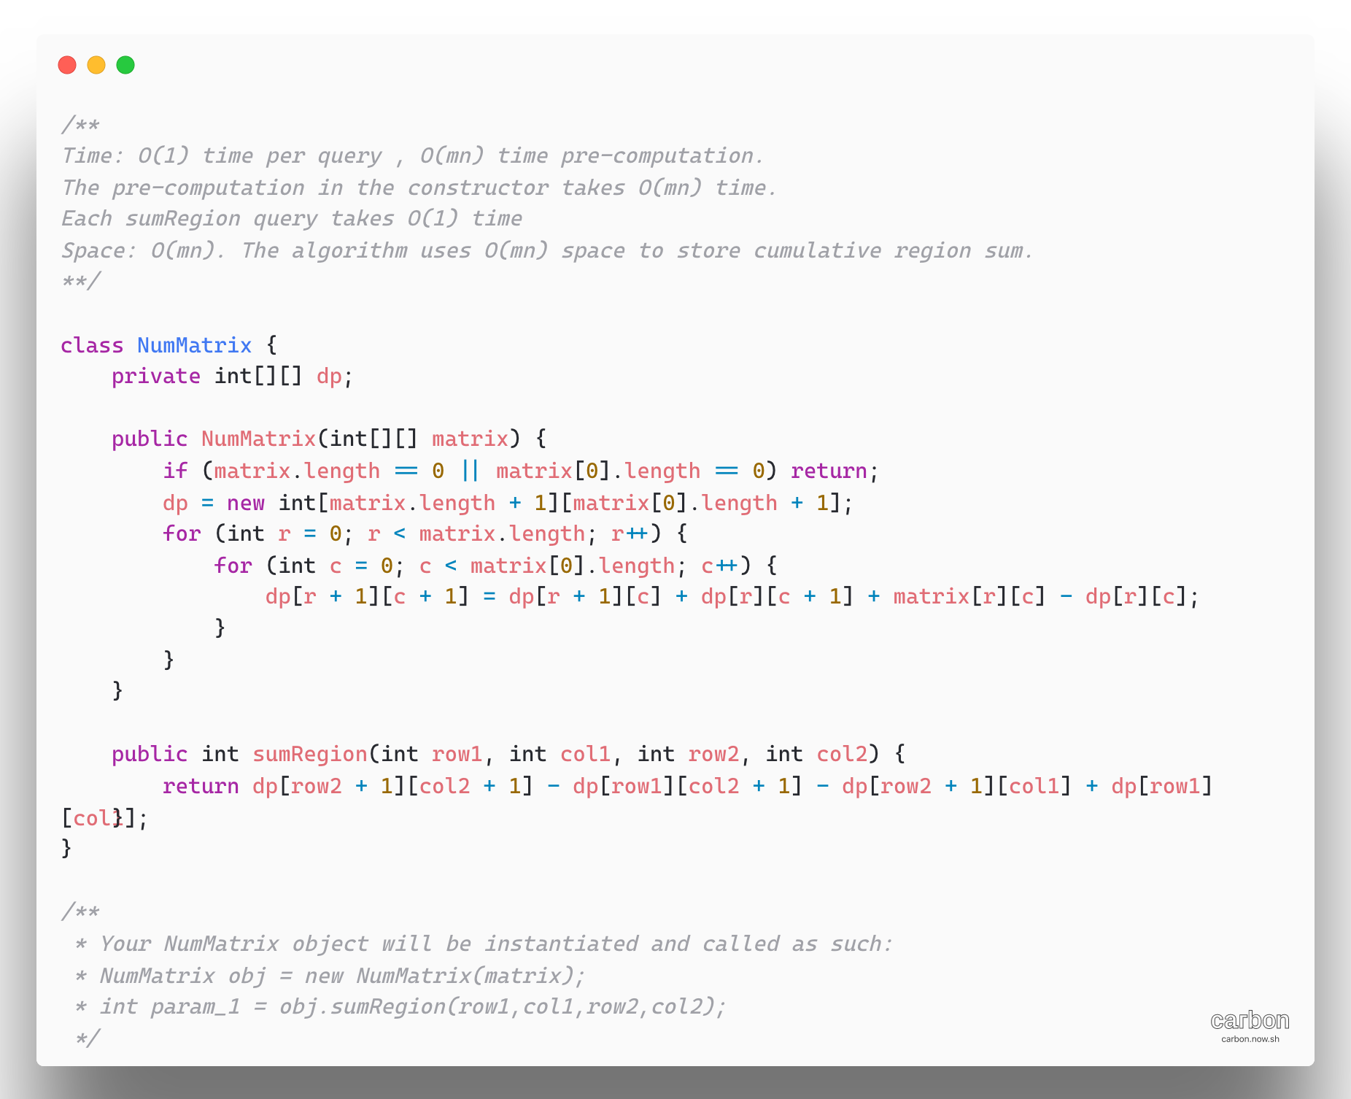

**Backtracking**

1. [N-Queens](https://leetcode.com/problems/n-queens/)

A brute force solution would involve, generating all possible board states with N- queens, there are N^2 possible square to place first queen, N^2 – 1 to place second queen so on. Which leads to a time complexity of O(N^2N)

The actual number of solutions is far fewer than the number of possible board states, so we should aim to minimize our consideration of invalid board states.

This is a perfect problem for backtracking, we should not put a queen on a square that another queen can attack.

Backtracking function that makes some changes to the state, call itself again, and then when that call returns it undoes those changes (this last part is call backtracking)

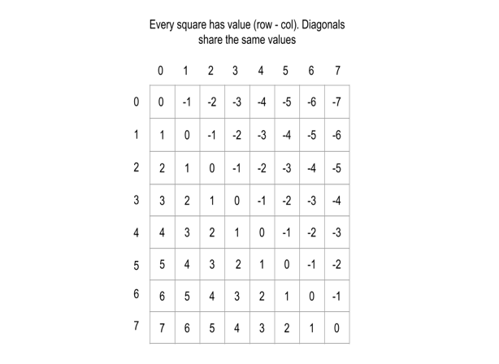 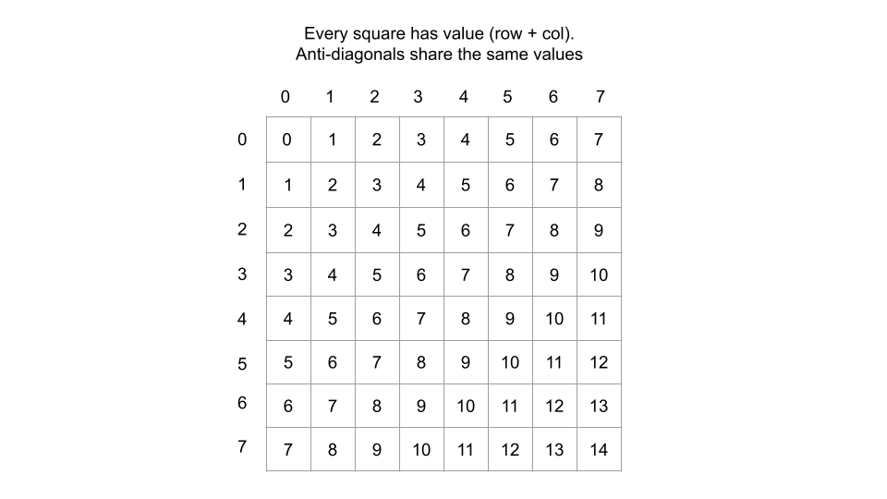

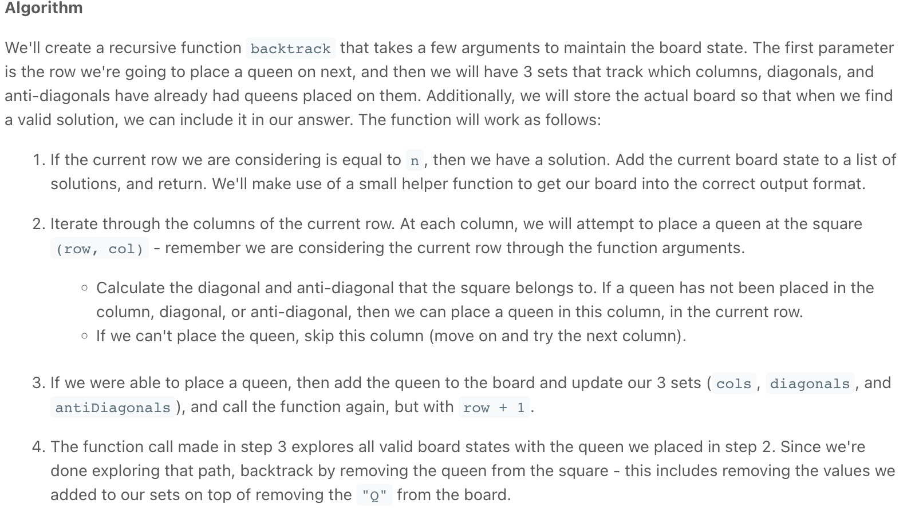

Complexity: O(n!), Space(n^2)

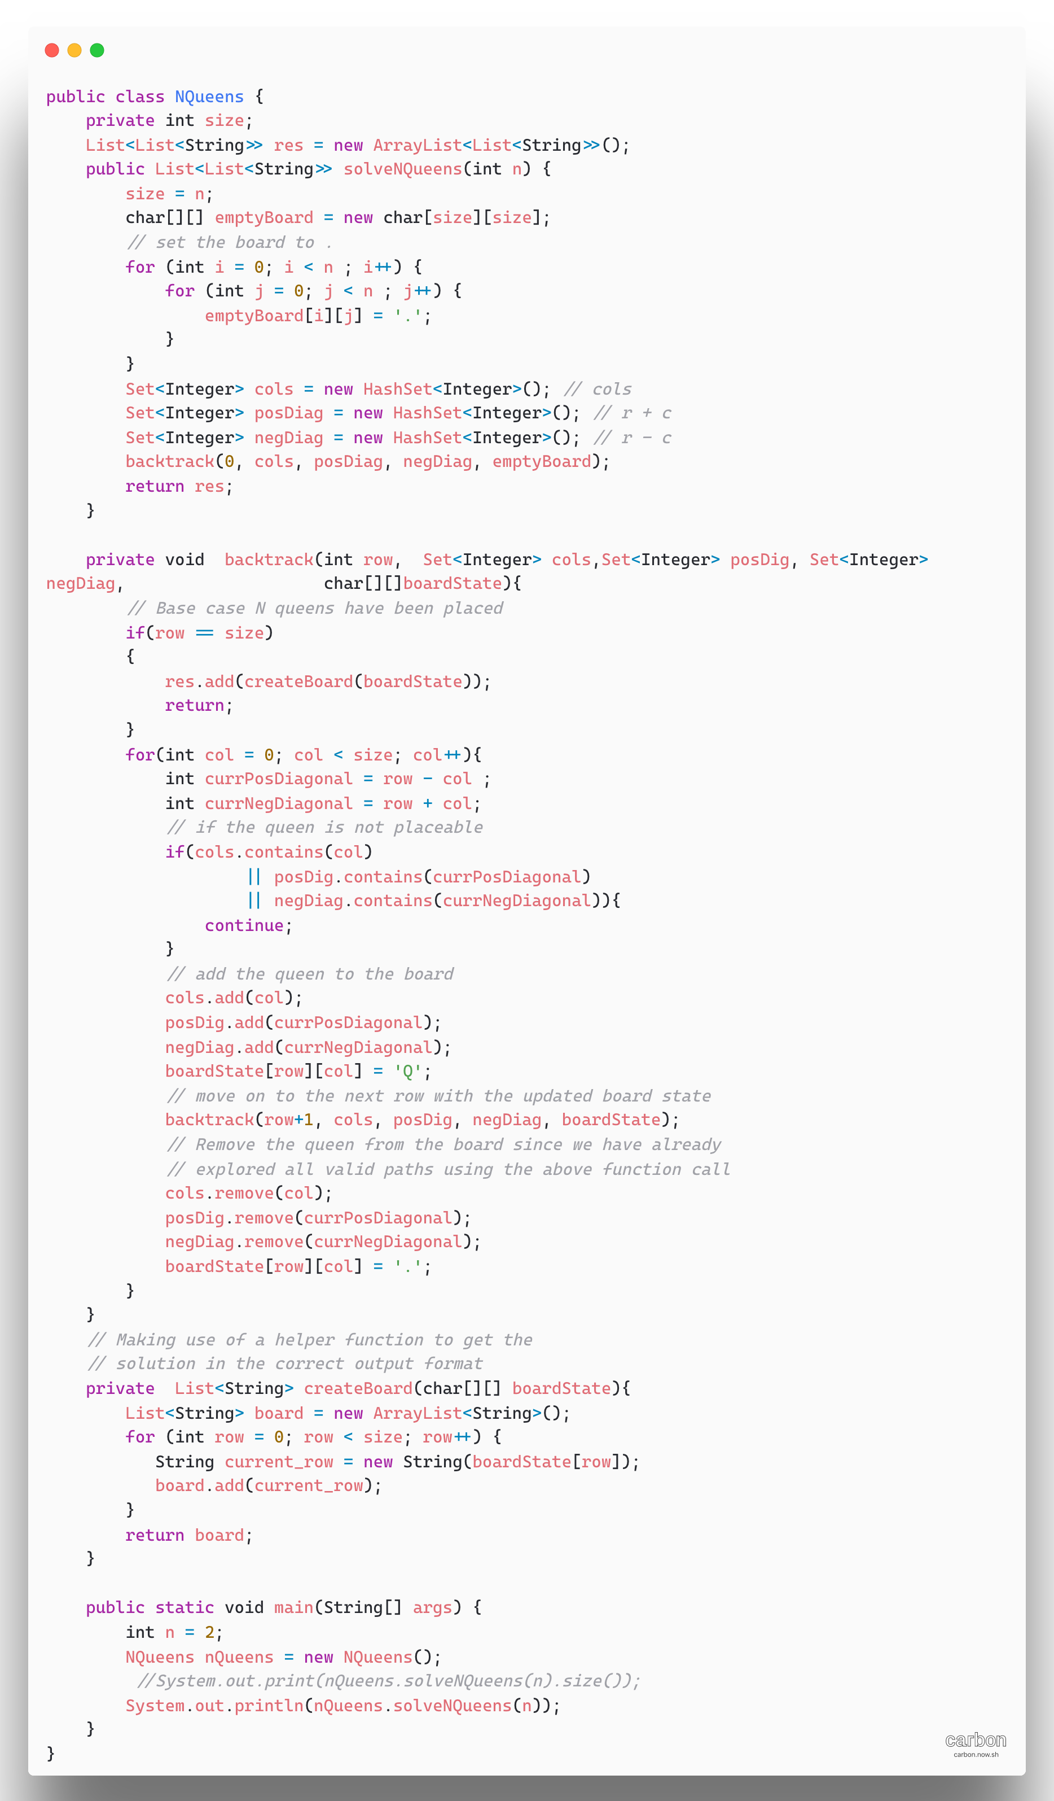

1. [**N-ary Tree Postorder Traversal**](https://leetcode.com/problems/n-ary-tree-postorder-traversal/)

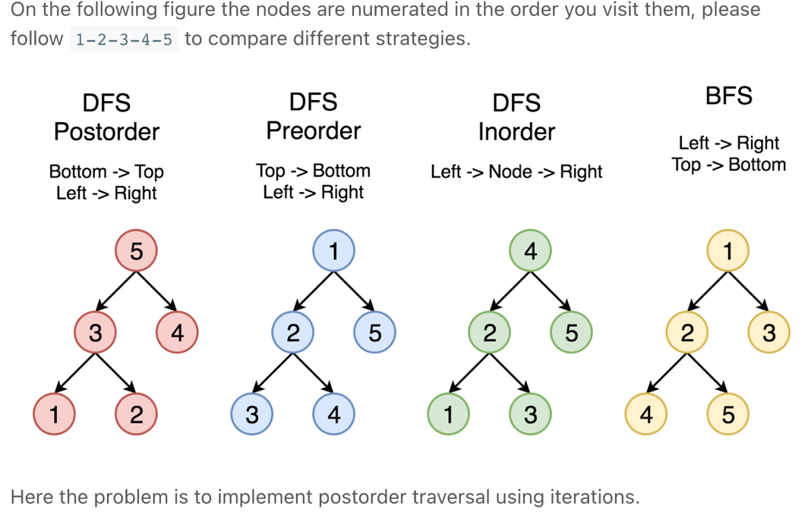

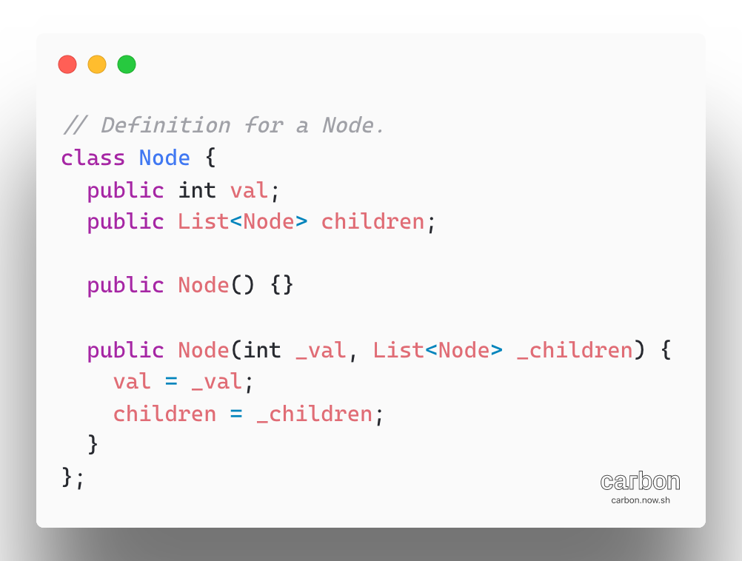

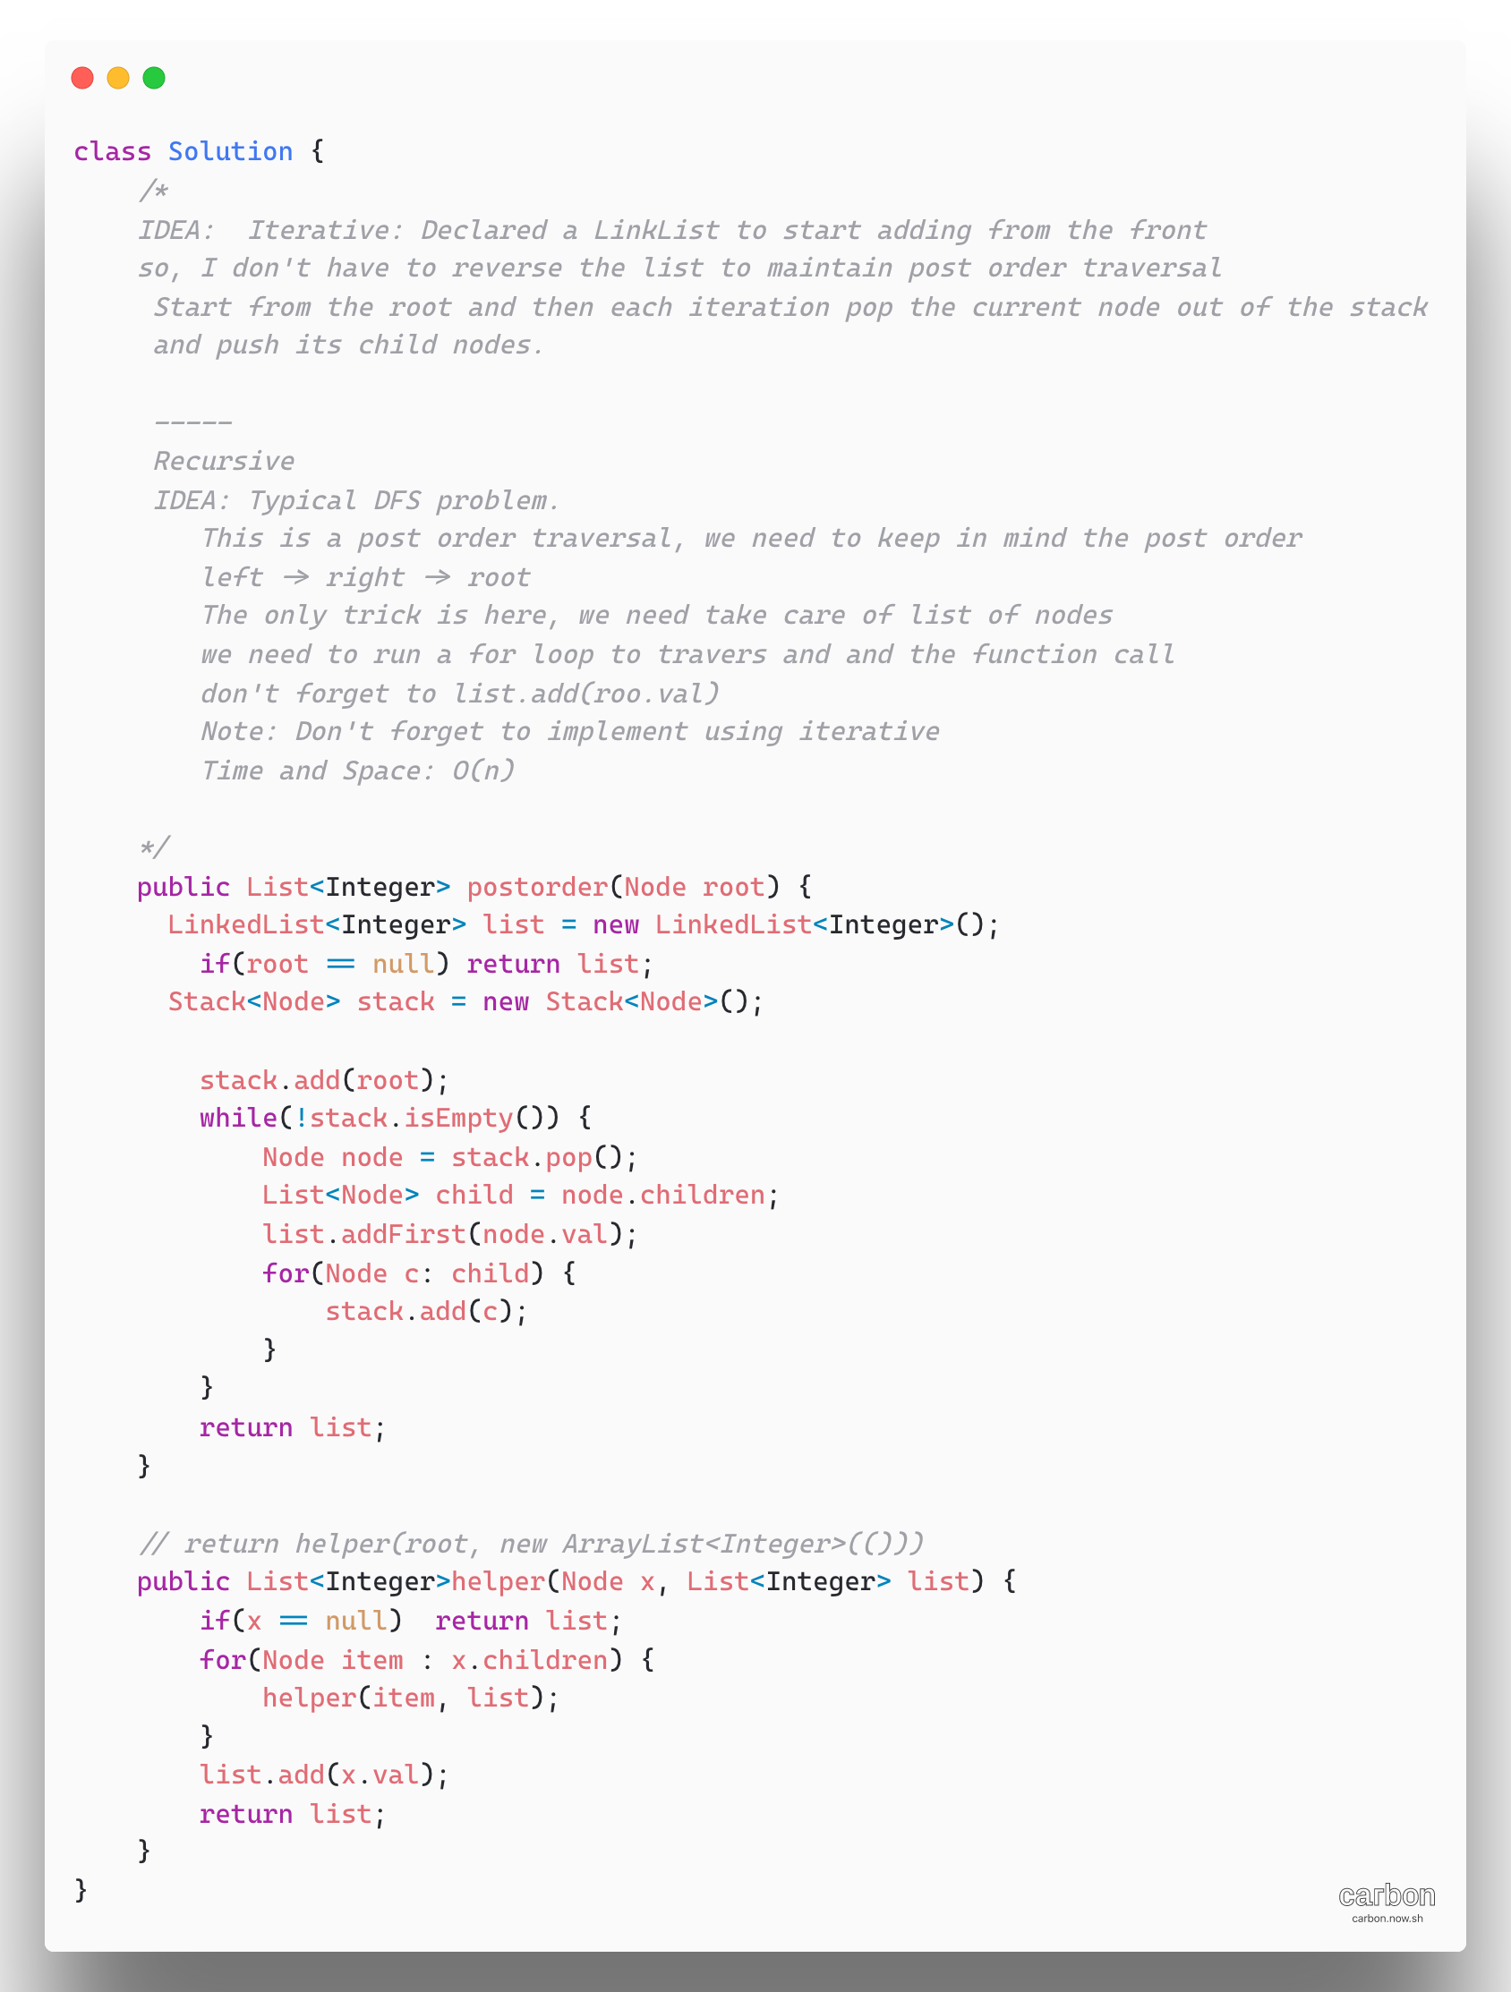

1. [Longest Substring Without Repeating Characters](https://leetcode.com/problems/longest-substring-without-repeating-characters/)

**Refer**: <https://www.youtube.com/watch?v=4i6-9IzQHwo>

[**Leetcode Article**](https://leetcode.com/problems/longest-substring-with-at-most-two-distinct-characters/discuss/49708/Sliding-Window-algorithm-template-to-solve-all-the-Leetcode-substring-search-problem.)  
Brute for Approach:

**O(n^3)**

For i in string //n

For j in string // n

Subs = string.substring(i, j+1); //

If(hasUniqueChars(subs) // n

result = max(result, len(subs)) // if all characters are unique

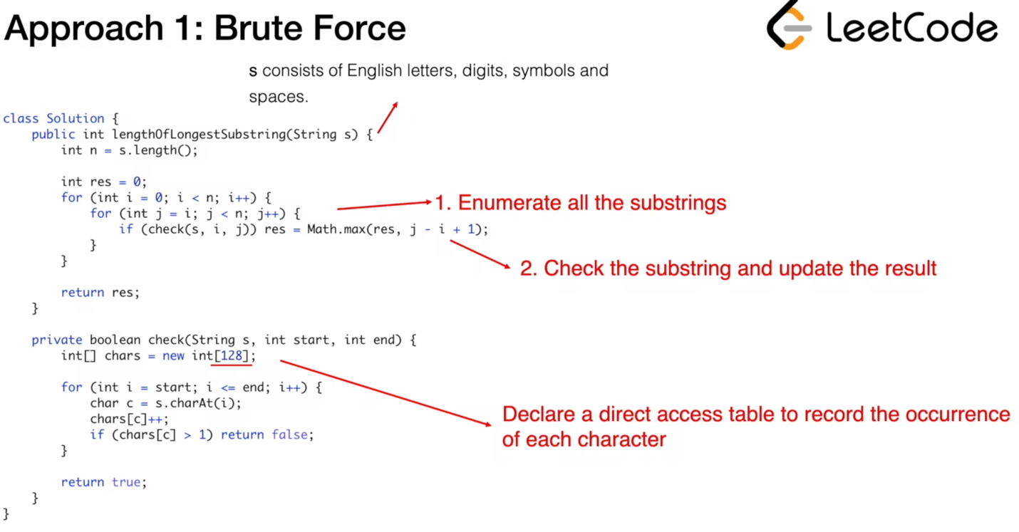

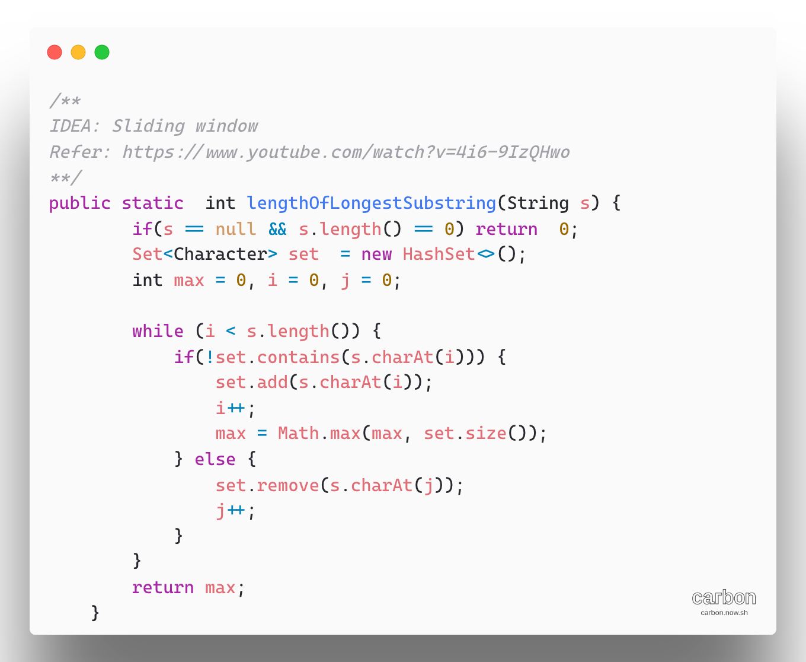

**Approach 2:**

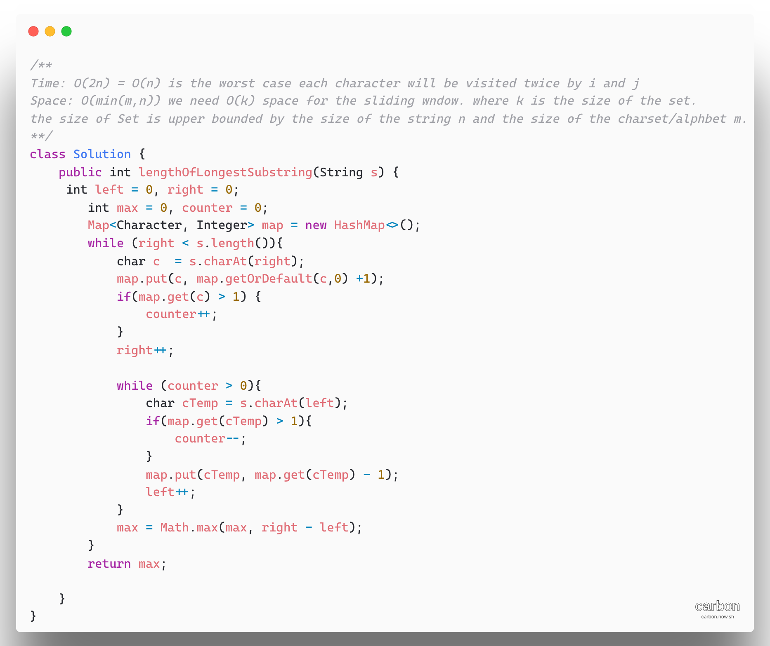

**Approach 3:**

Instead of using set to tell if character exists or not, we could define mapping of the characters to its index. Then we can skip the characters immediately when found a repeated character

The reason is that if s[j] have duplicate in the range [i,j] with index j, we don’t need to increase i little bit. We can skip all the elements in the range [i, j] and let i to be j’ +1 directly.

The basic idea is, keep a hashmap which stores the characters in string as keys and their positions as values, and keep two pointers which define the max substring. move the right pointer to scan through the string , and meanwhile update the hashmap. If the character is already in the hashmap, then move the left pointer to the right of the same character last found. Note that the two pointers can only move forward.

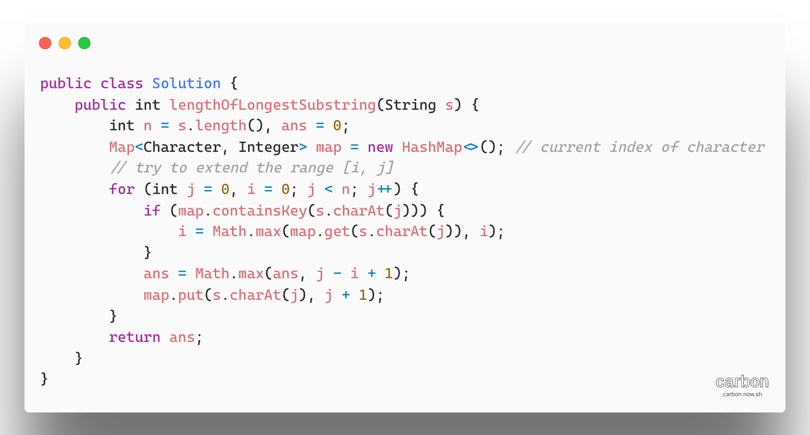

If we know that charset is rather small, we can replace the map with an integer array as direct access table

Time: O(n) index j will iterate n times

Space: HashMap: O (min(m,n))

Space: table: O(m). m is the size of the charset

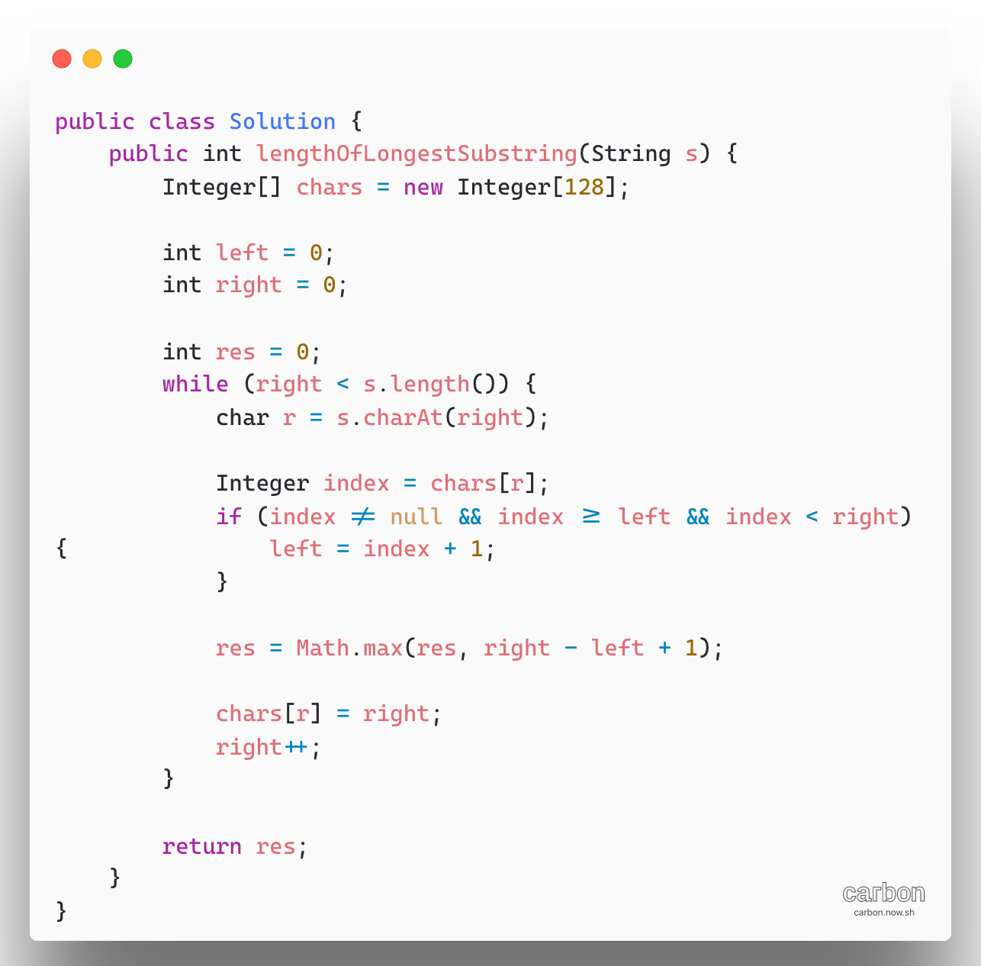

1. [**159. Longest Substring with At Most Two Distinct Characters**](https://leetcode.com/problems/longest-substring-with-at-most-two-distinct-characters/)

[Just follow template to solve all string related to sliding window using HashMap.](https://leetcode.com/problems/longest-substring-with-at-most-two-distinct-characters/discuss/49708/Sliding-Window-algorithm-template-to-solve-all-the-Leetcode-substring-search-problem.)

Complexity Analysis:

Time: O(n) where n is number of characters in the input string

Space: O(1) since additional space is used only for HashMap with at most 3 elements

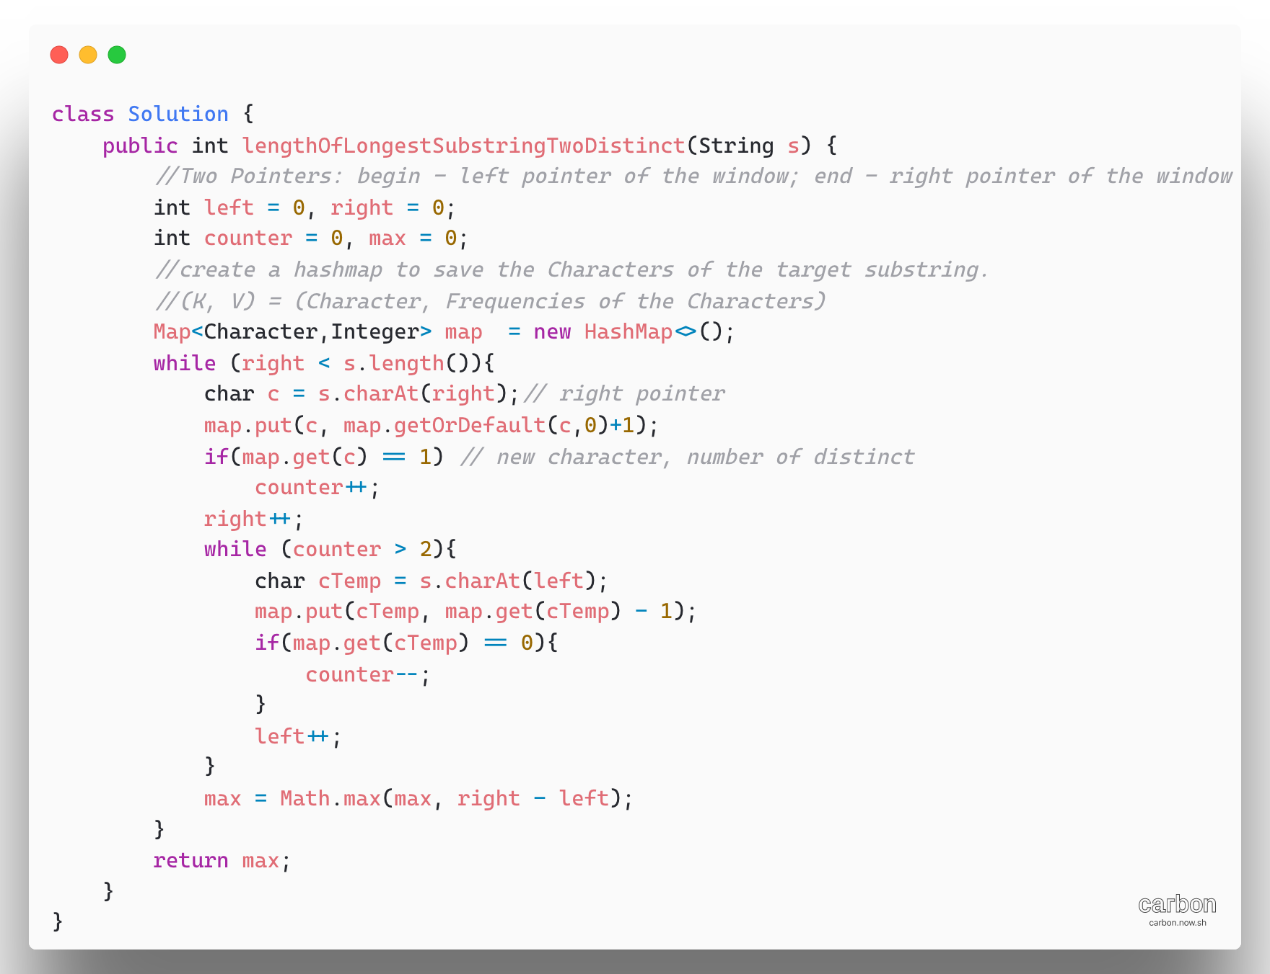

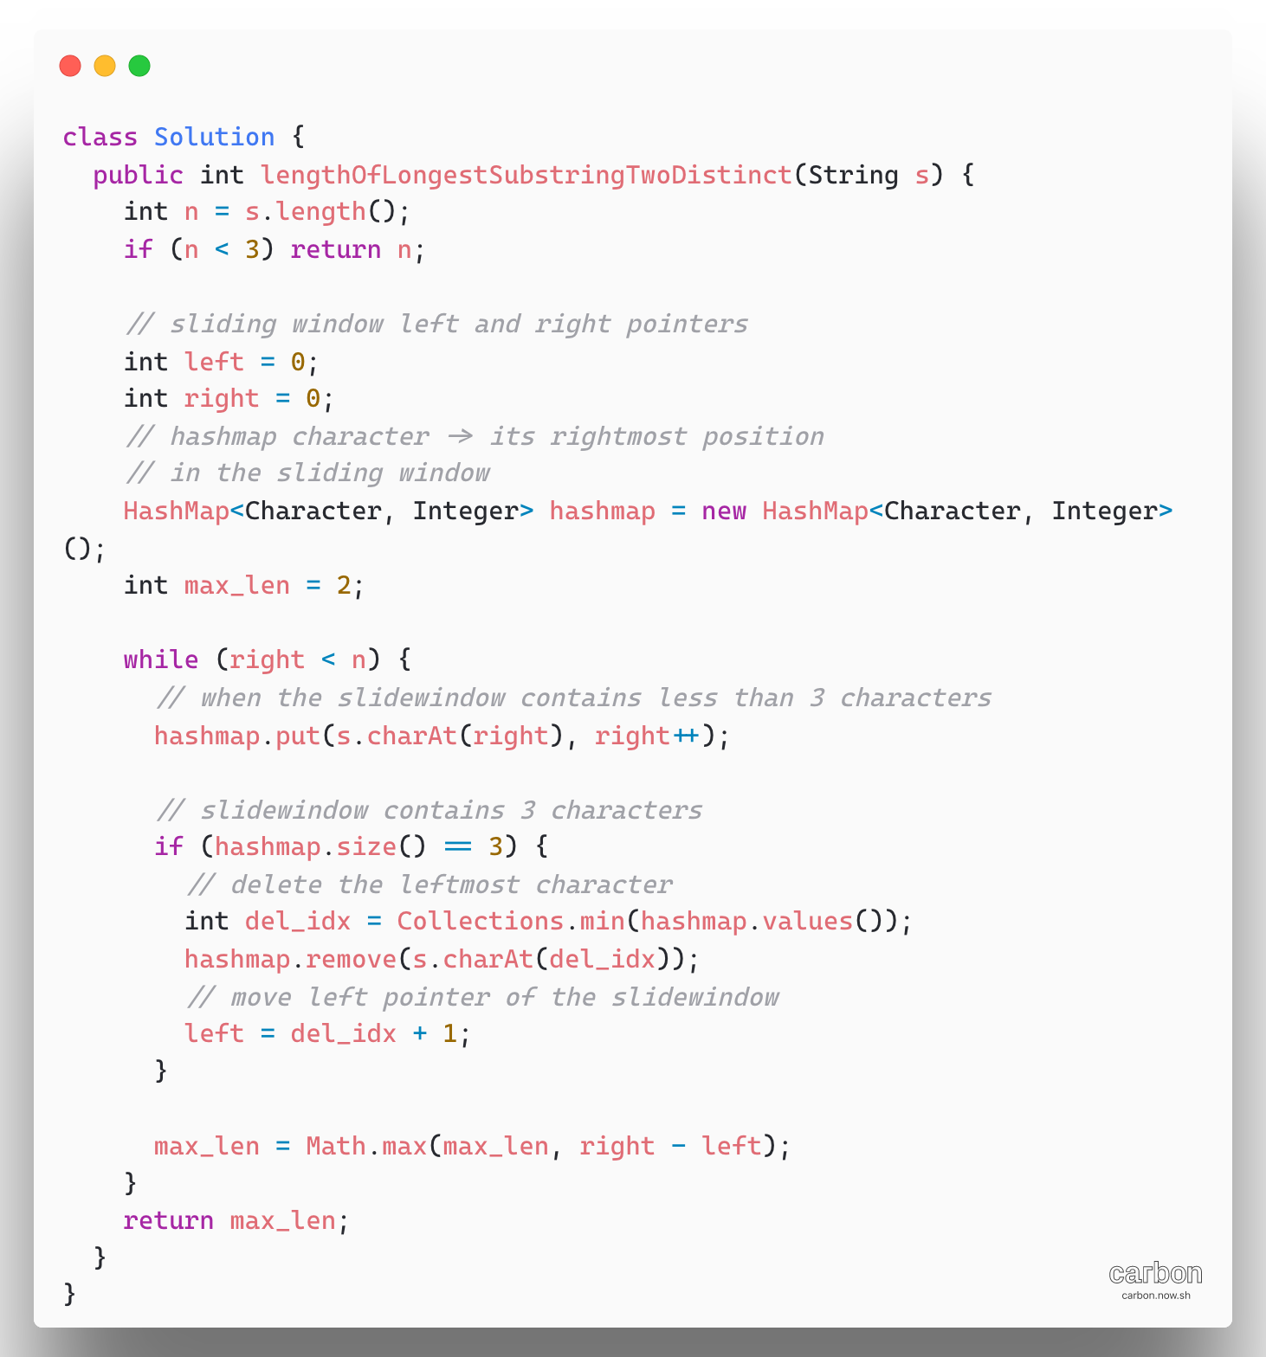

1. Palindrome String check using recursion.

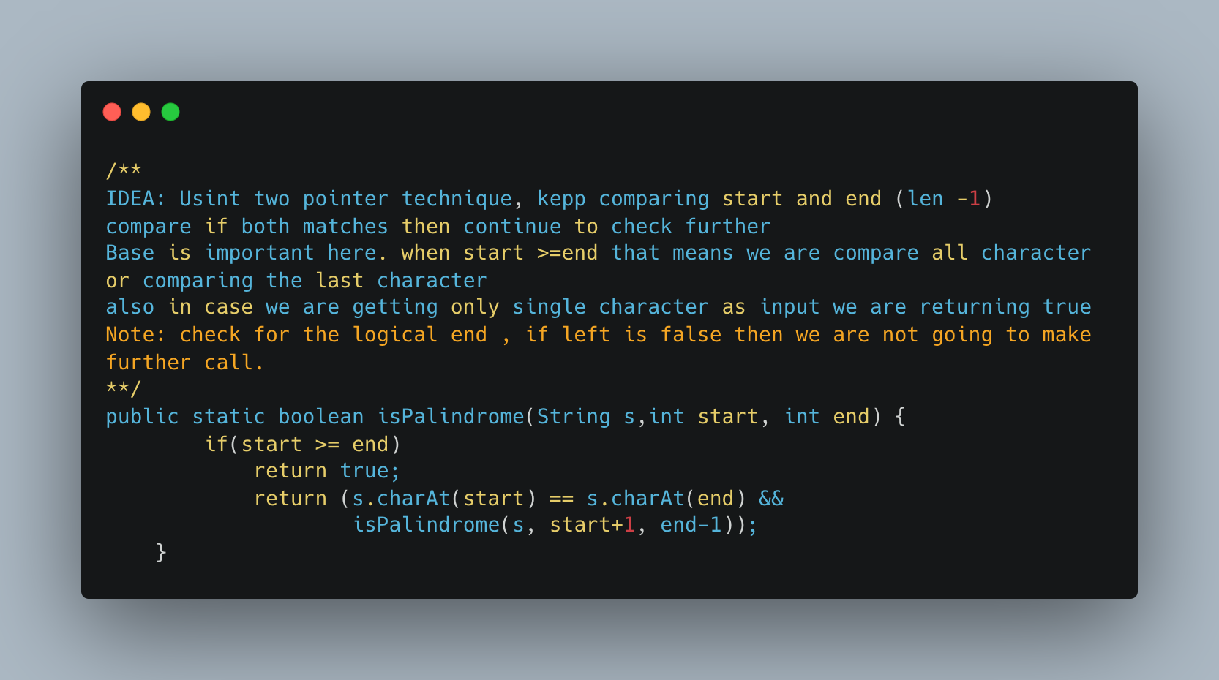

1. [Palindromic Substrings](https://leetcode.com/problems/palindromic-substrings/)

Palindromes are like onions, you remove the boundary characters and you’re left with another, smaller palindrome

Algorithm:

1. We choose all possible centers for potential palindromes:

* Every single character in the string is a center for possible odd-length palindromes
* Every pair of consecutive characters in the string is a center for possible even-length palindromes

1. For every center, we can expand around it as long as we get palindromes (i.e. the first and last characters should match)

**Complexity:** O(N^2) for input string of length N. The total time taken in this approach is dictated by two variables

* The number of possible palindromic center we process
* How much time we spend processing each center?

The number of possible palindromic centers is 2N-1; there are N single character center and N-1 consecutive pairs as centers.

Each center can potentially expand to the length of the string, so no time spent on each center is linear on average. Thus, total time spent is N.(2N-1) ~N^2

Space Complexity: O (1)

Refer:

* <https://www.youtube.com/watch?v=XmSOWnL6T_I>
* [Leetcode Solution Arrticle:](https://leetcode.com/problems/palindromic-substrings/solution/)

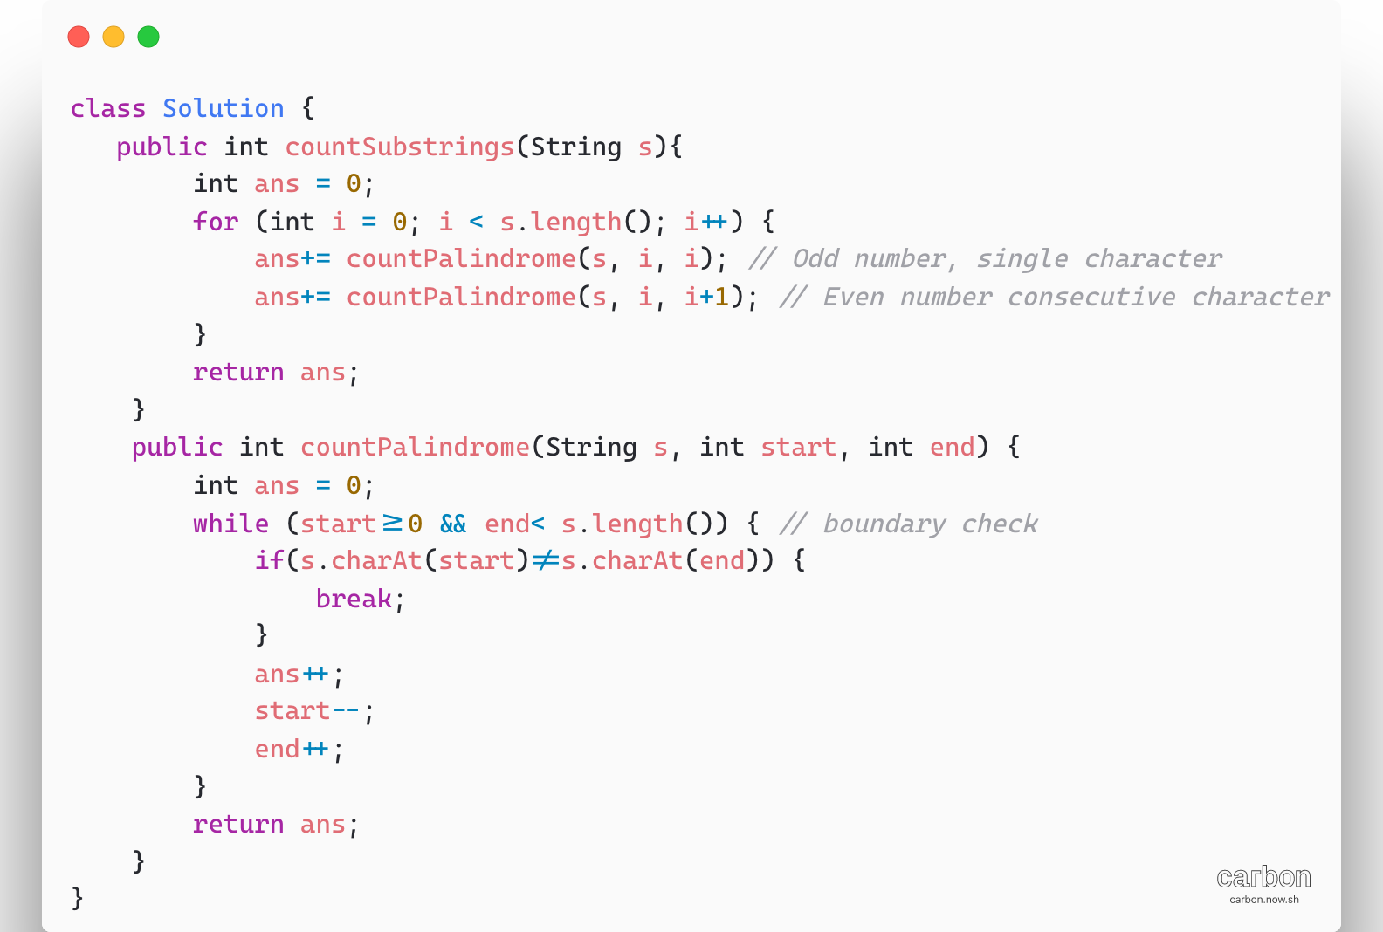

1. [Longest Palindromic Substring](https://leetcode.com/problems/longest-palindromic-substring/)

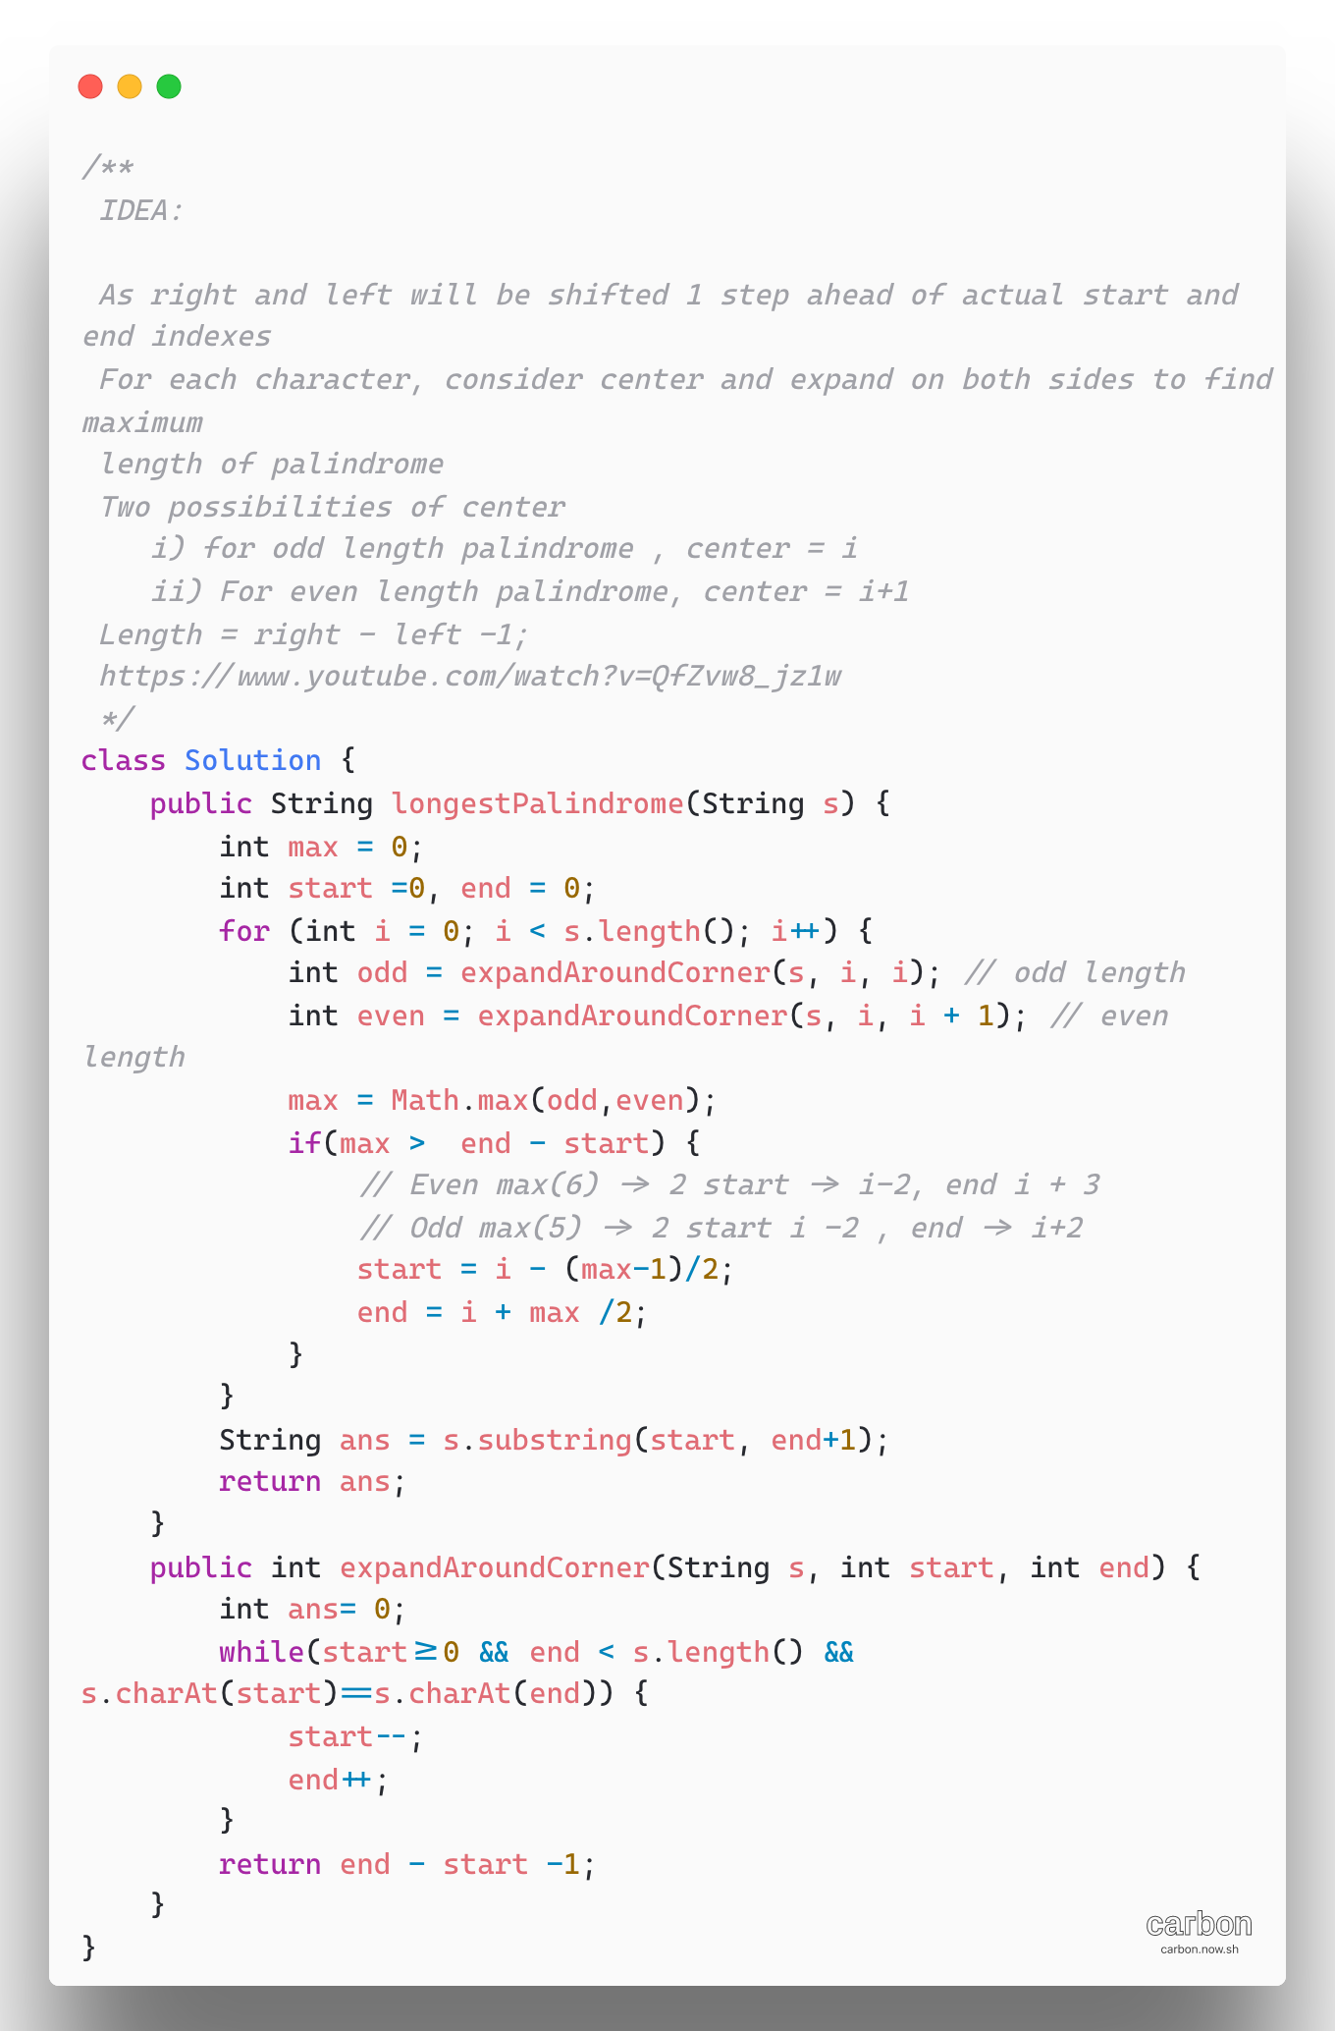

1. [Group Anagrams](https://leetcode.com/problems/group-anagrams/)

**Intuition**

Two strings are anagrams if and only if their sorted strings are equal.

**Algorithm**

Maintain a map ans: {String -> List} where each key K is sorted string, and each value is the list strings from initial input that when sorted are equal to K.

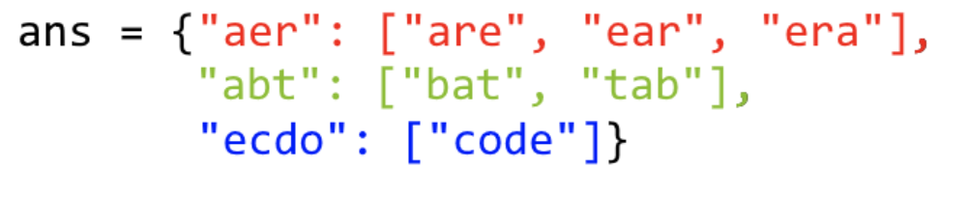

**Complexity Analysis:**

**Time complexity:** O(NKlogK), where N is the length of strs, and K is the maximum length of a string in strs. The outer loop has complexity O(N) as we iterate through each string, then we sort each string in O(KlogK)

**Space Complexity:** O(NK), the total information content stored in ans.

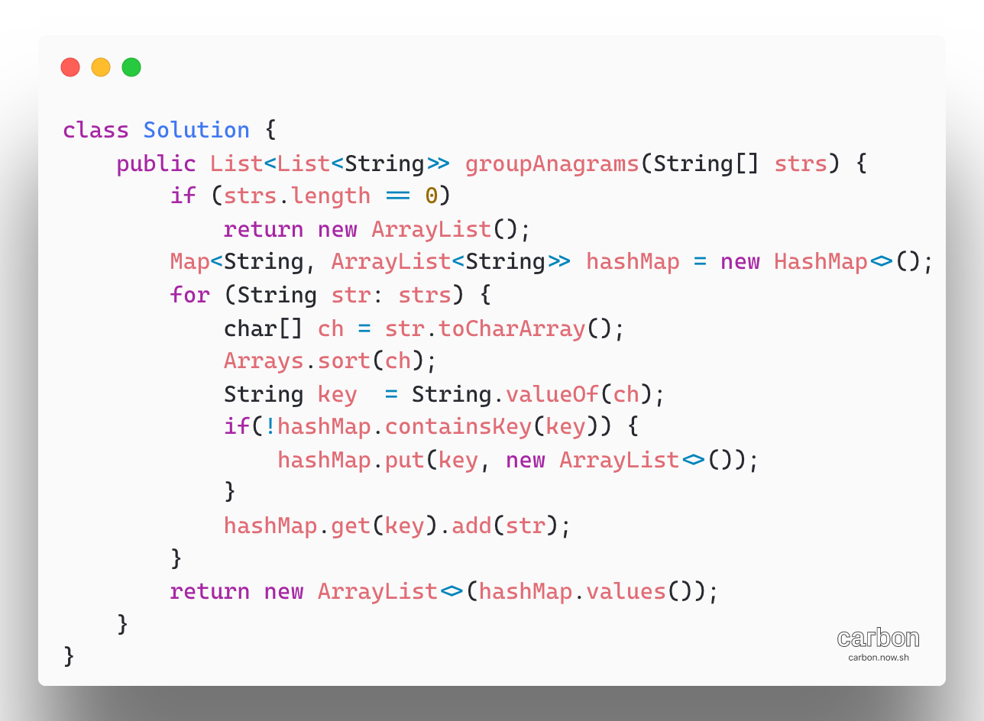

1. Cutting Rope Cutting

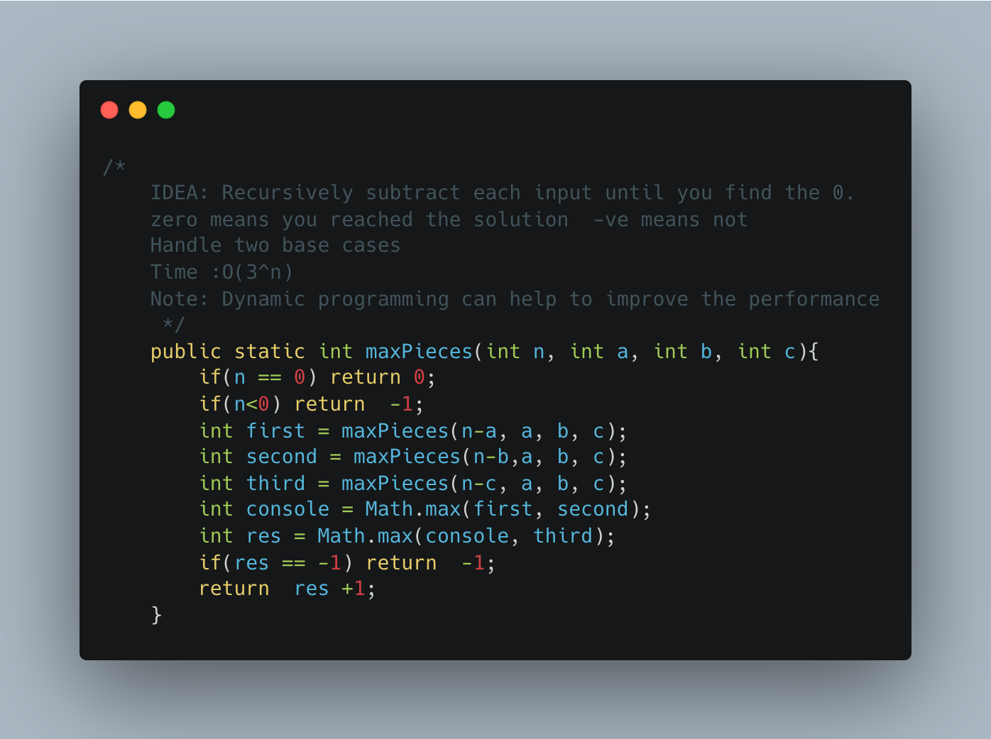

1. Generate Subsets of a given string

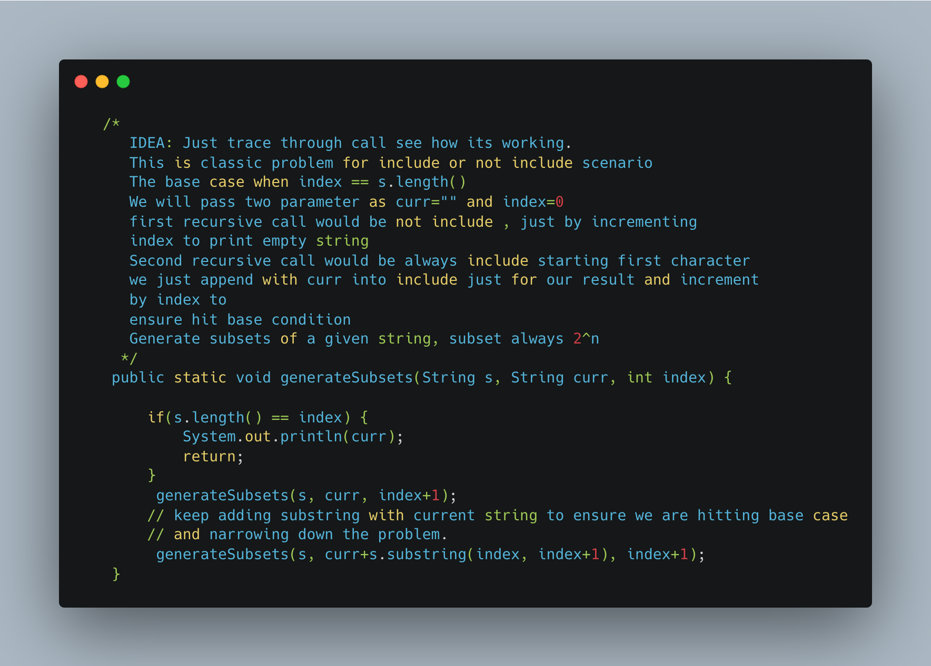

1. [Longest Repeating Character Replacement](https://leetcode.com/problems/longest-repeating-character-replacement/)

TBD- V.IMP

1. Array Dequeue

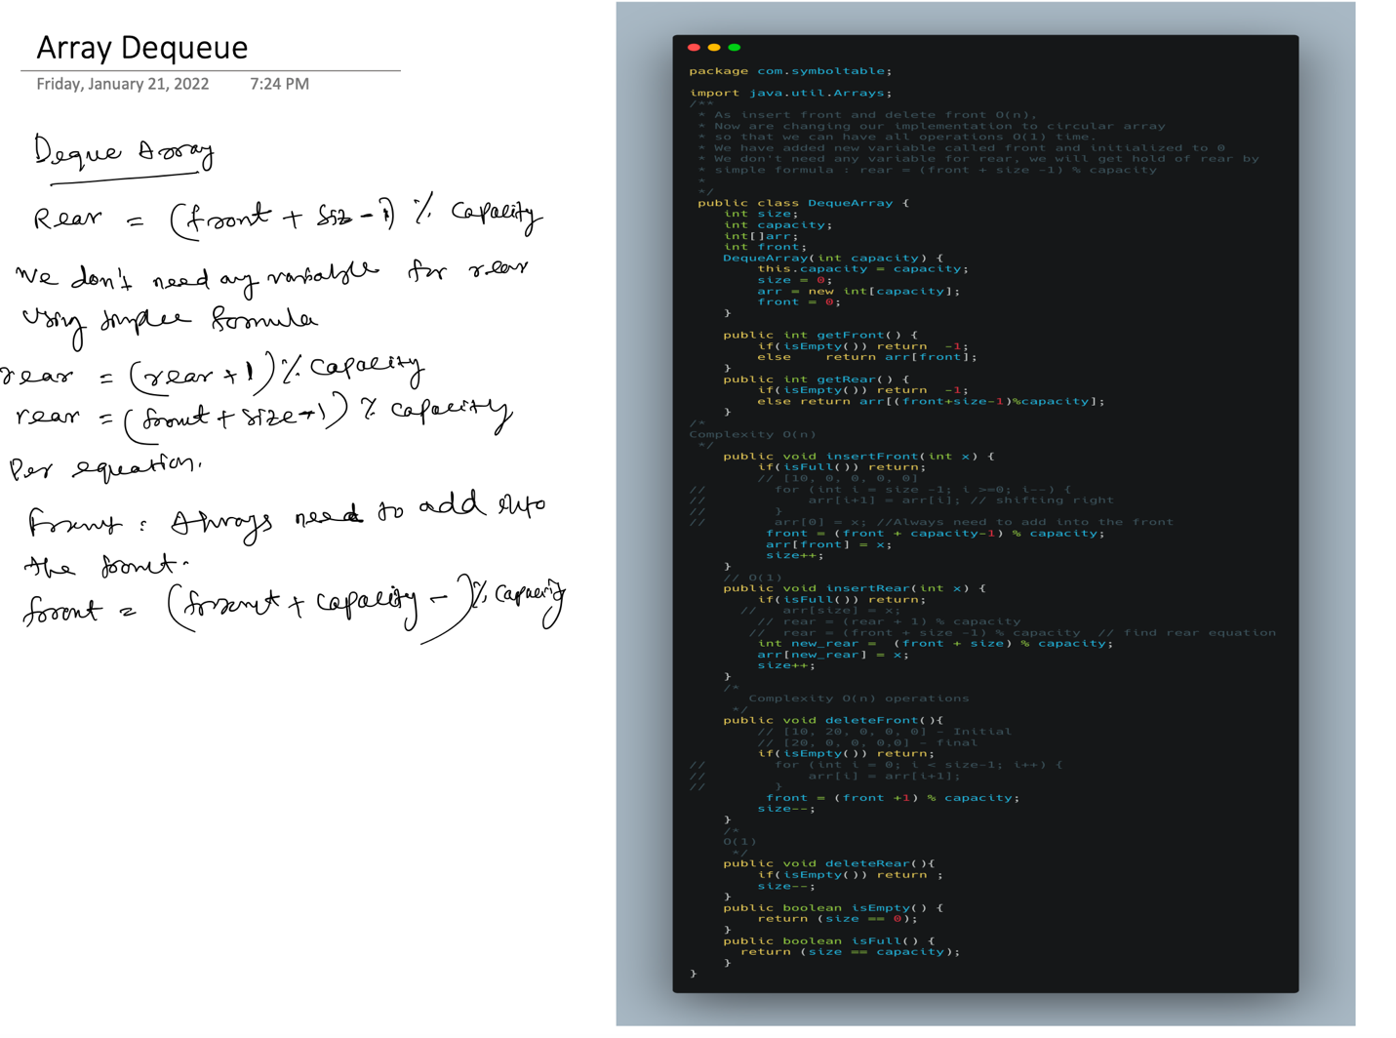

1. [Distant Barcodes](https://leetcode.com/problems/distant-barcodes/)

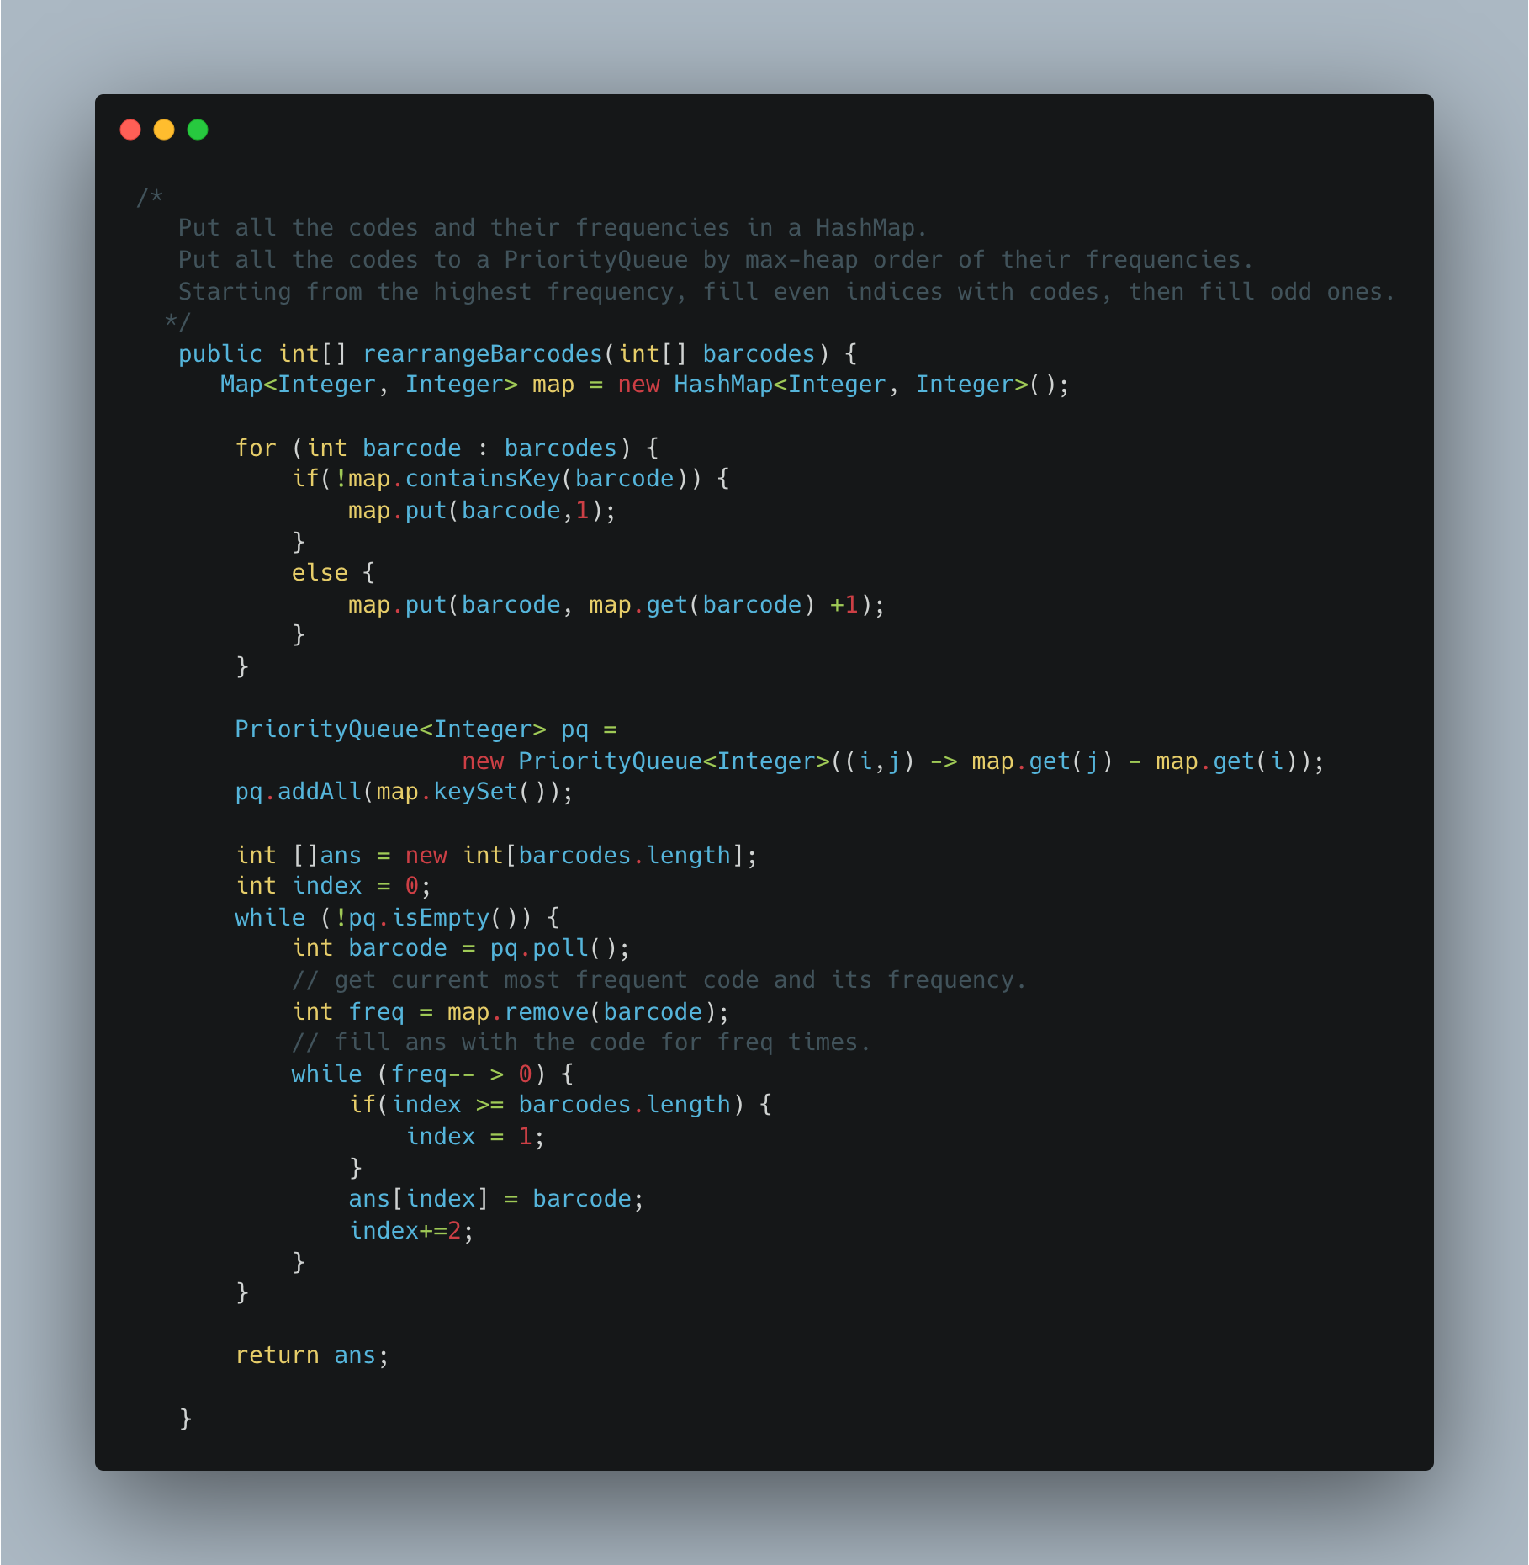

1. [Simplify Path](https://leetcode.com/problems/simplify-path/)

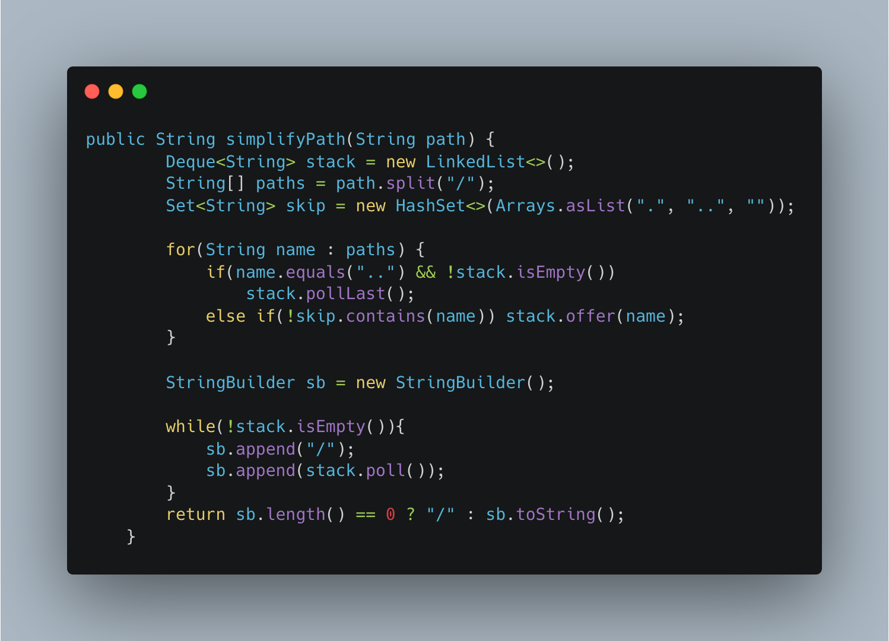

1. Maximum Activity – Greedy

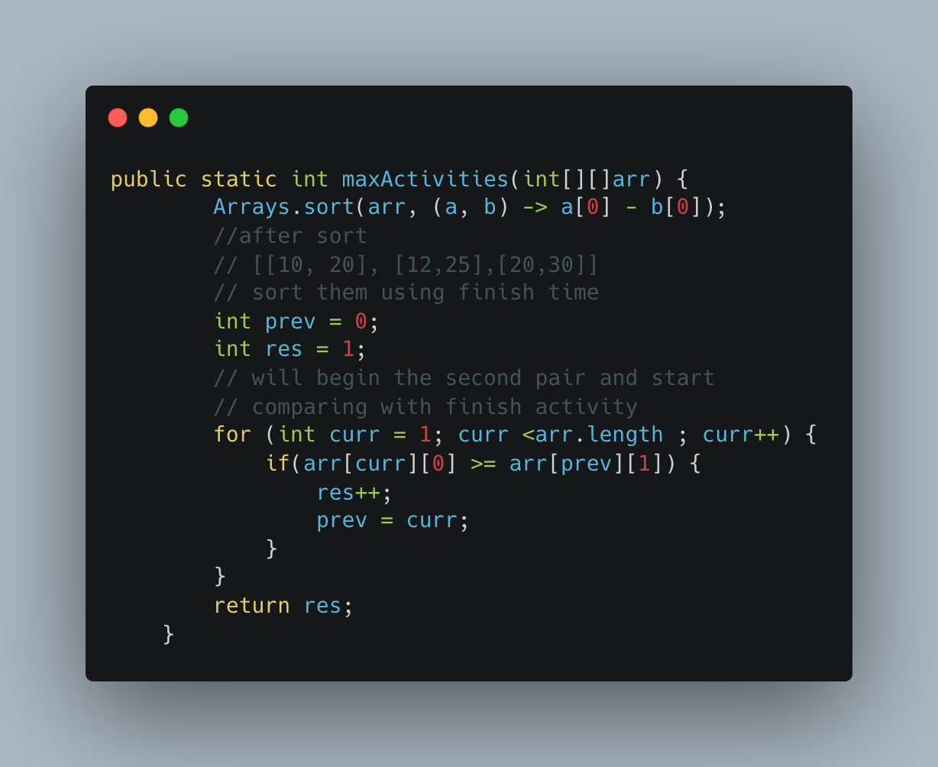

1. Another way of implementing

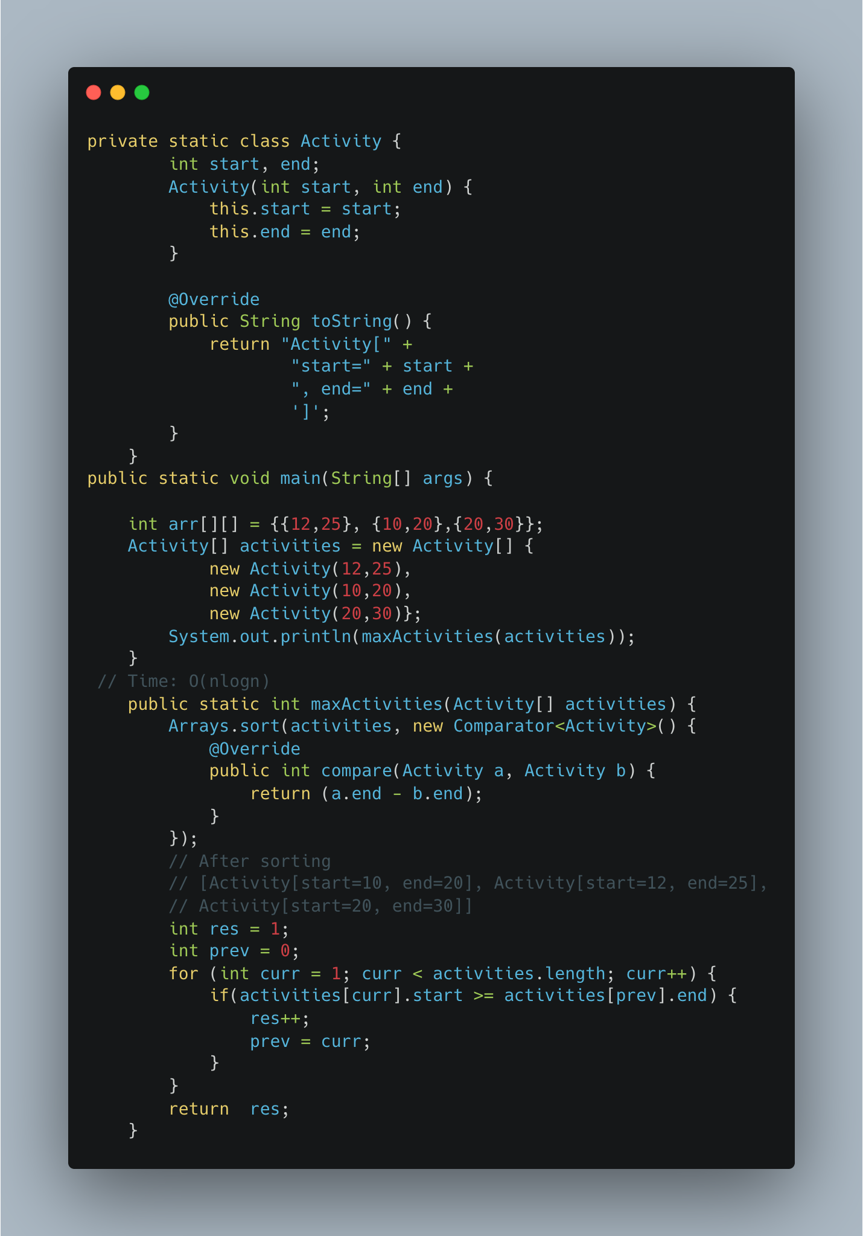

1. [Fractional Knapsack](https://www.geeksforgeeks.org/fractional-knapsack-problem/)

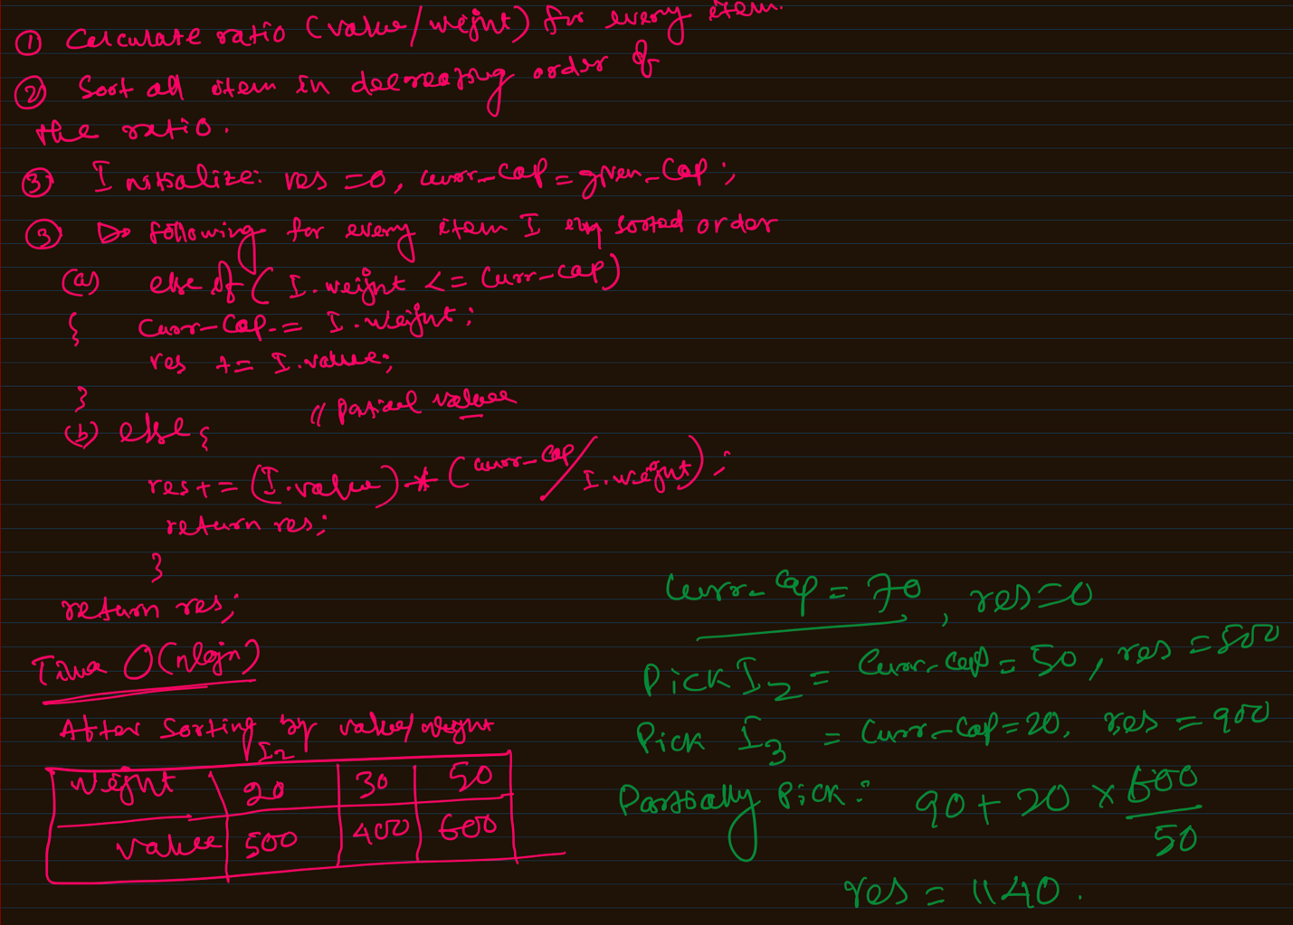

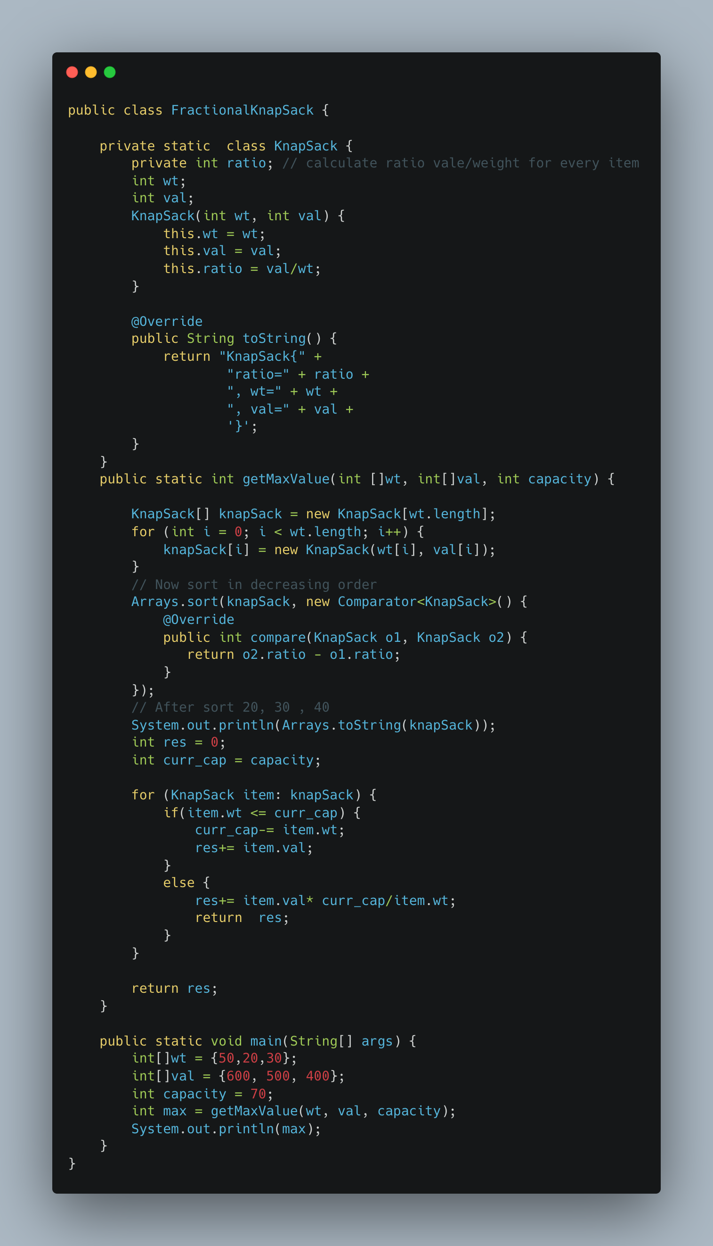

1. [Print Word Vertically](https://leetcode.com/problems/print-words-vertically/)

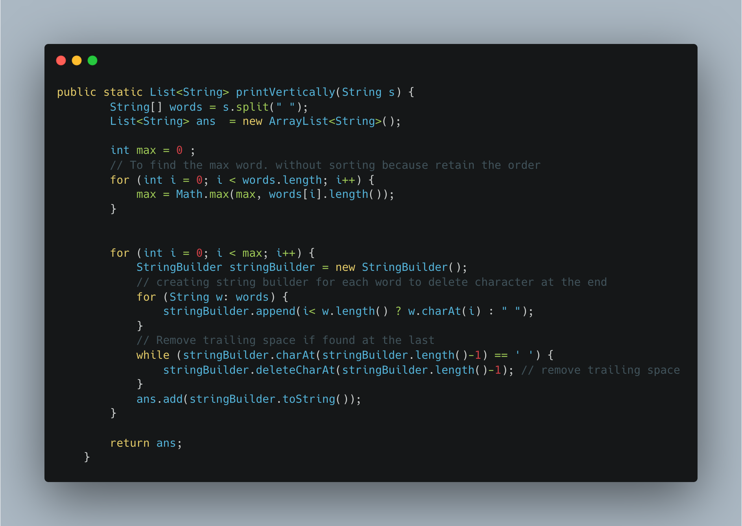

1. [Two Sum II Array is Sorted](https://leetcode.com/problems/two-sum-ii-input-array-is-sorted/)

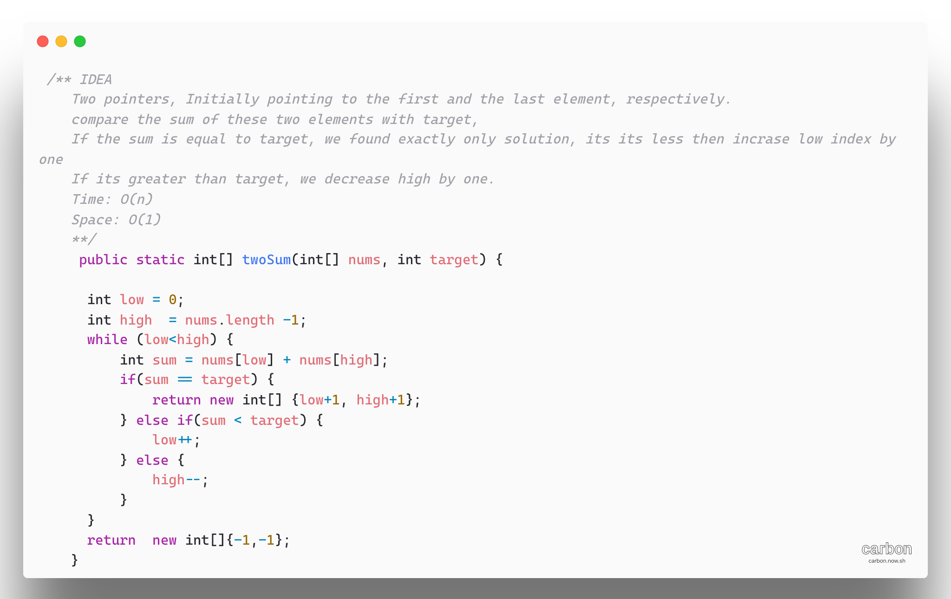

1. [Minimum Moves to Equal Array elements II](https://leetcode.com/problems/minimum-moves-to-equal-array-elements-ii/)

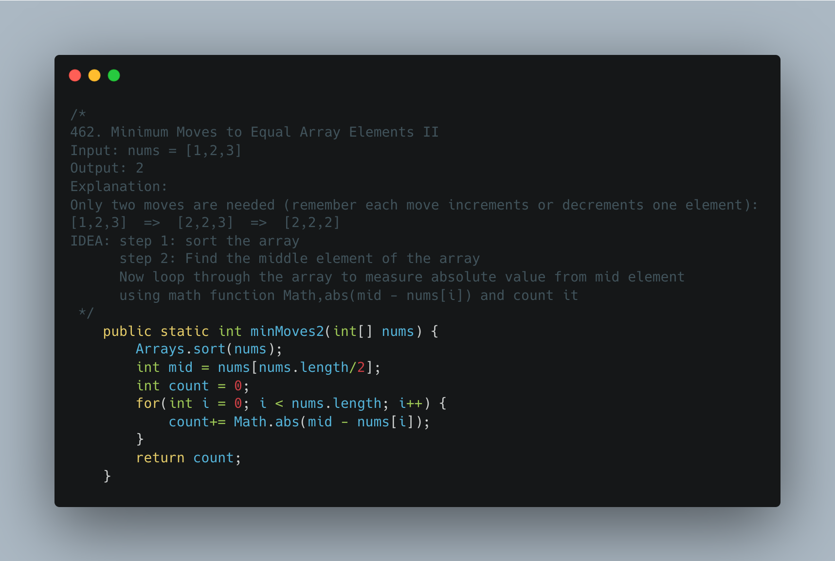

1. [Same Tree](https://leetcode.com/problems/same-tree/)

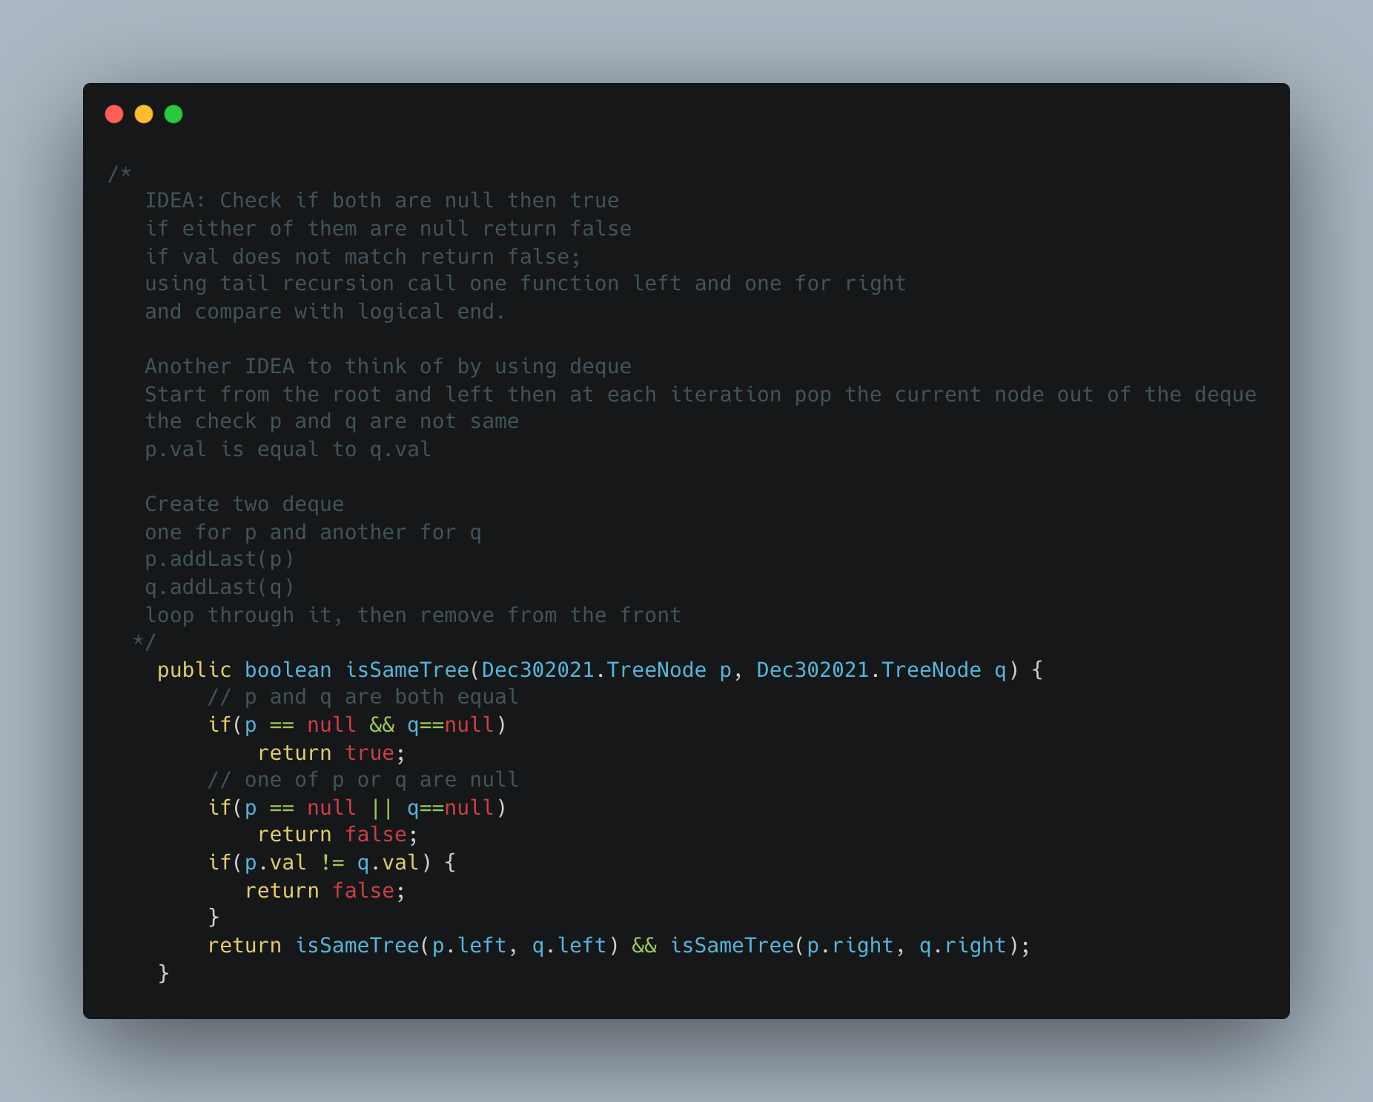

1. Maximize the number of toys that can be purchased with amount K using min Heap

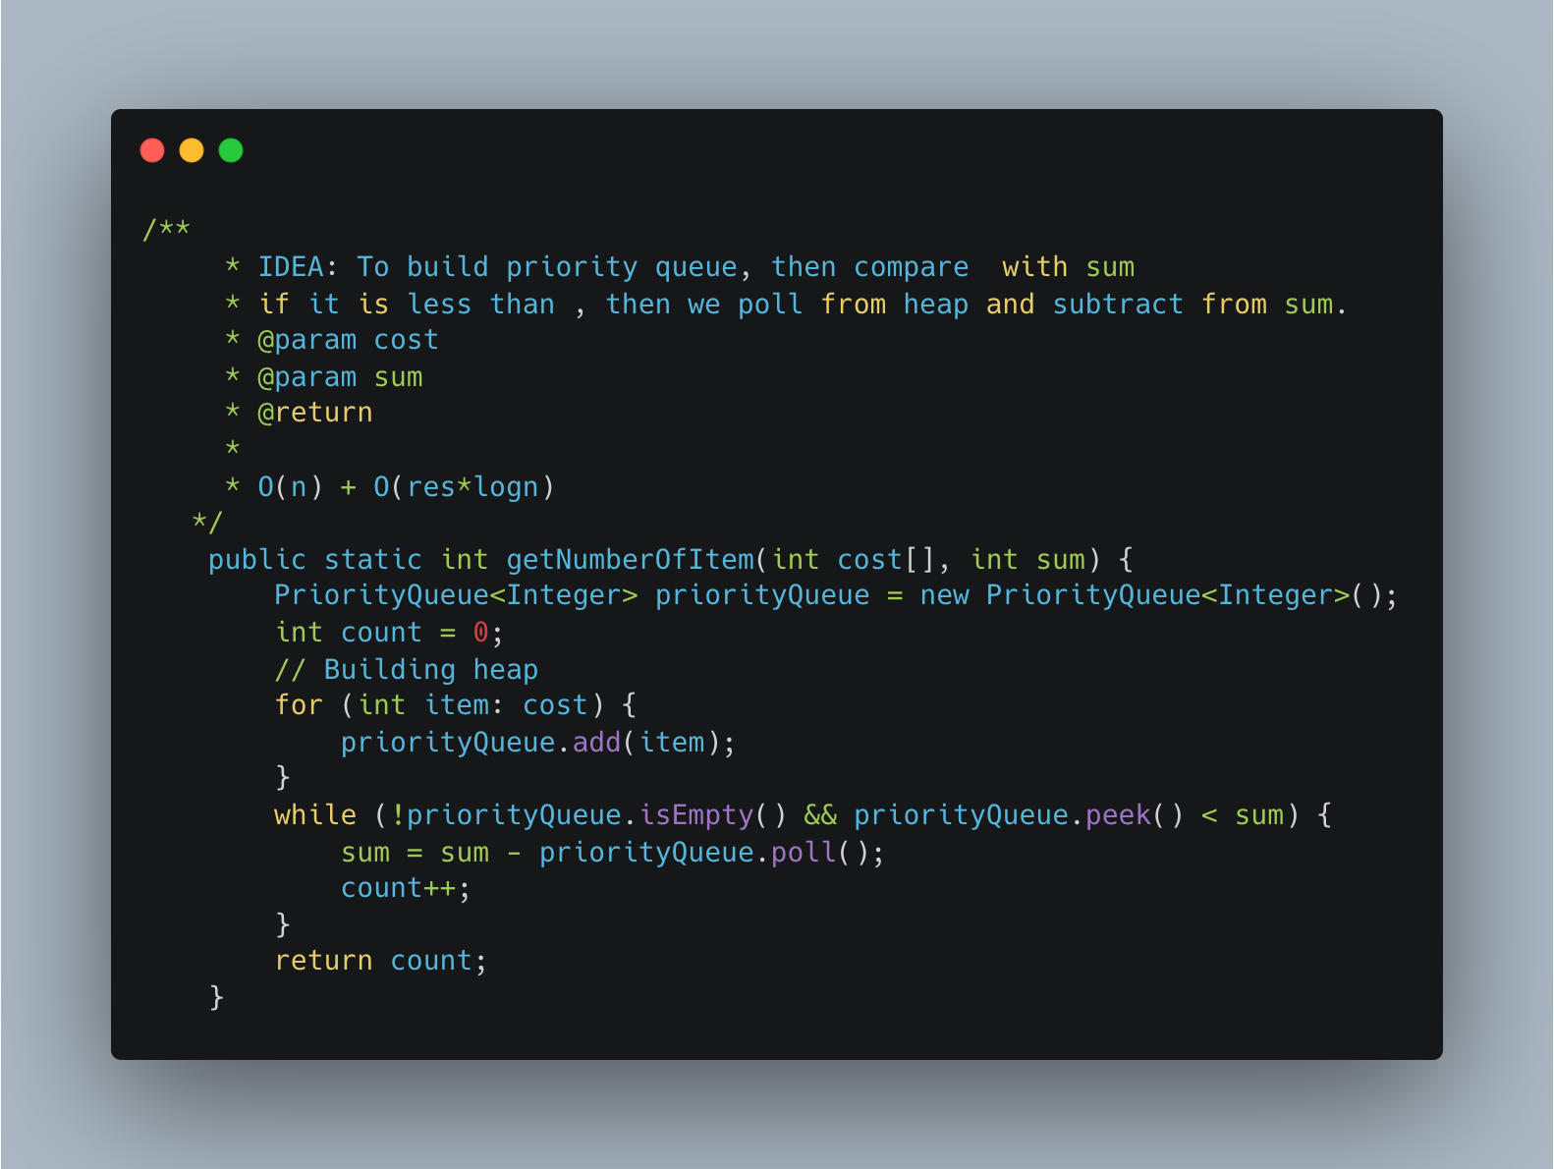

1. [Find K Closest Elements](https://leetcode.com/problems/find-k-closest-elements/)

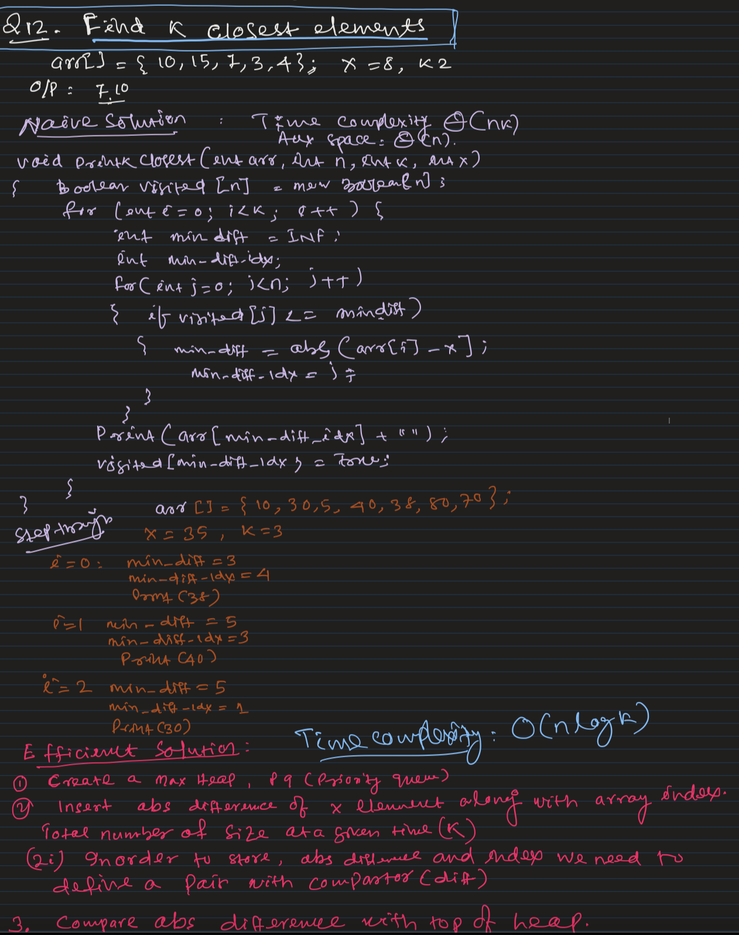

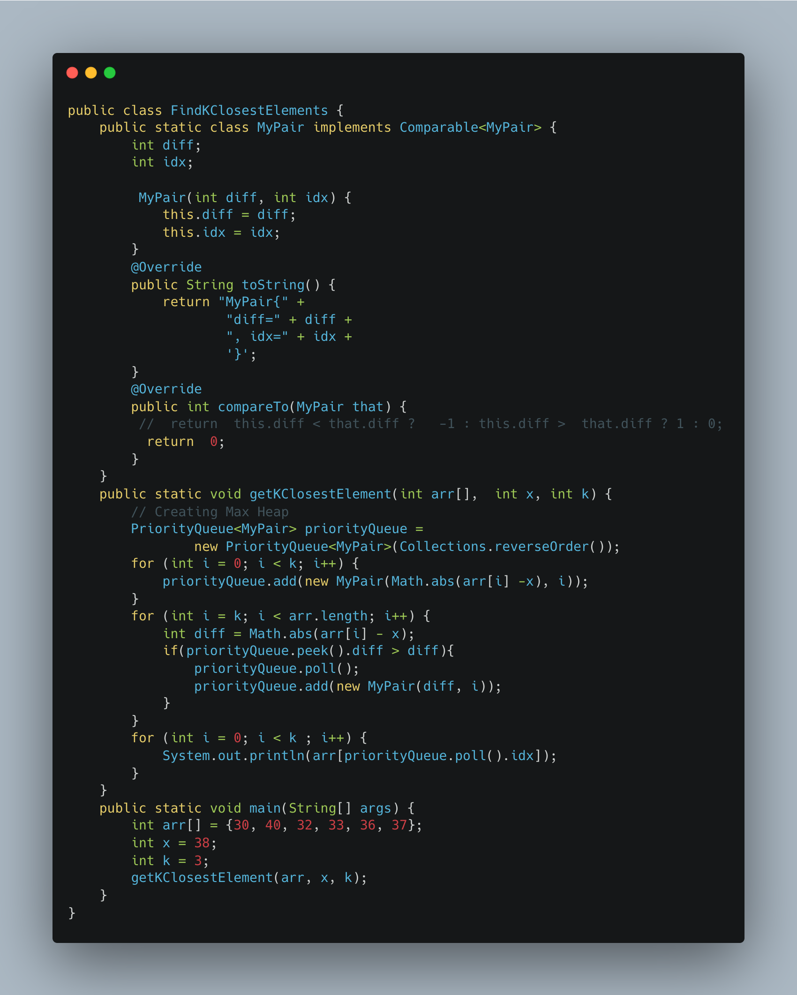

1. [Partition into Minimum Number of Deci -Binary Numbers](https://leetcode.com/problems/partitioning-into-minimum-number-of-deci-binary-numbers/)

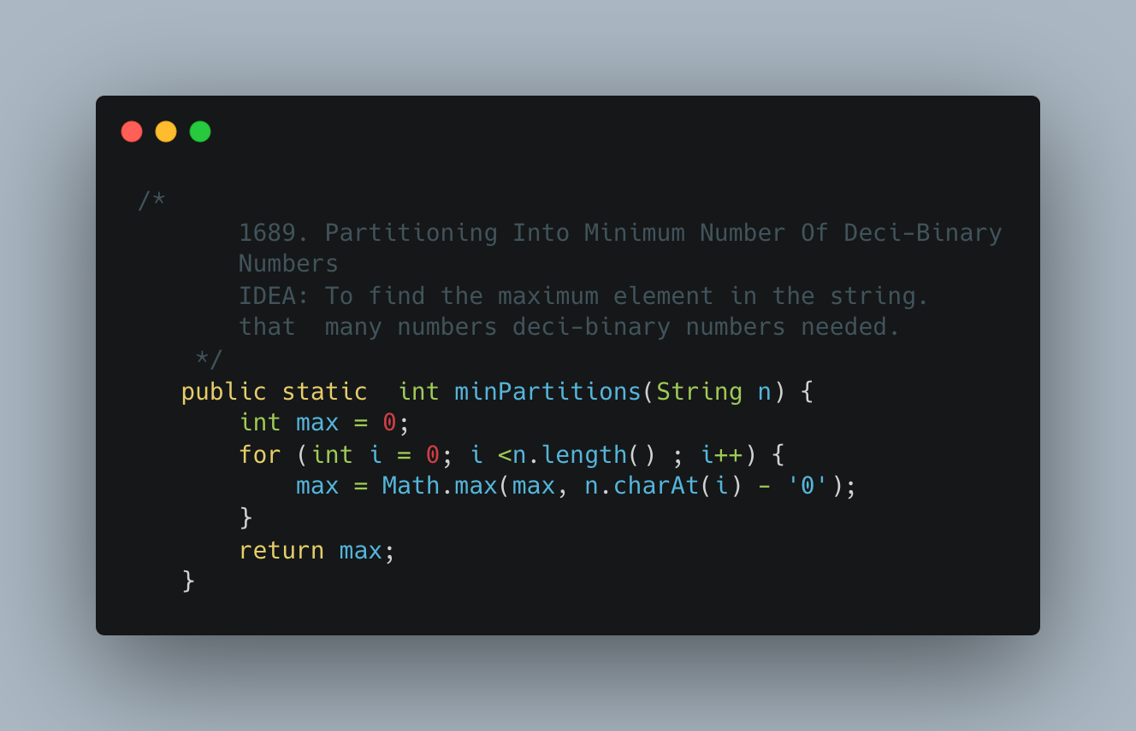

1. [Number of Closed Islands](https://leetcode.com/problems/number-of-closed-islands/)

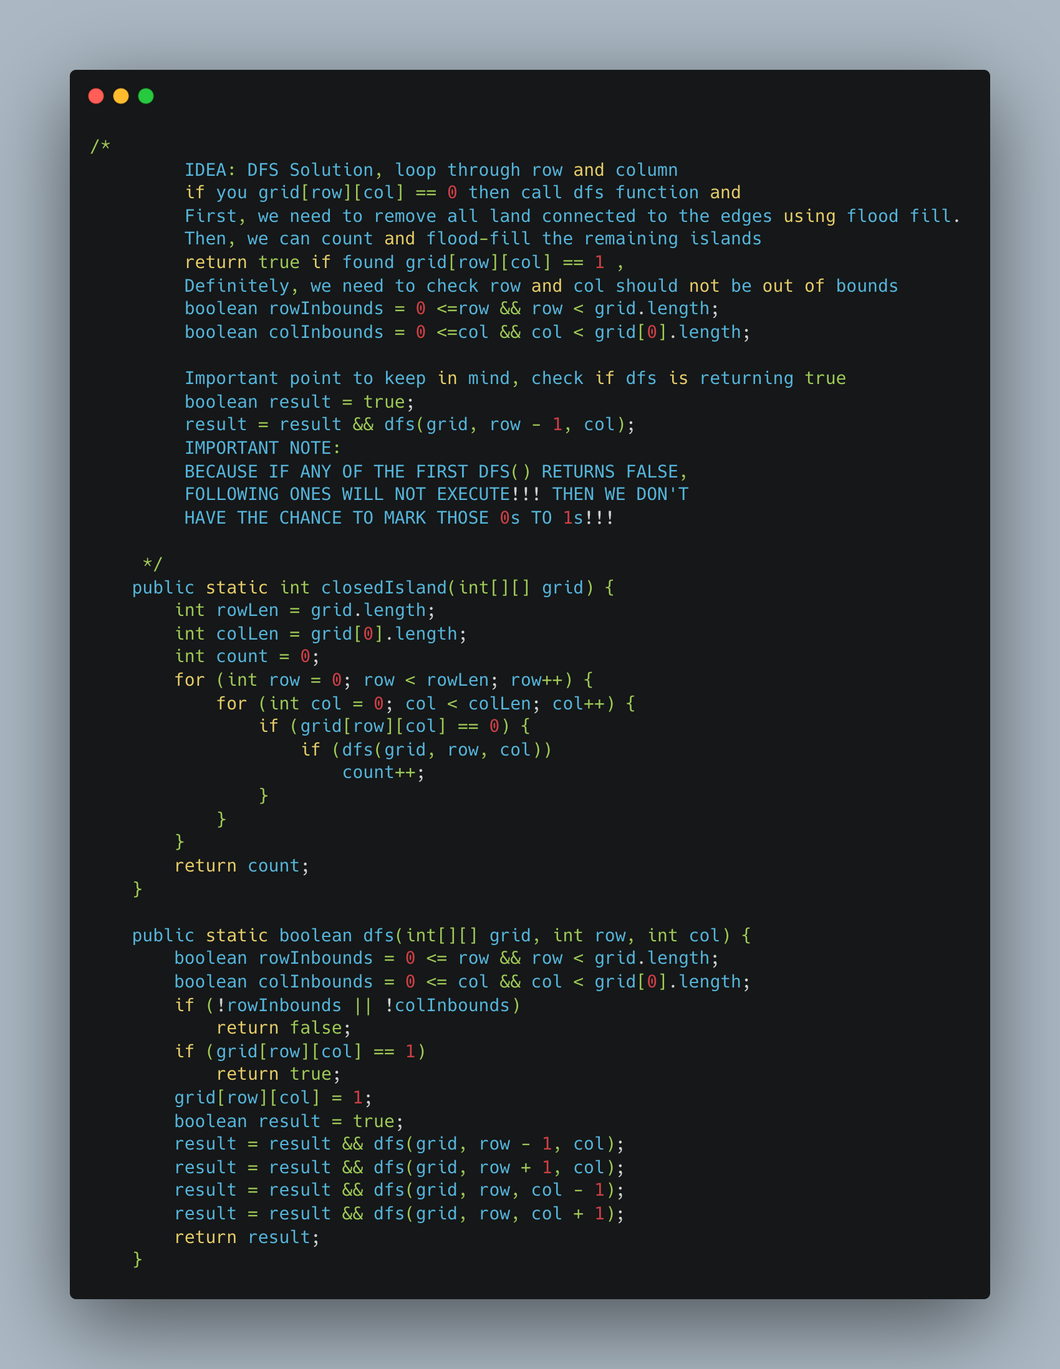

1. [Rank Transform of an Array](https://leetcode.com/problems/rank-transform-of-an-array/)

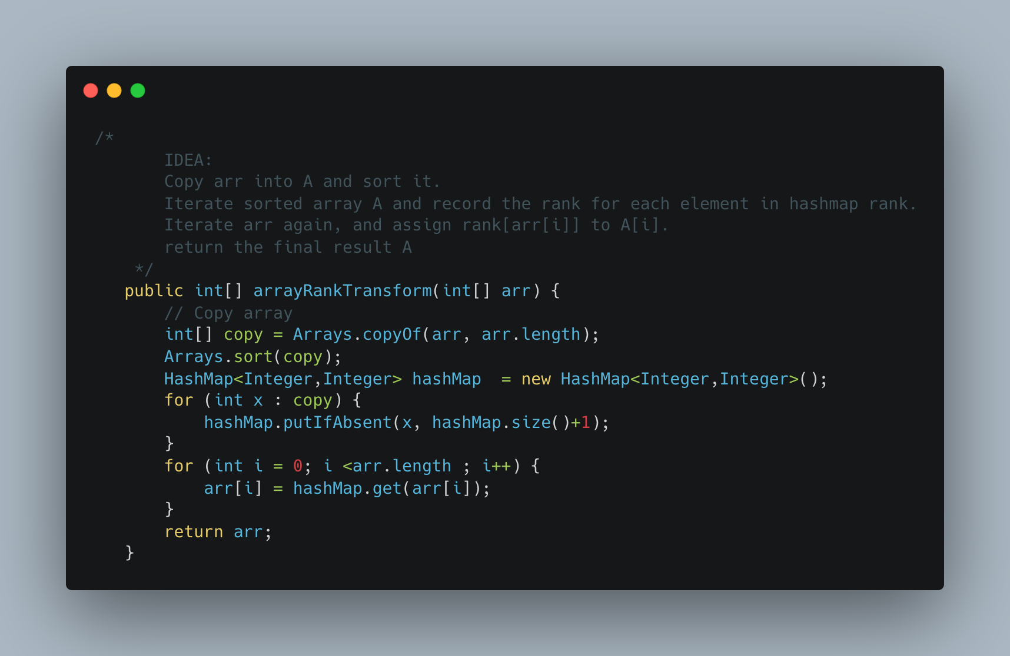

1. [Numbers with Same consecutive differences](https://leetcode.com/problems/numbers-with-same-consecutive-differences/)

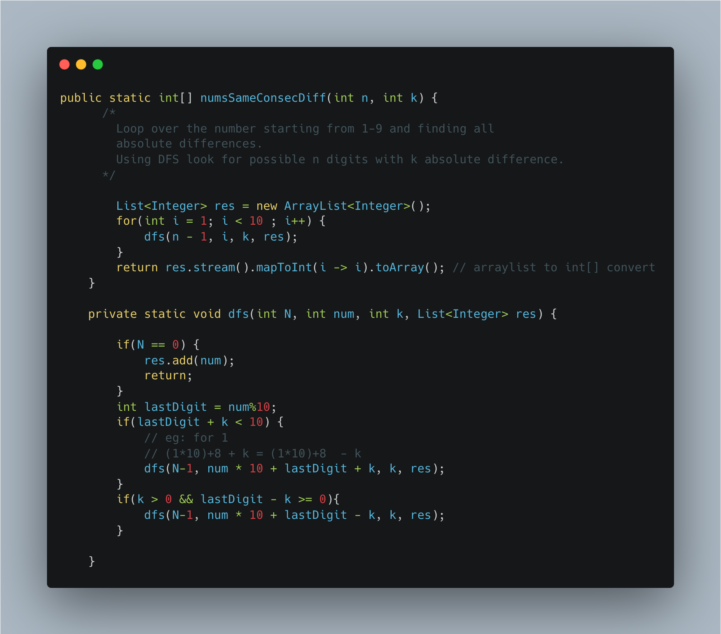

1. [Word Search](https://leetcode.com/problems/word-search/submissions/)

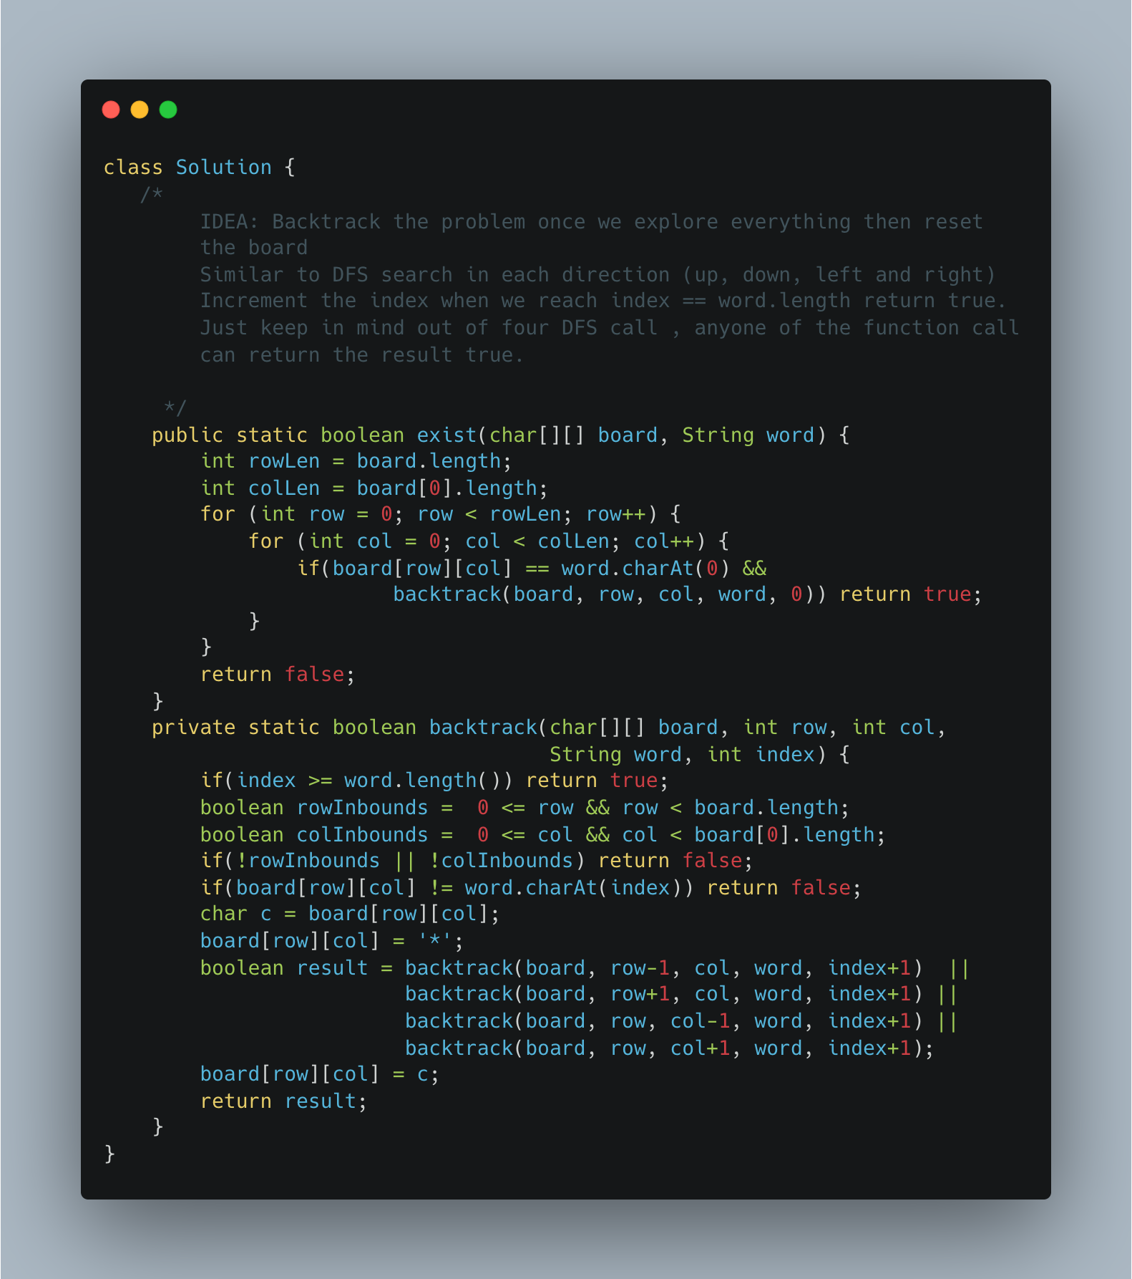

1. [Find Minimum in Rotated Sorted Array](https://leetcode.com/problems/find-minimum-in-rotated-sorted-array/)

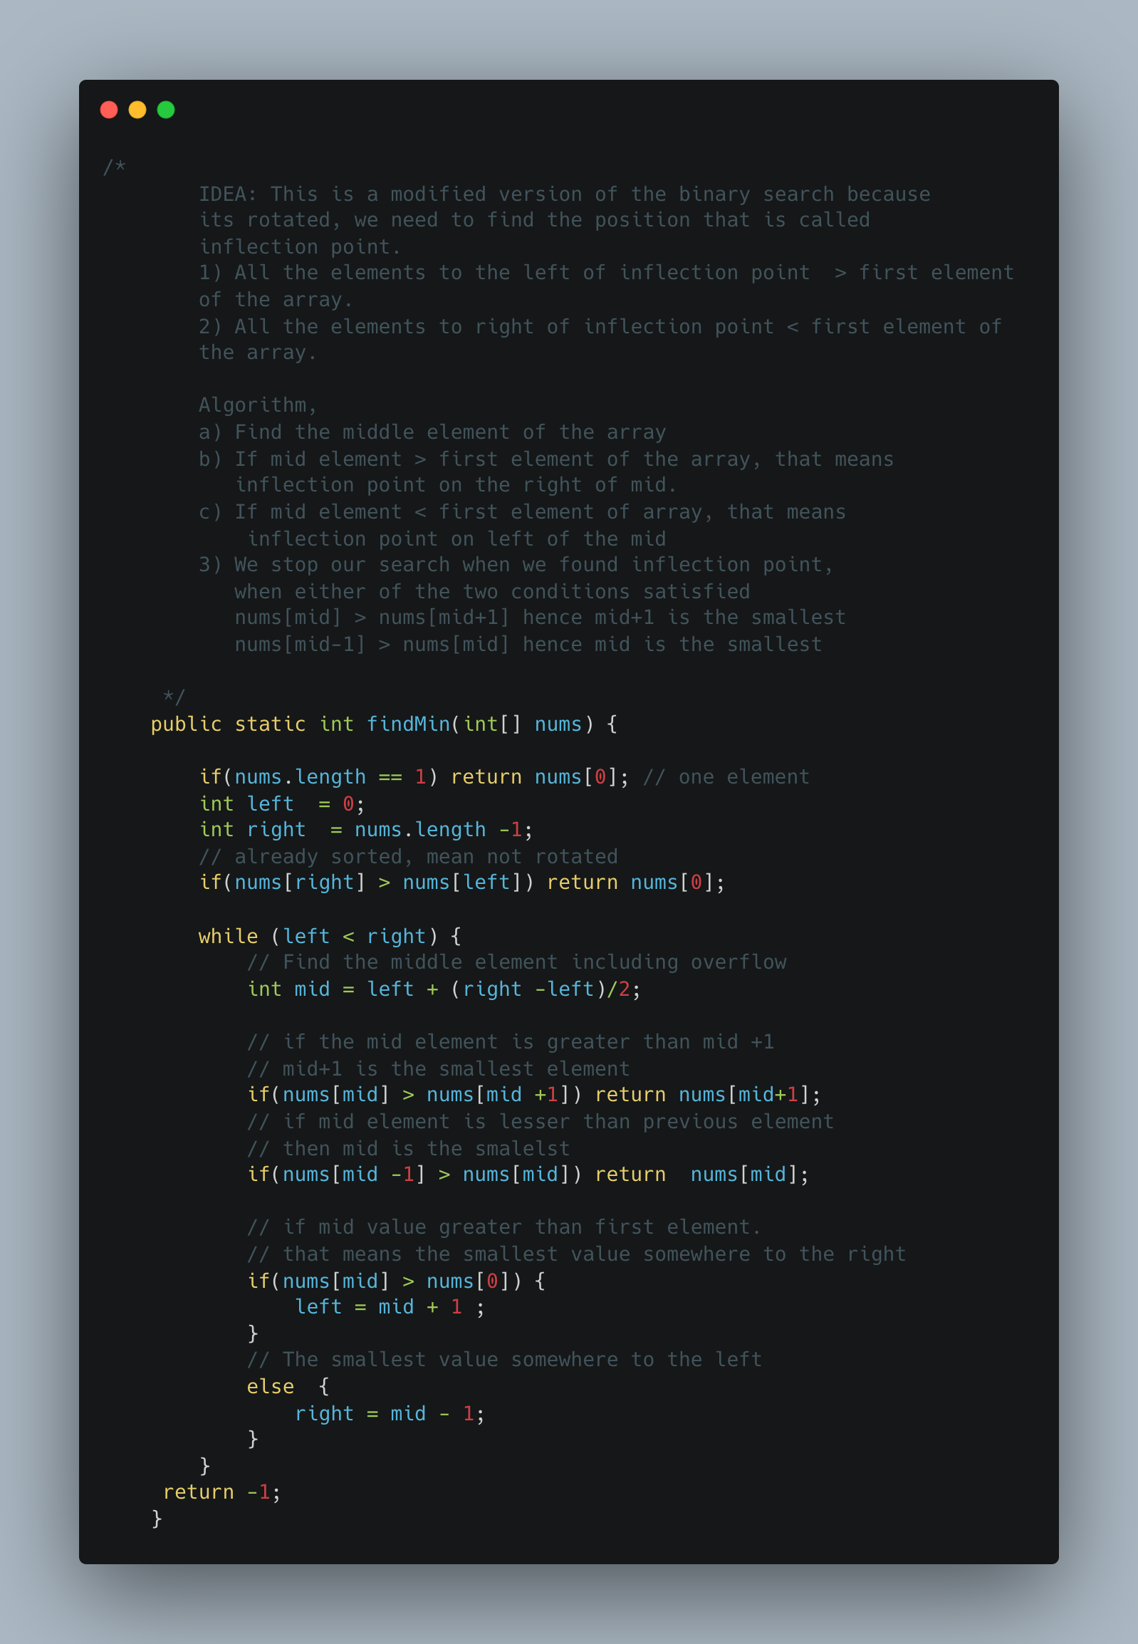

1. [Relative Sort Array](https://leetcode.com/problems/relative-sort-array/)

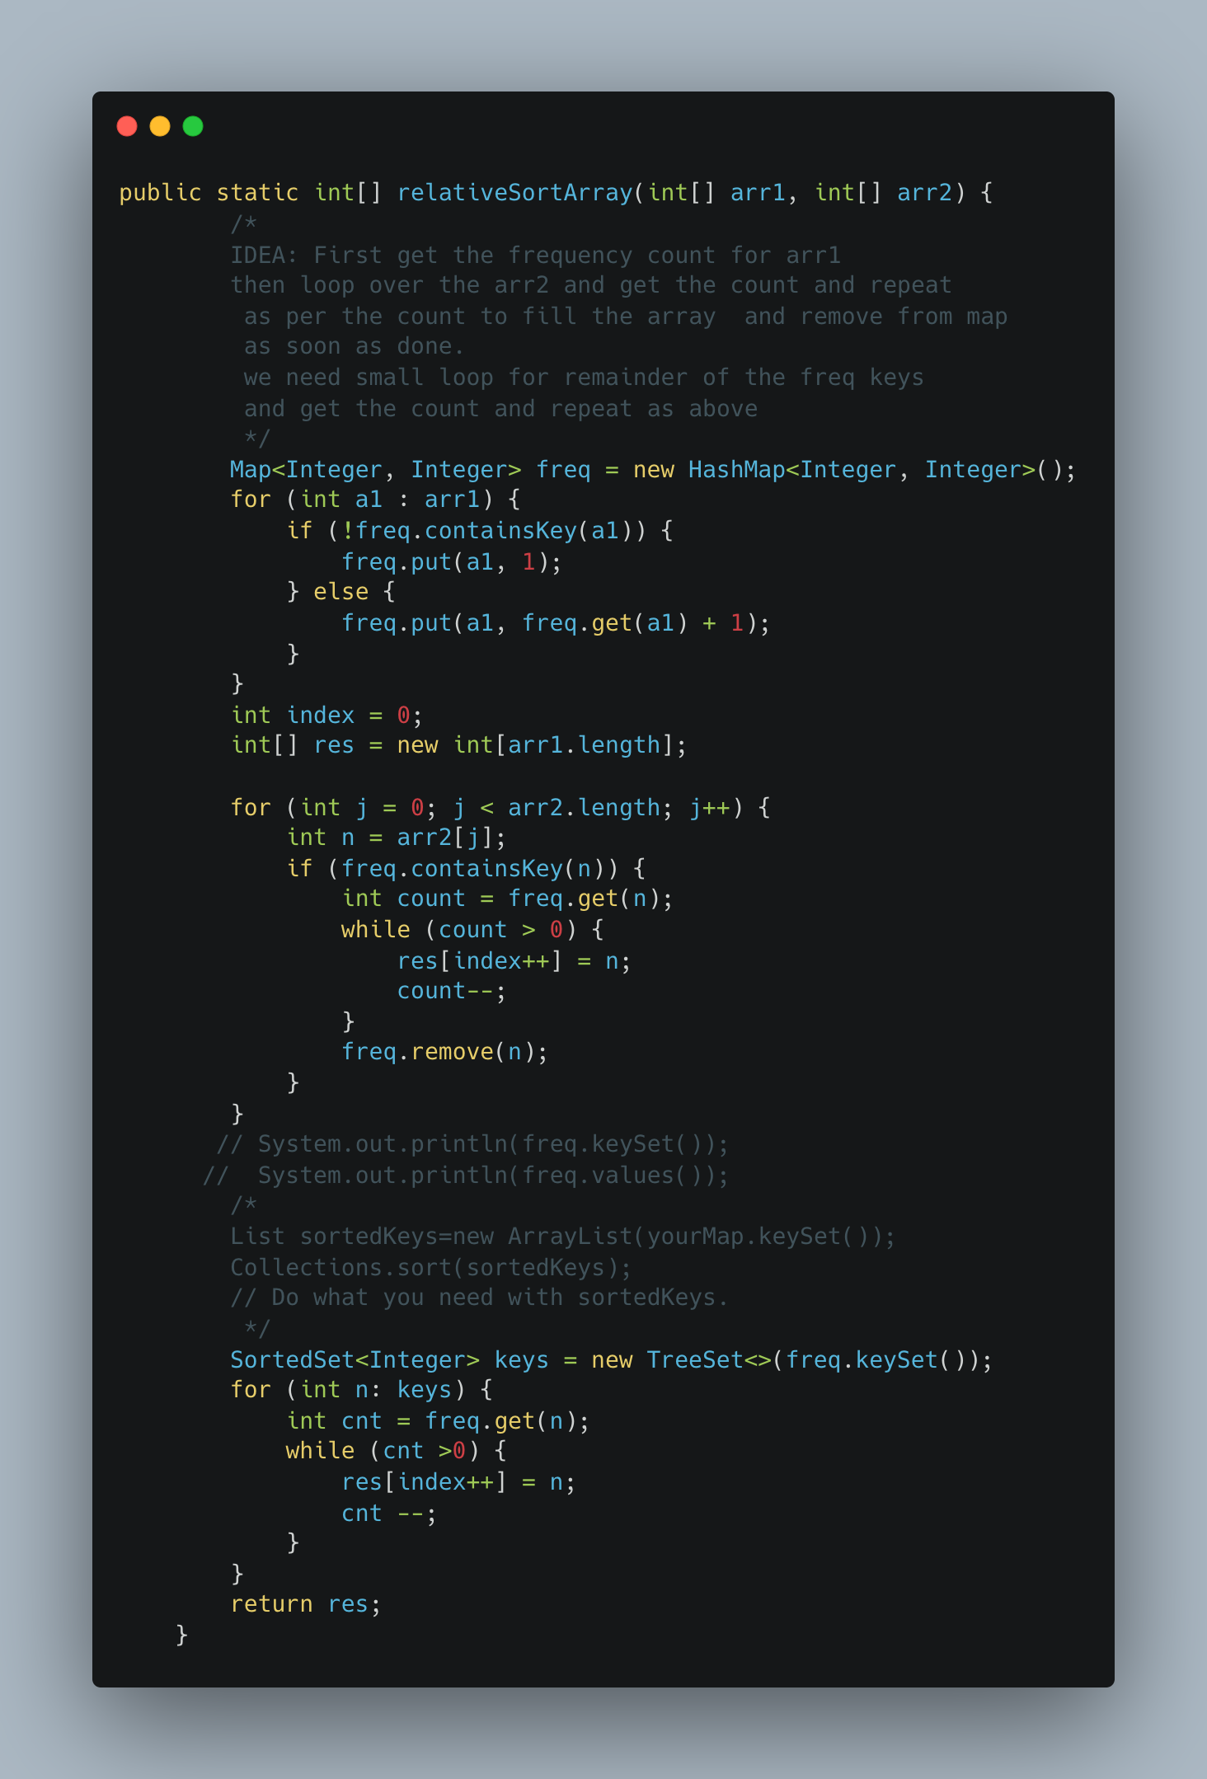

1. [Remove K Digits](https://leetcode.com/problems/remove-k-digits/)

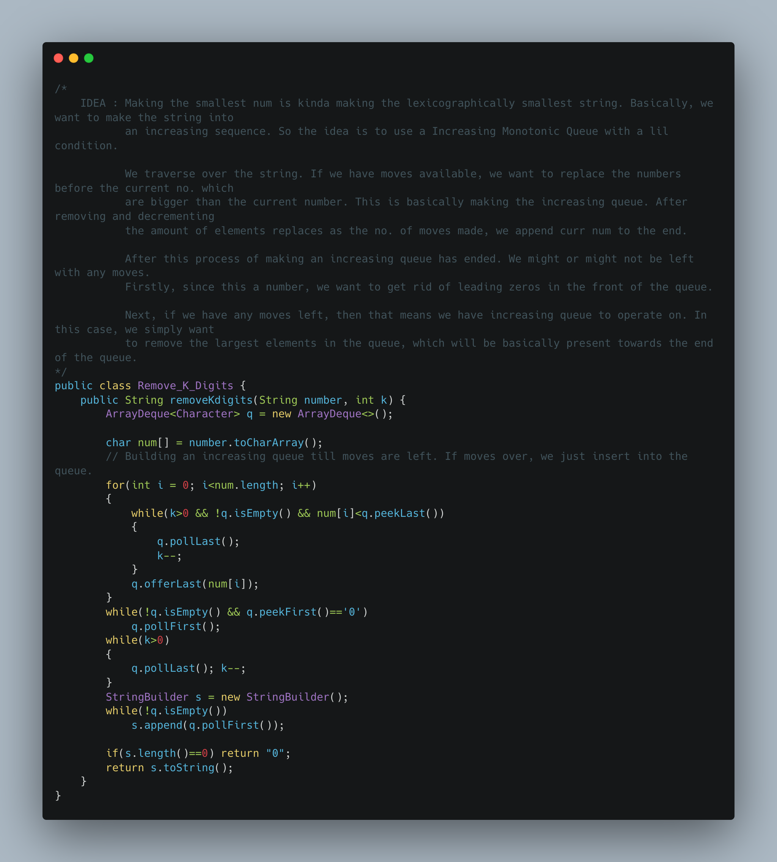

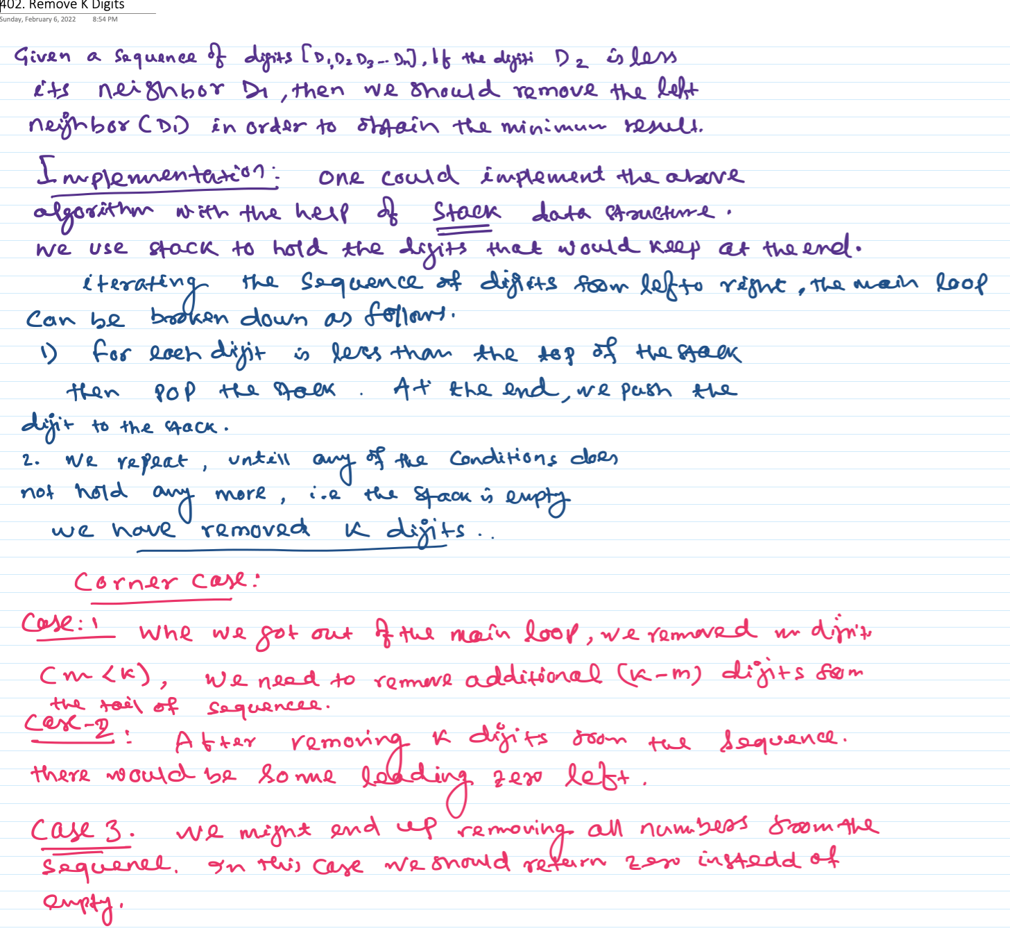

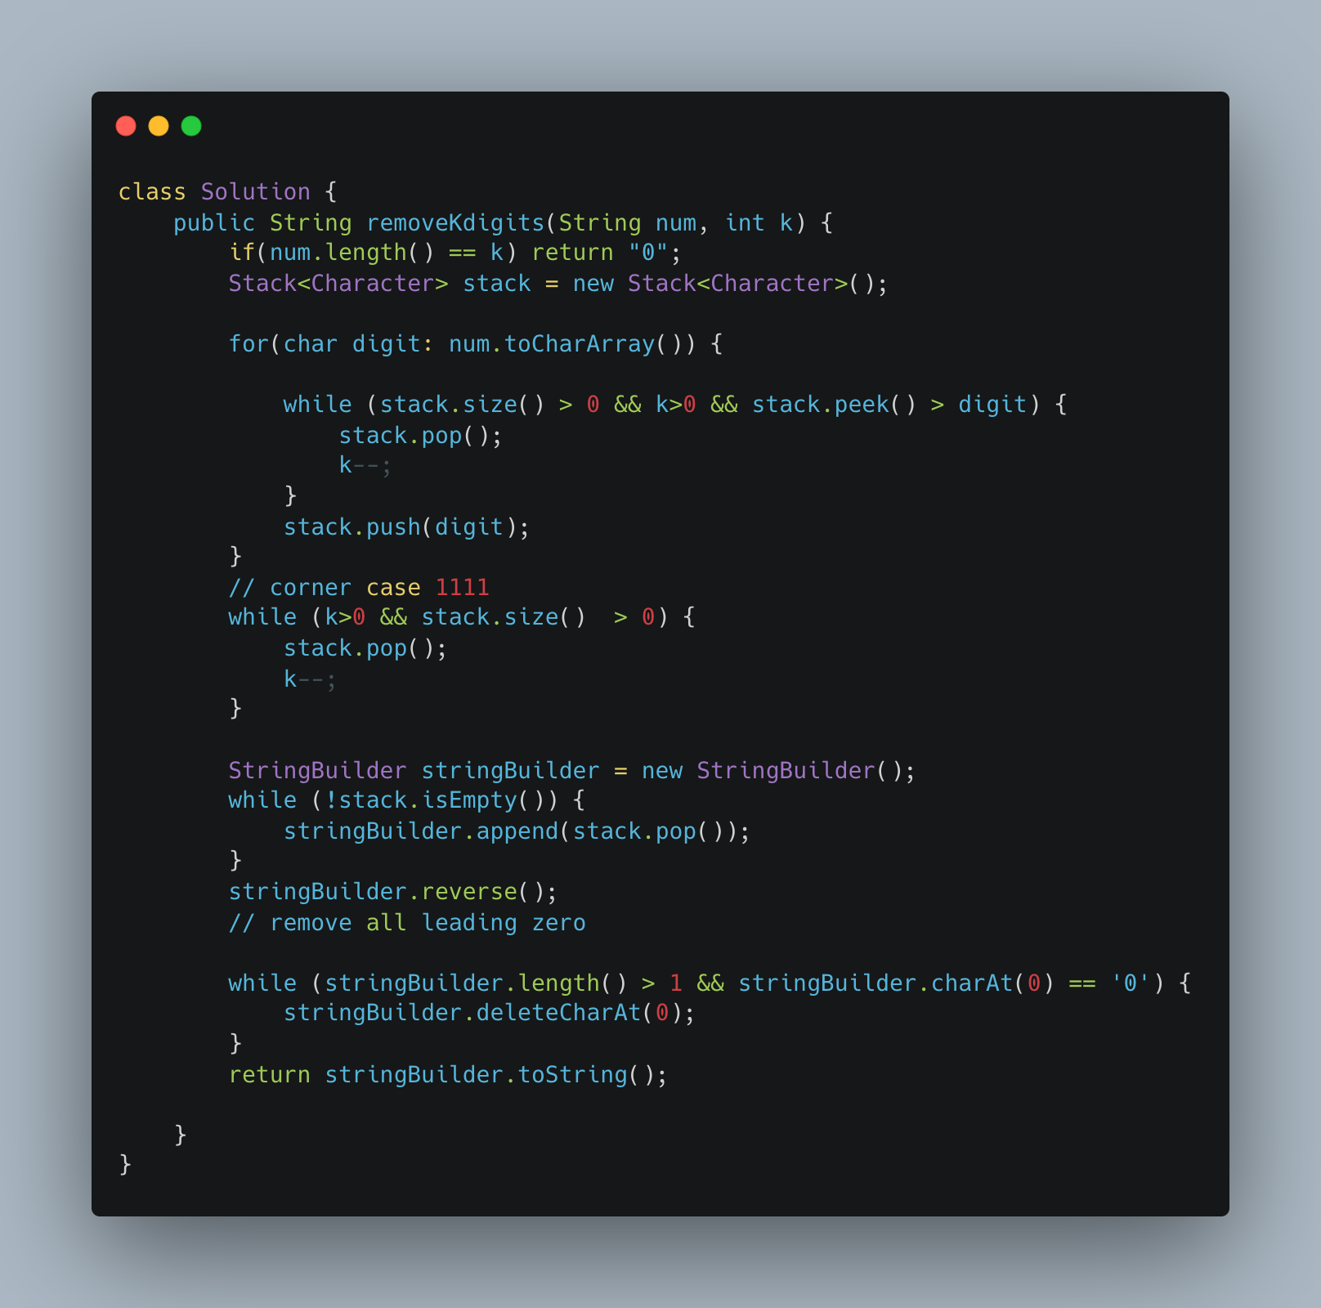

1. [Partition Labels](https://leetcode.com/problems/partition-labels/)

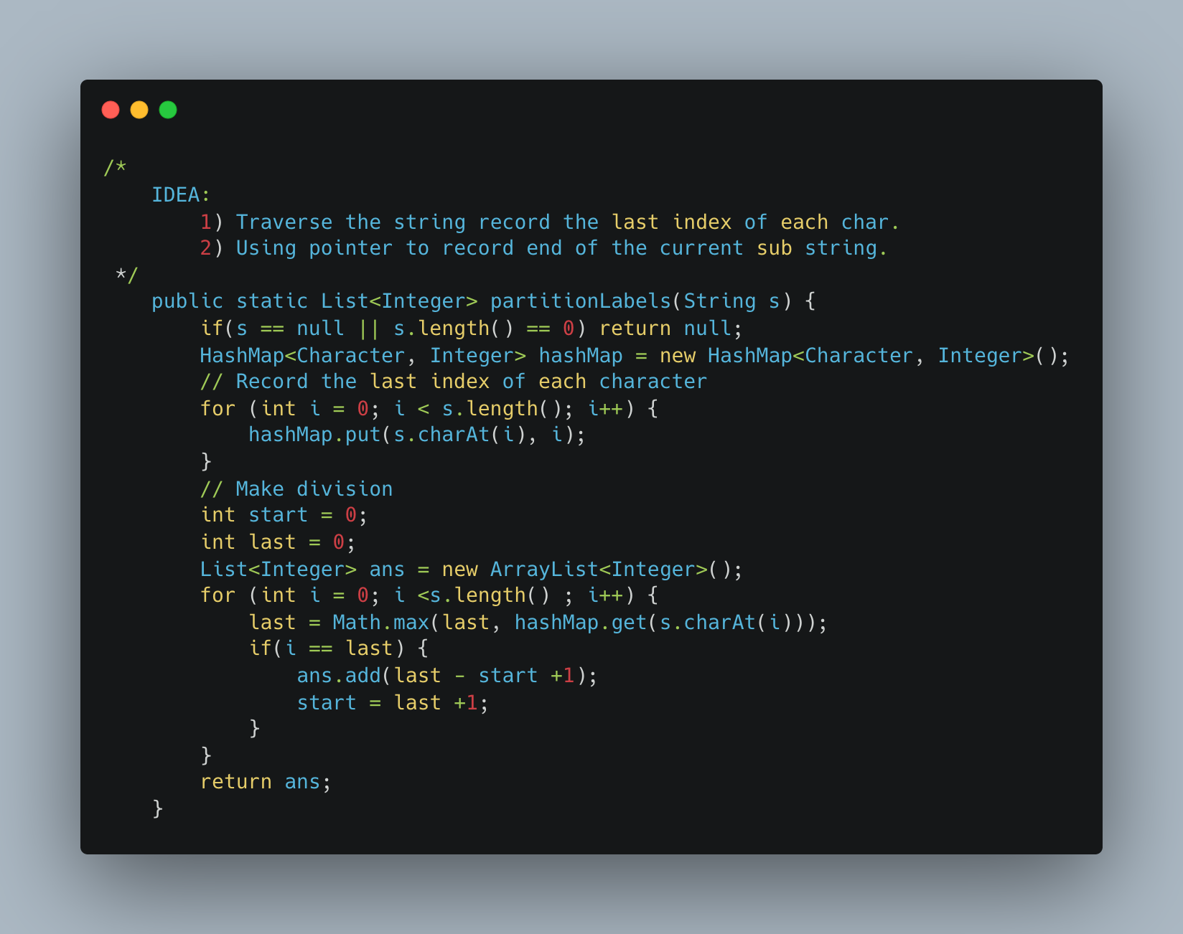

1. Fibonacci Dynamic Programming

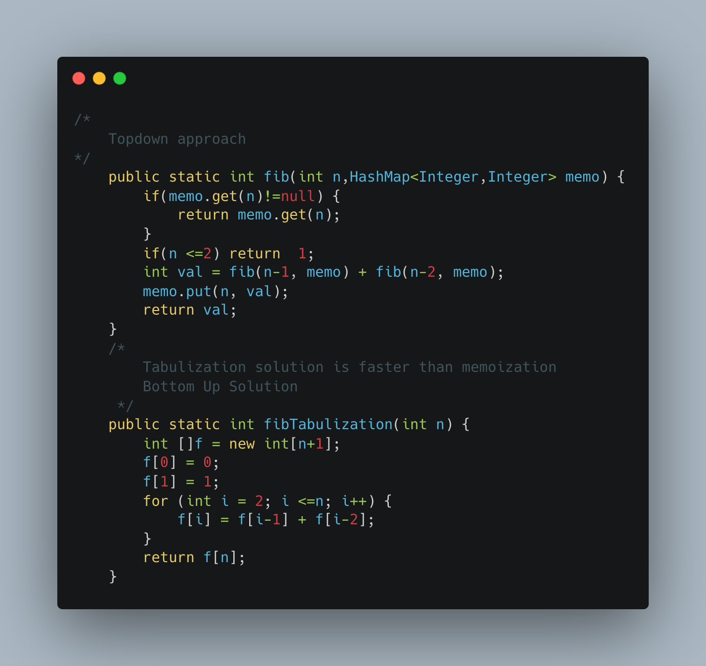

1. Distribute Coins in Binary Tree

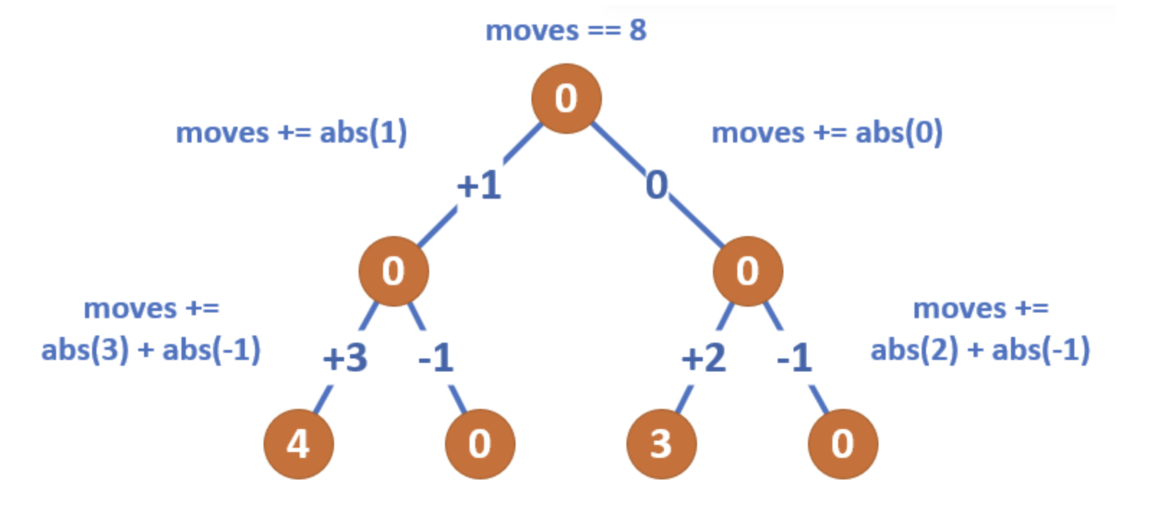

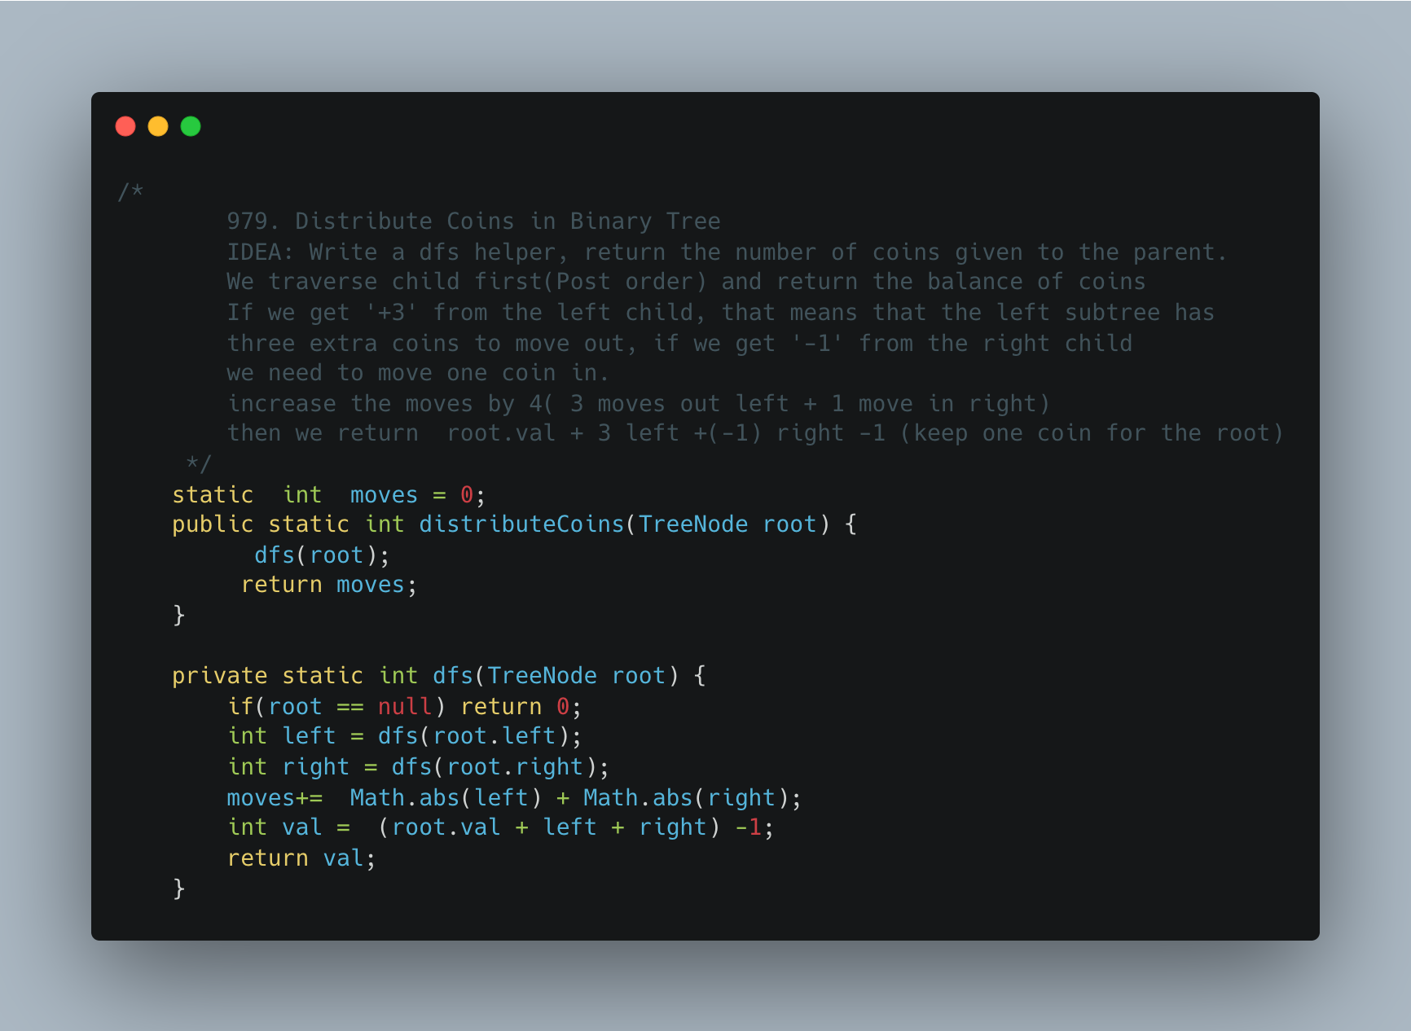

1. [Sorted Matrix](https://practice.geeksforgeeks.org/problems/sorted-matrix2333/1)

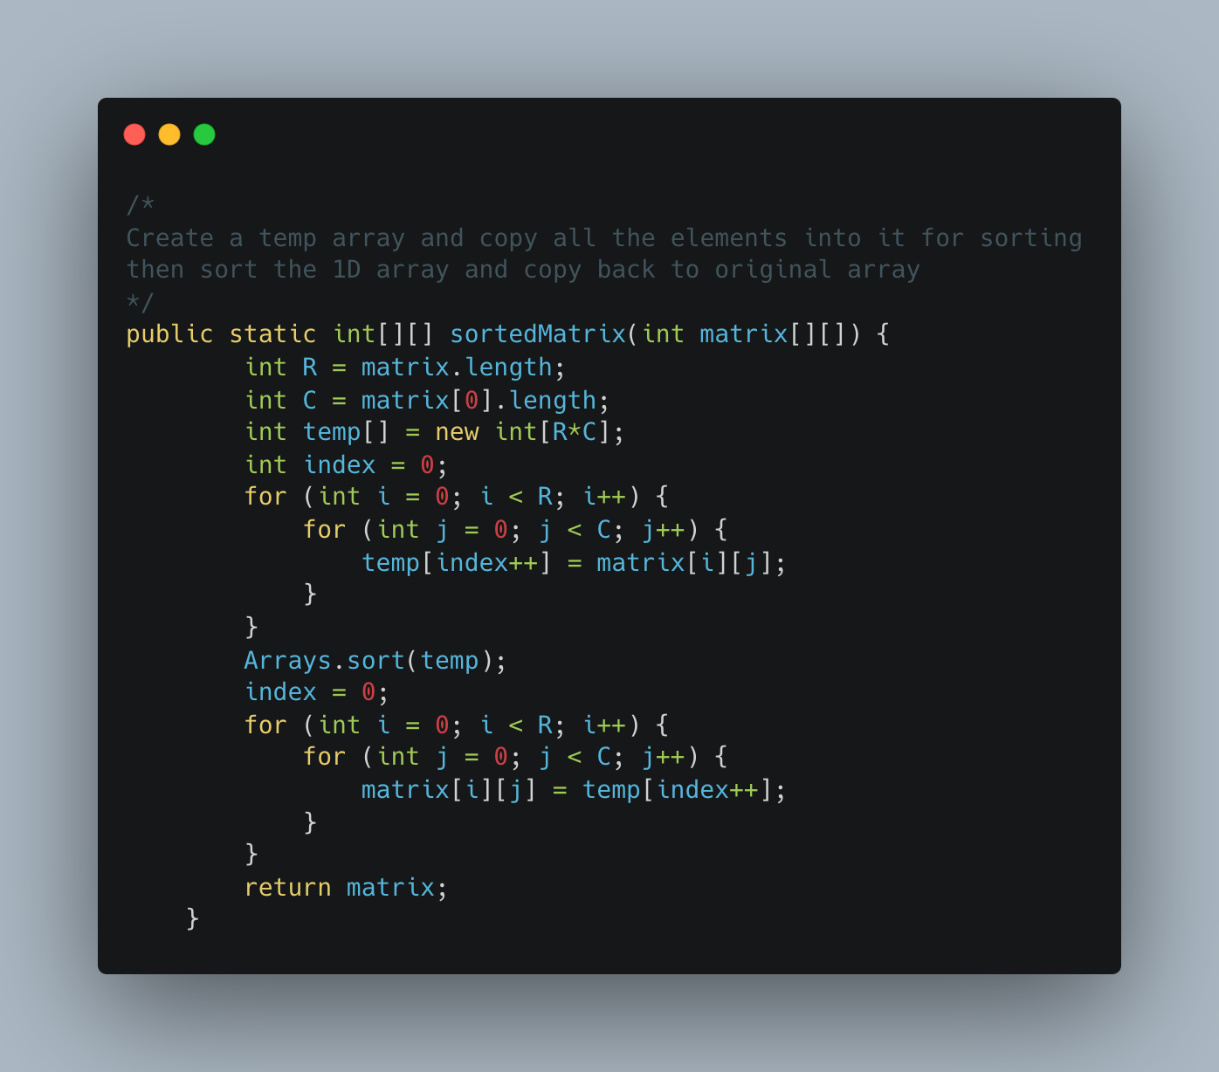

1. [Row with Max 1s](https://practice.geeksforgeeks.org/problems/row-with-max-1s0023/1)

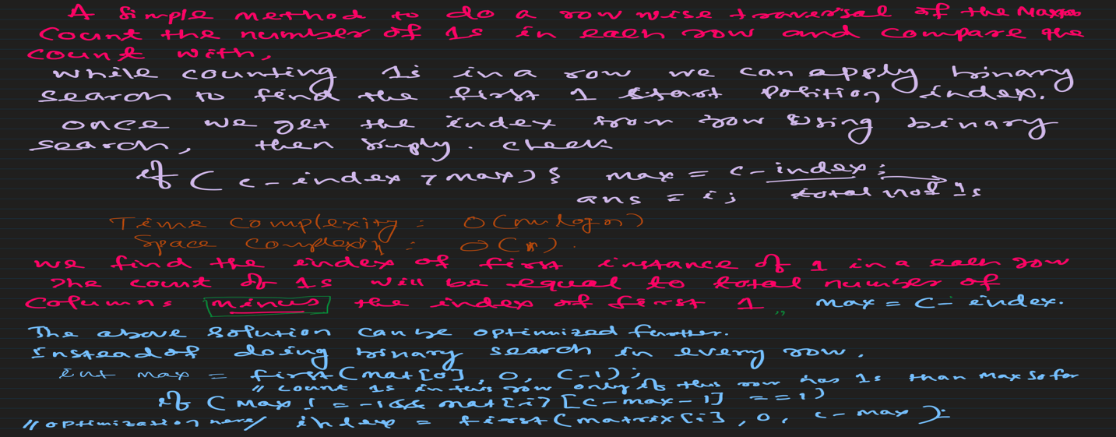

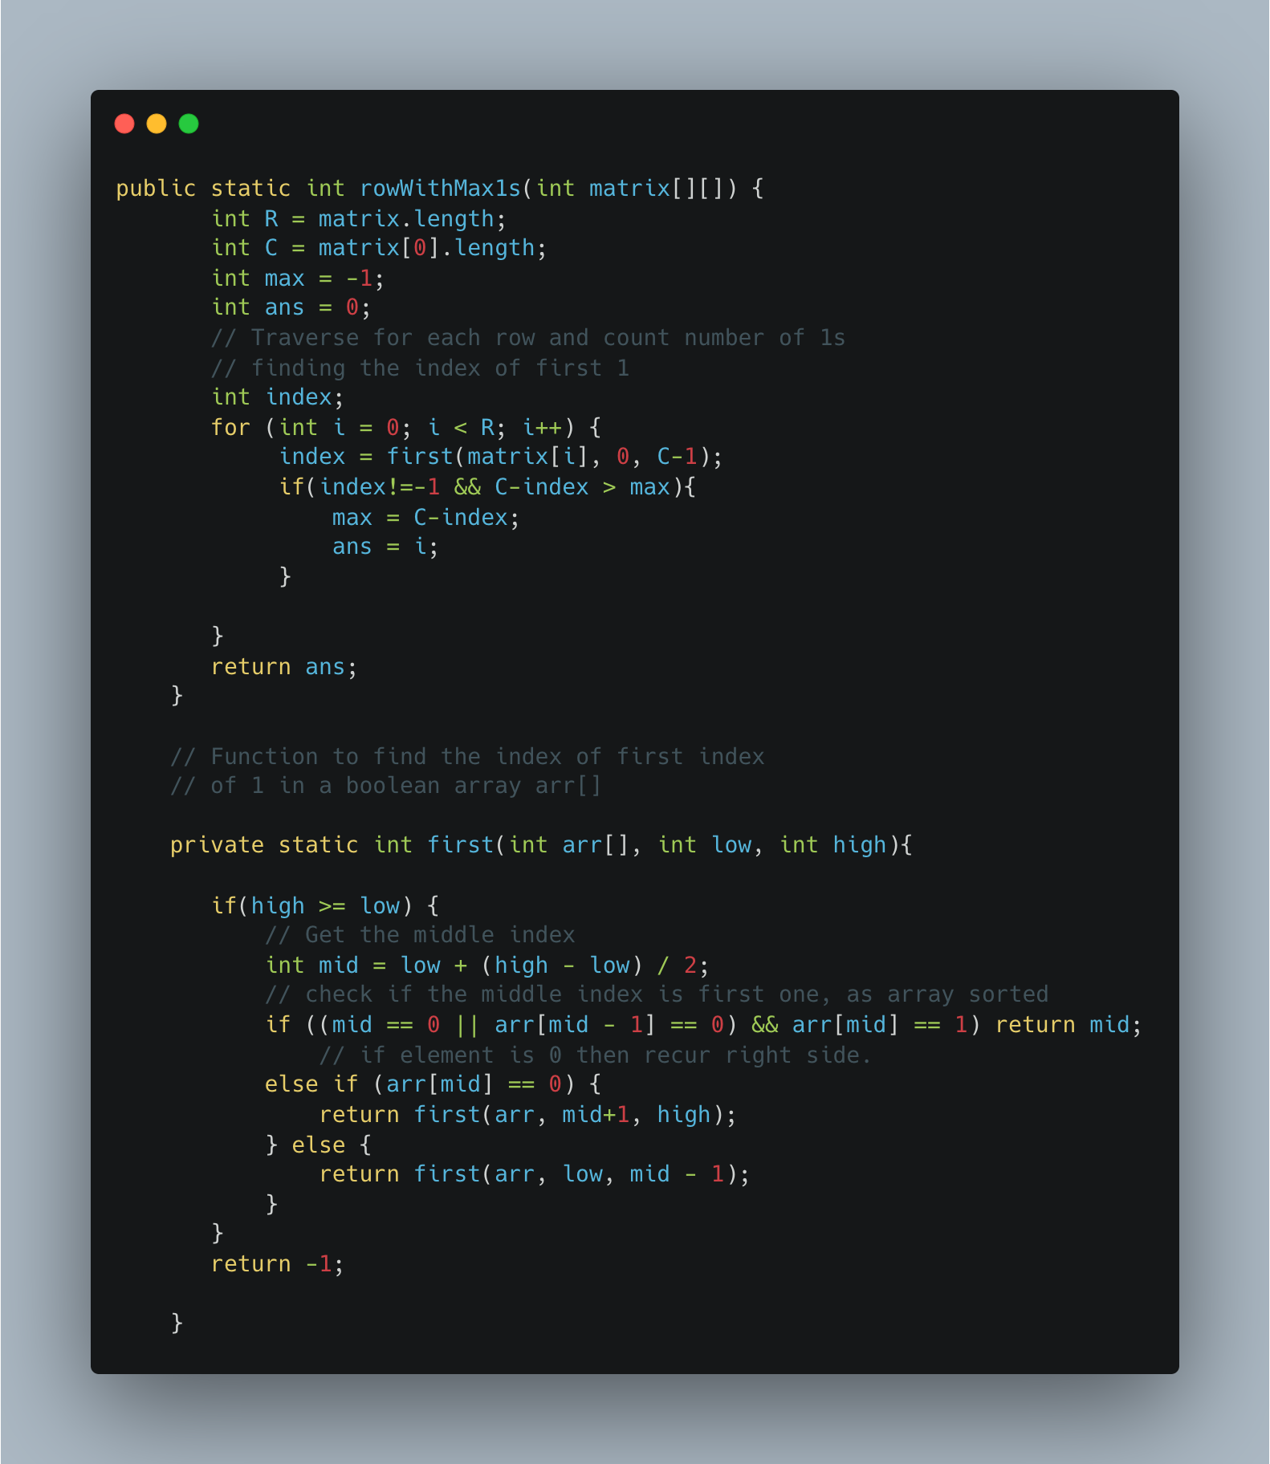

1. [Search a 2D Matrix](https://leetcode.com/problems/search-a-2d-matrix/)

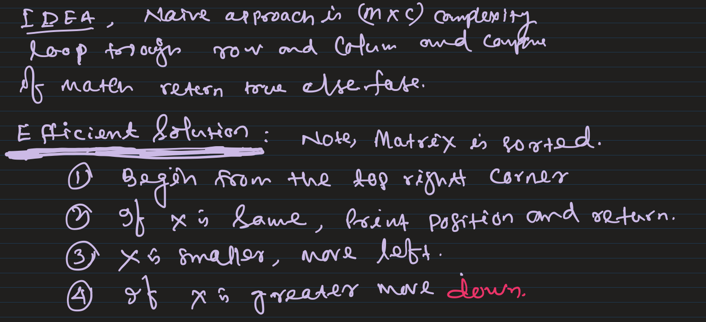

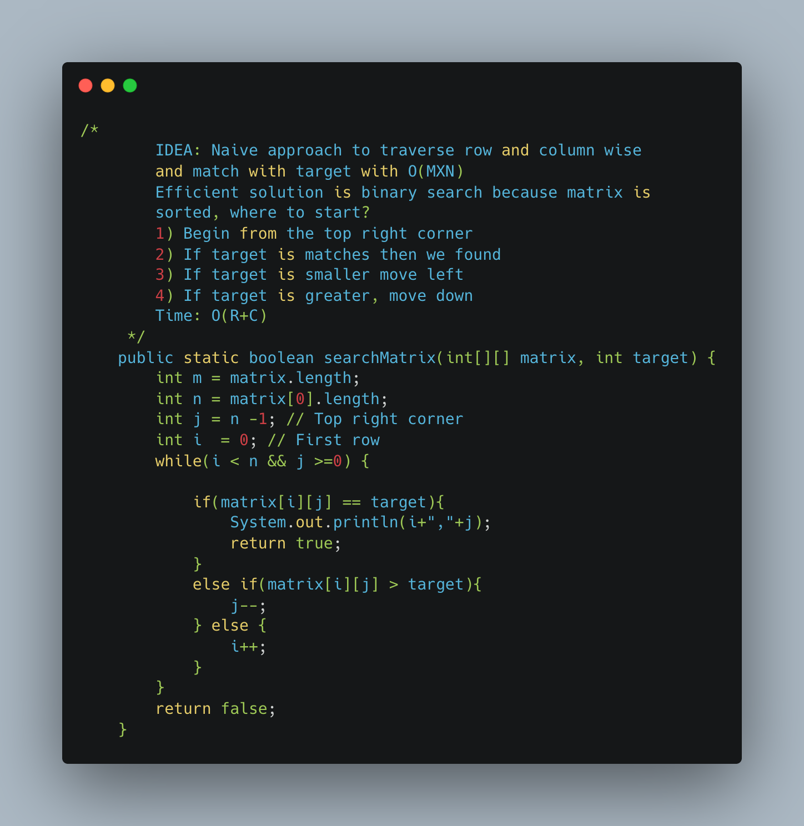

1. [Spirally Traversing a Matrix](https://practice.geeksforgeeks.org/problems/spirally-traversing-a-matrix-1587115621/1)

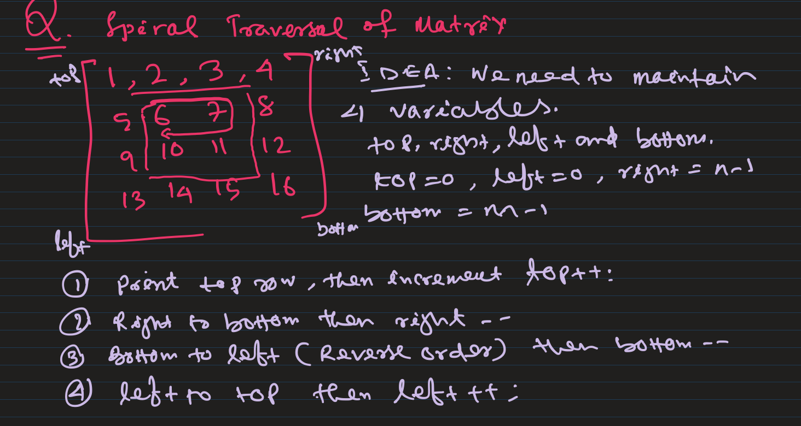

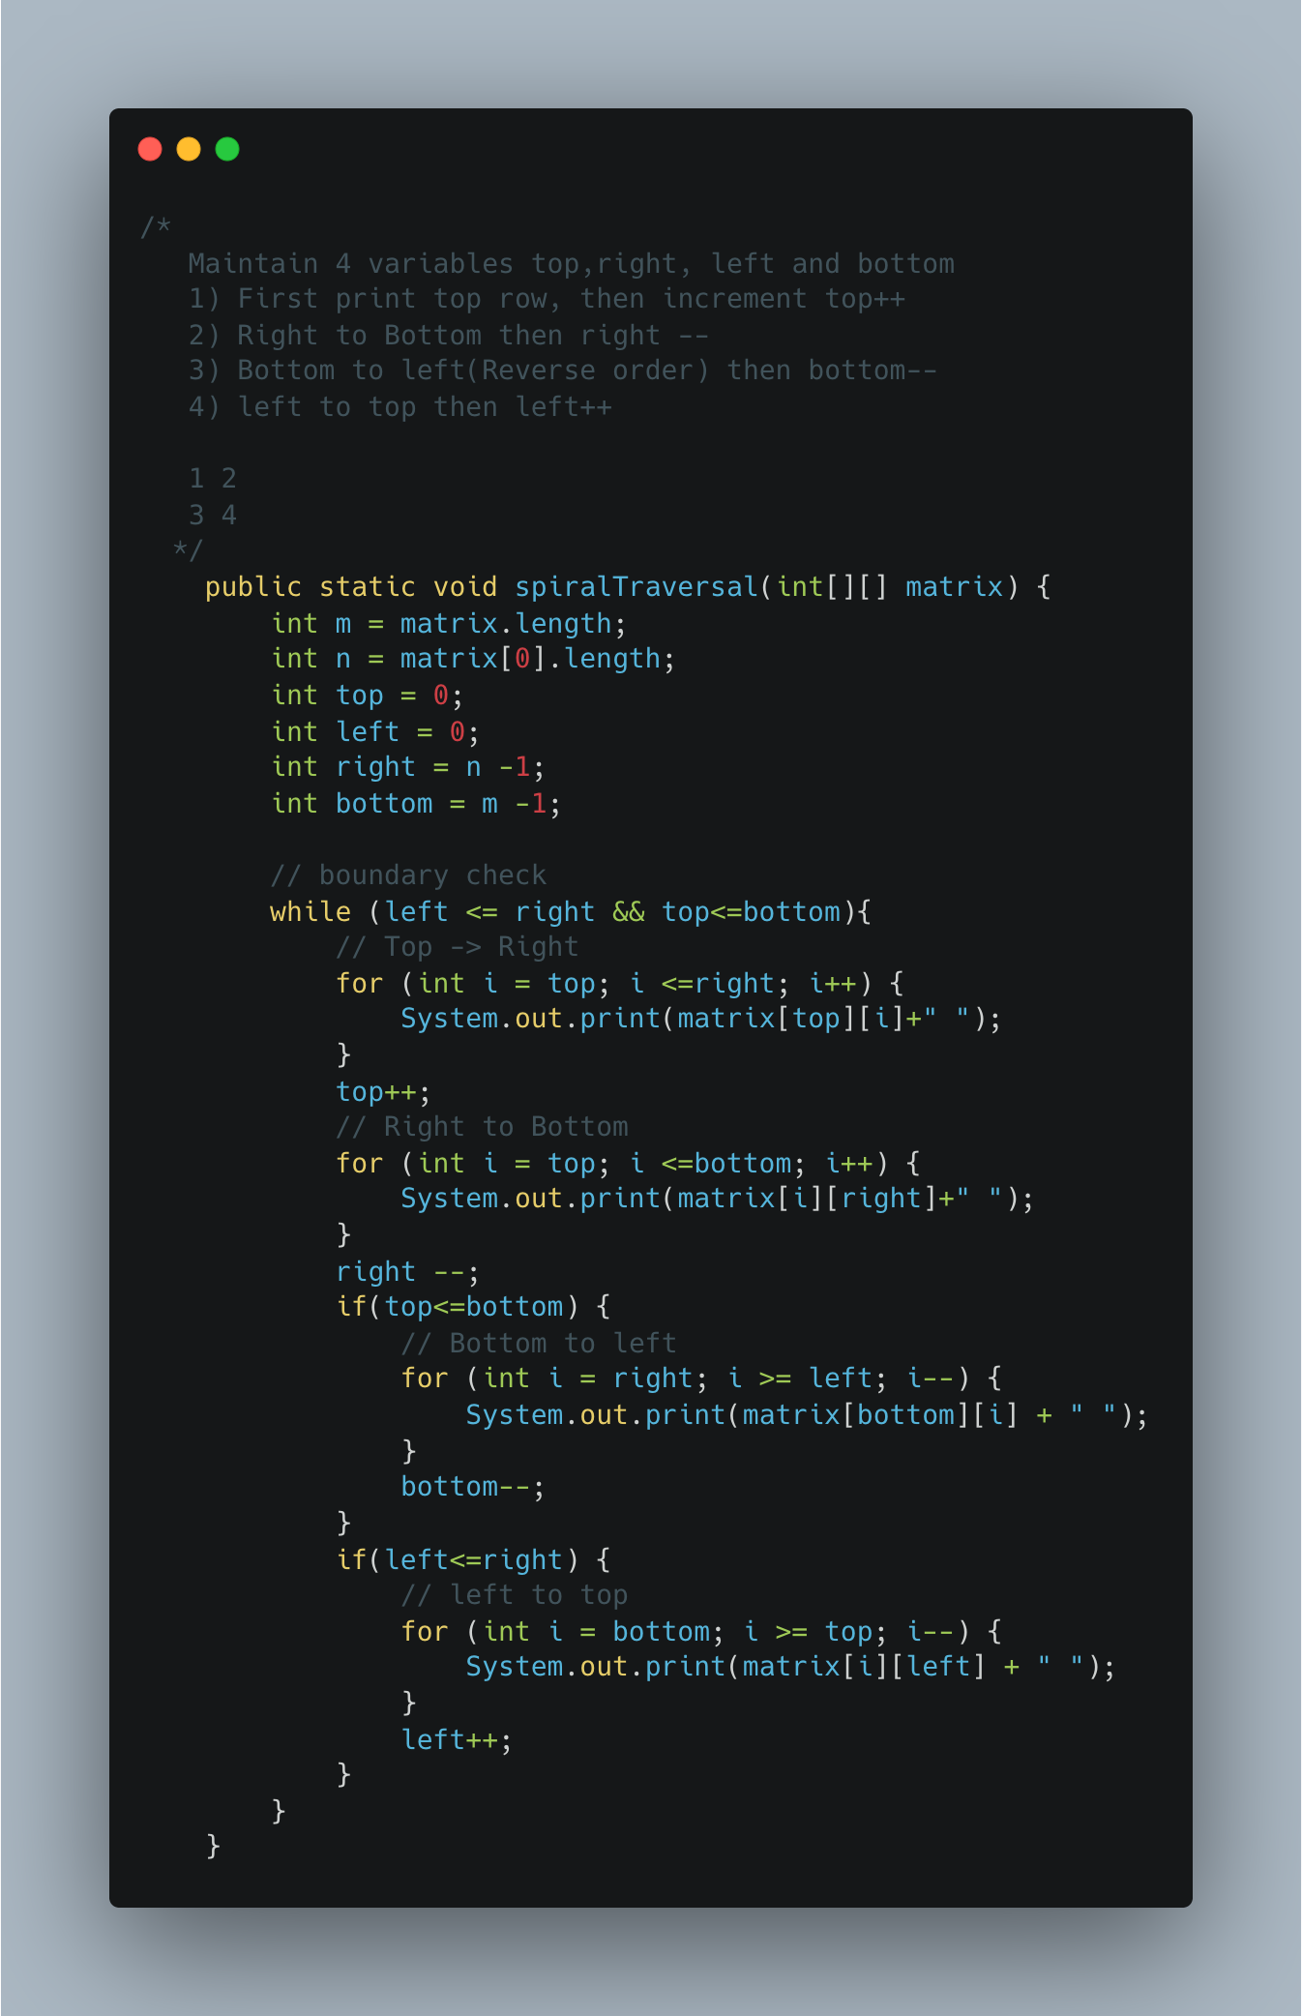

1. Transpose a Matrix

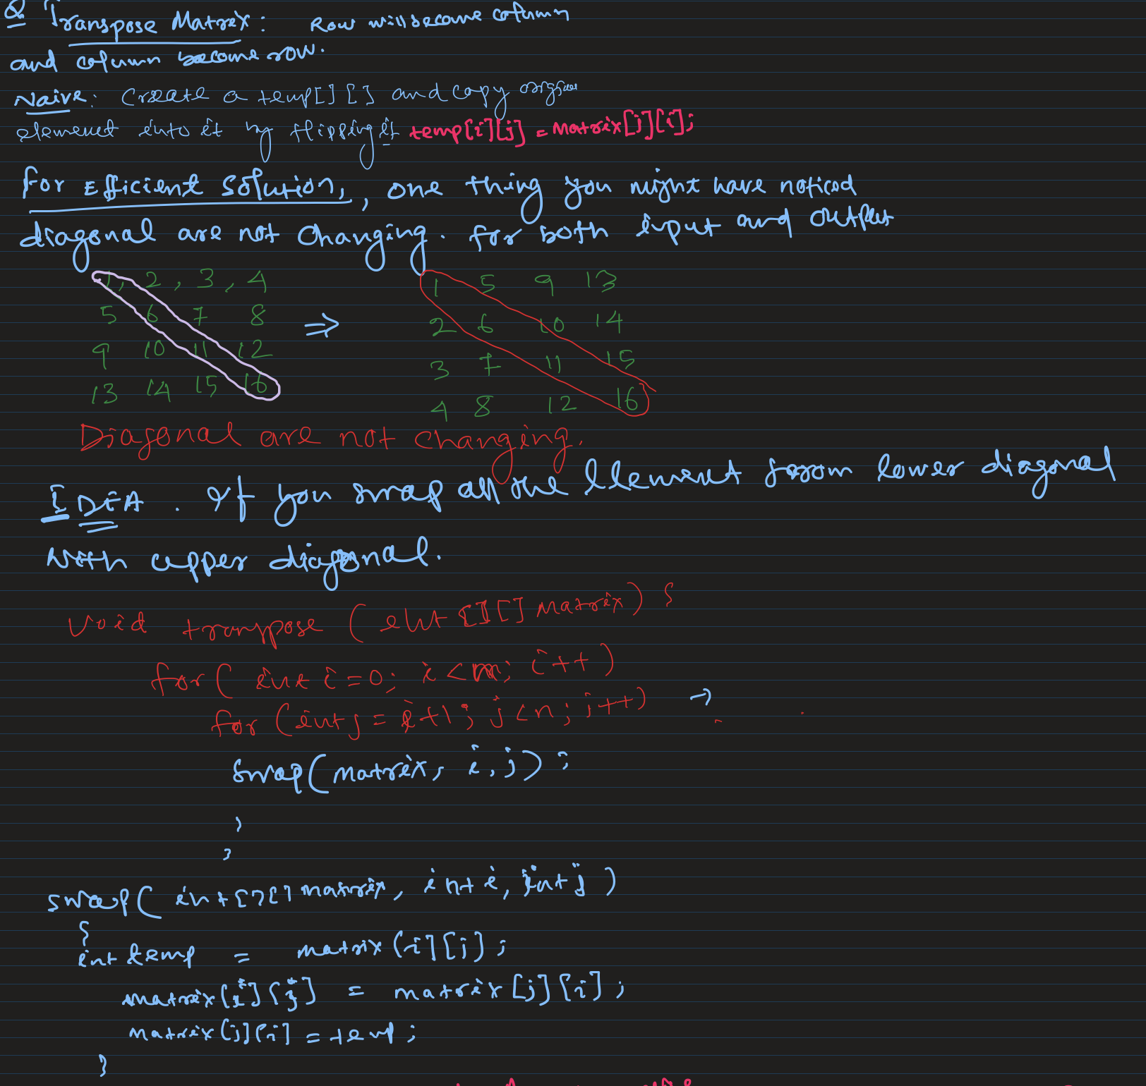

1. Rotate Matrix by 90* Anticlockwise

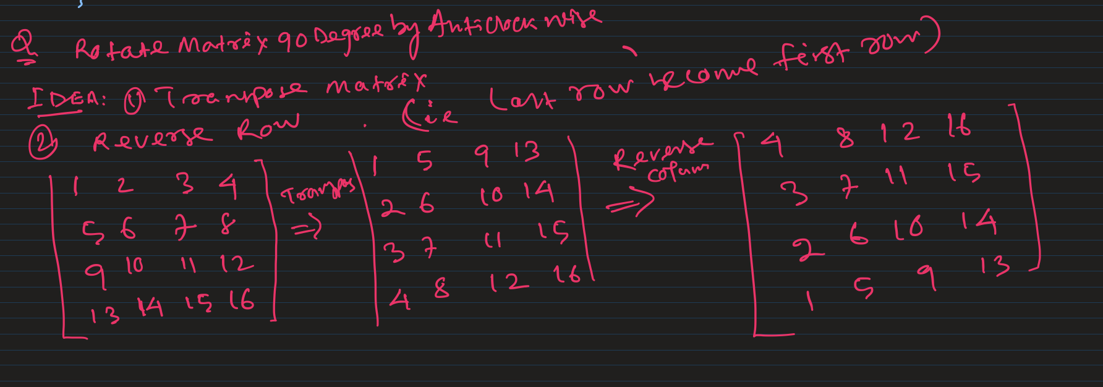

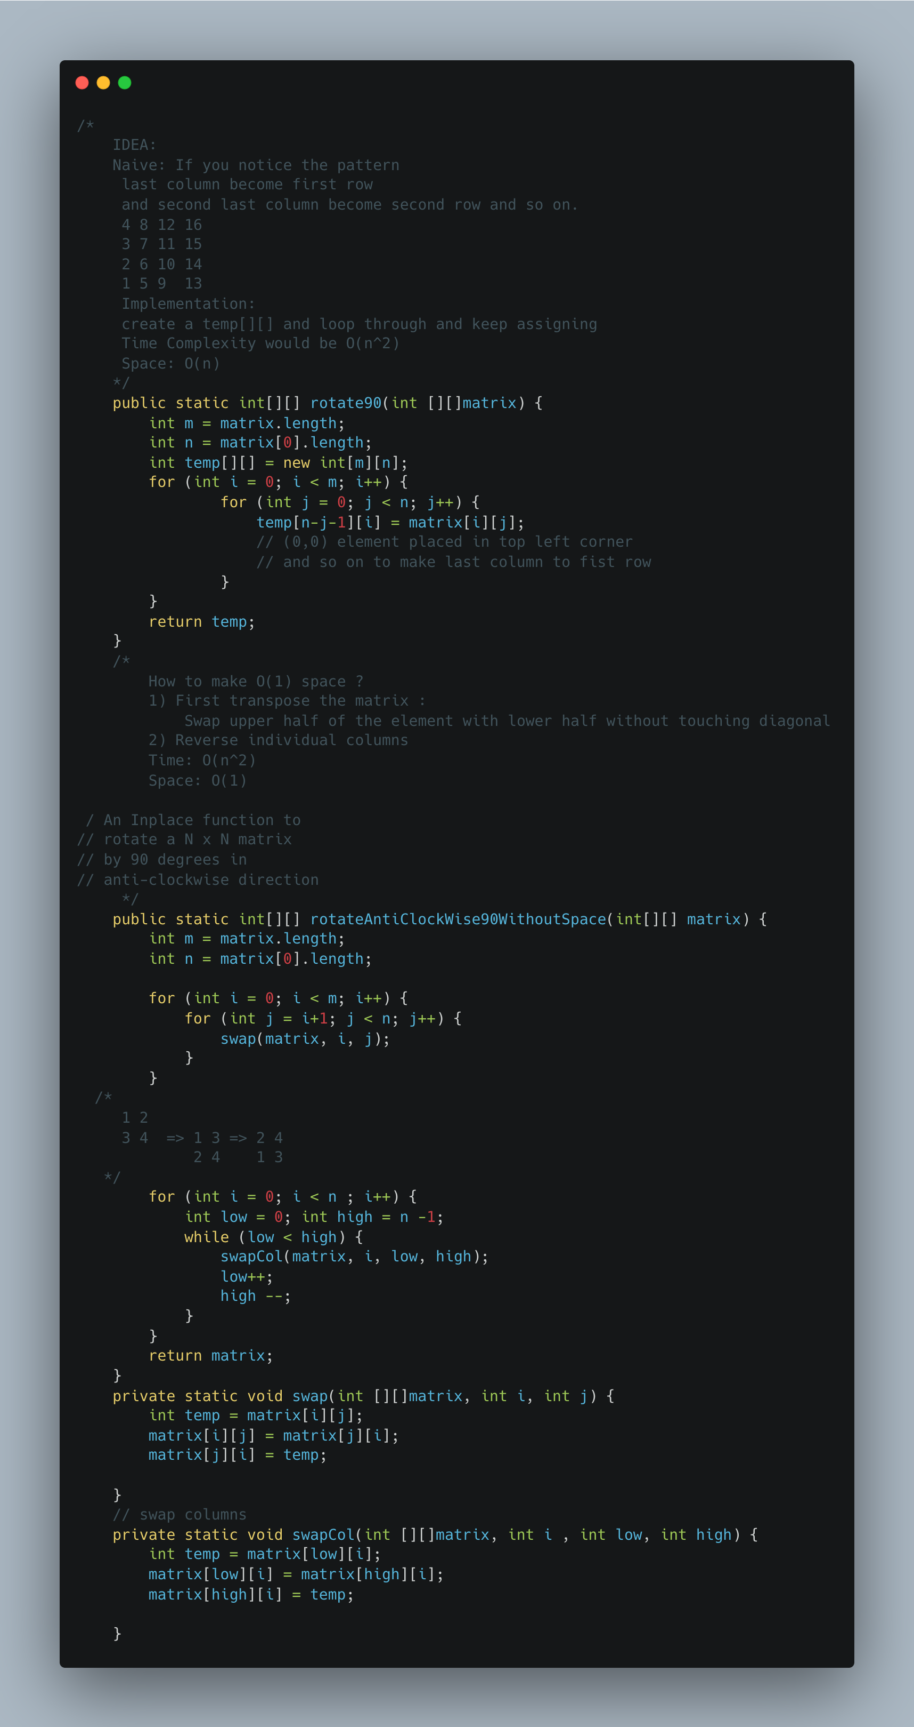

1. [Rotate a matrix by 90 Degree Clockwise](https://www.geeksforgeeks.org/rotate-a-matrix-by-90-degree-in-clockwise-direction-without-using-any-extra-space/)

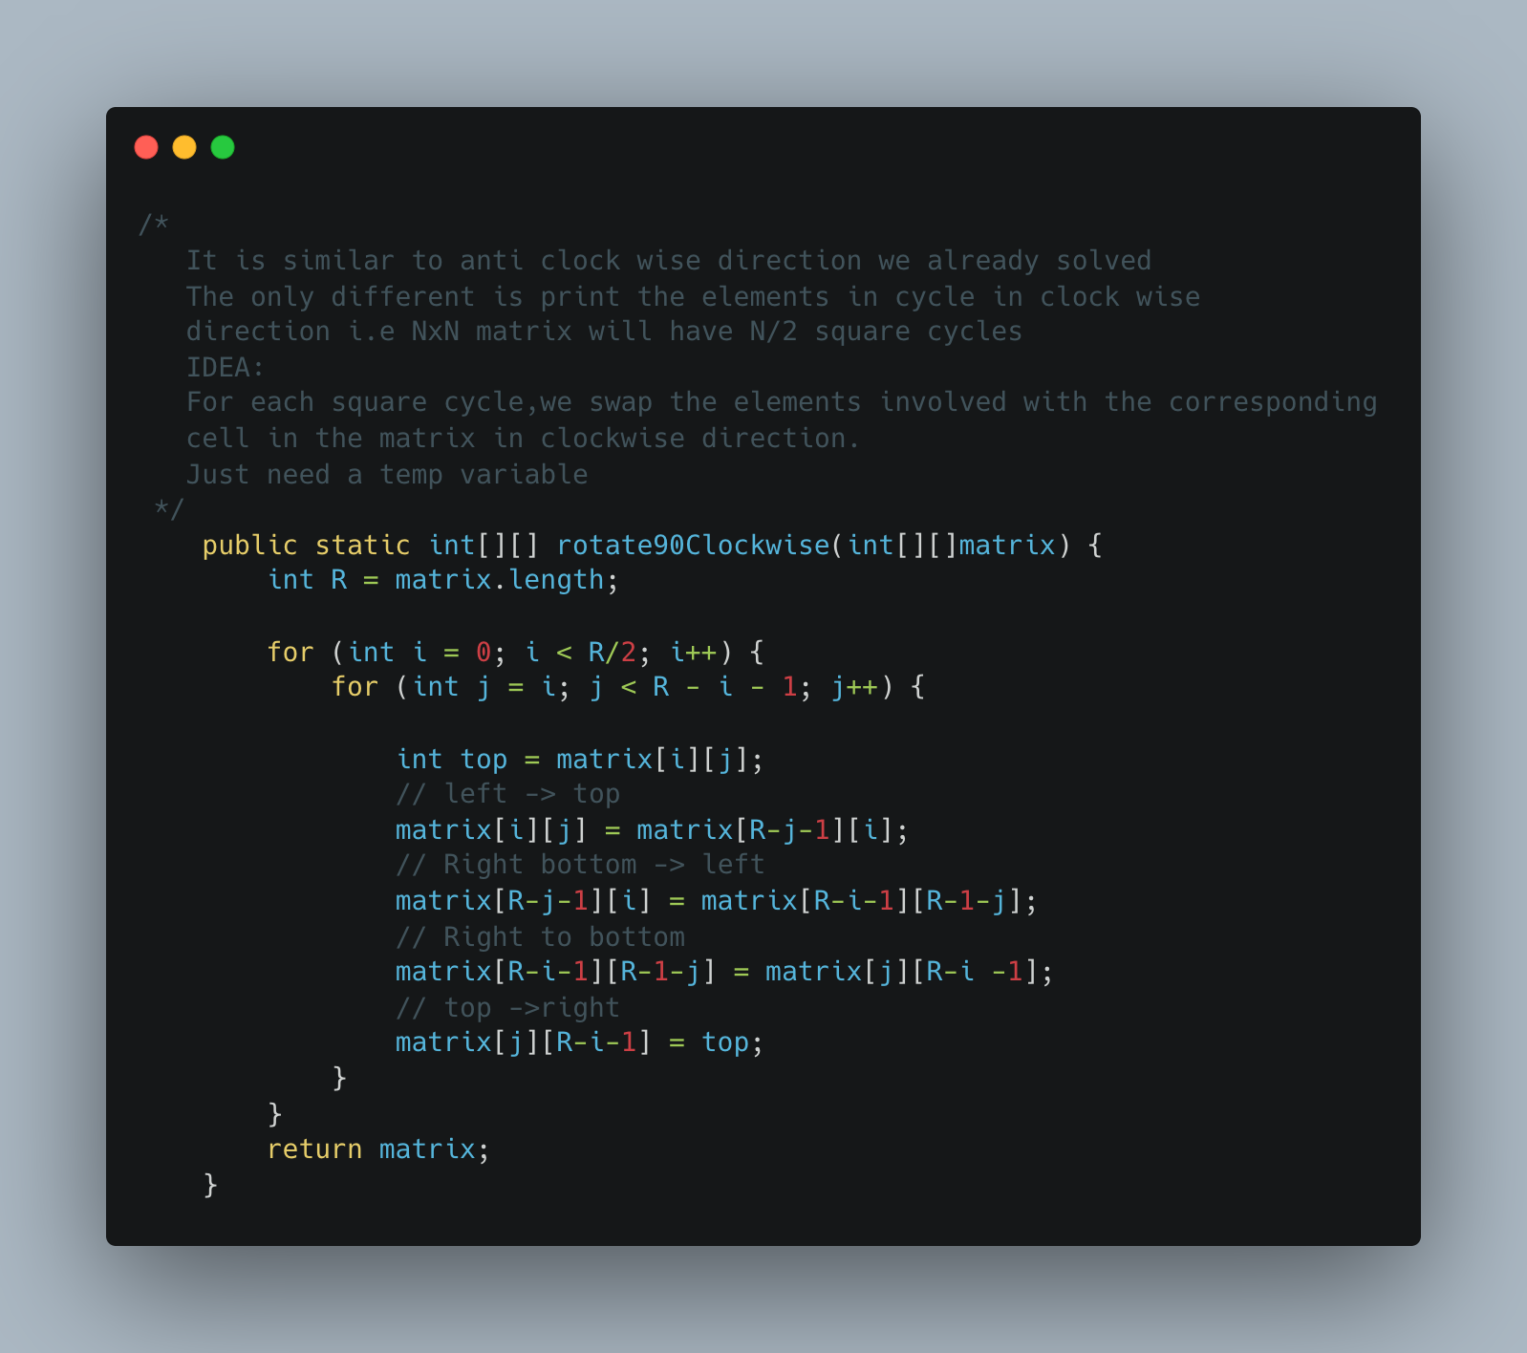

1. [Diagonal Traverse](https://leetcode.com/problems/diagonal-traverse/)

Refer: <https://www.youtube.com/watch?v=NTF7sDU0IWA>

No Direction Check, the key is here to realize that the sum of indices on all diagonals are equal.

[1 2 3]

[4 5 6]

[7 8 9]

2, 4 are on same diagonal, and they share the index sum 1. (2 is matrix[0][1] and 4 is in matrix[1][0]. 3,5 7 are on the same diagonal, and they share the sum of 2.(3 is matrix[0][2], 5 is matrix[1][1], and 7 is matrix [2][0])

So, if you can loop through the matrix, store each element by the sum of its indices in a dictionary, you have a collection of all elements on shared diagonals.

The last part is easy, build your answer (a list) by elements on diagonals. To capture the zig-zag or snake phenomena of this problem, simply reverse every other diagonal level, so check if the level is divisible by 2

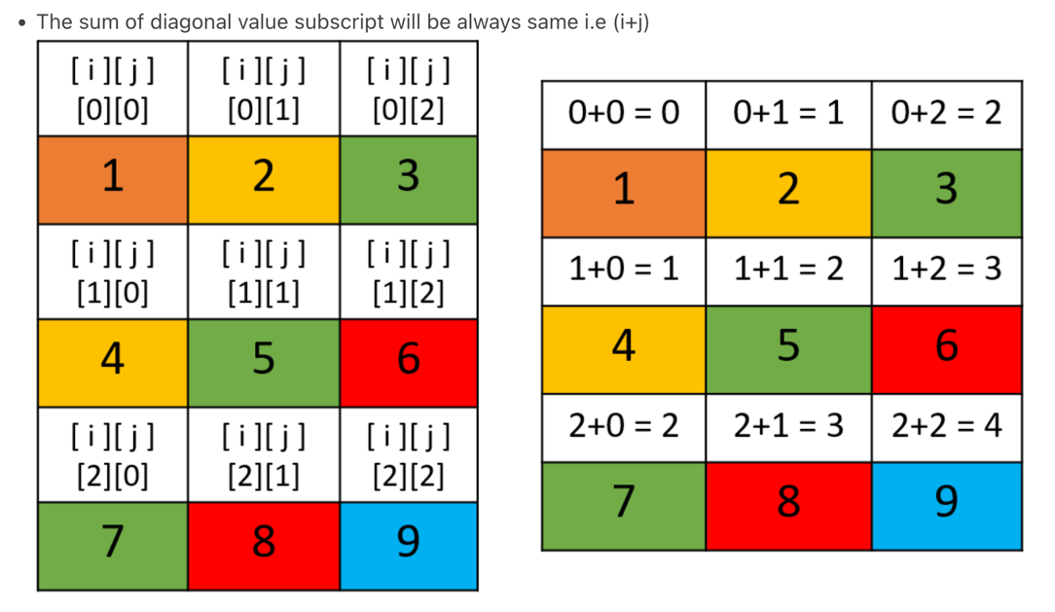

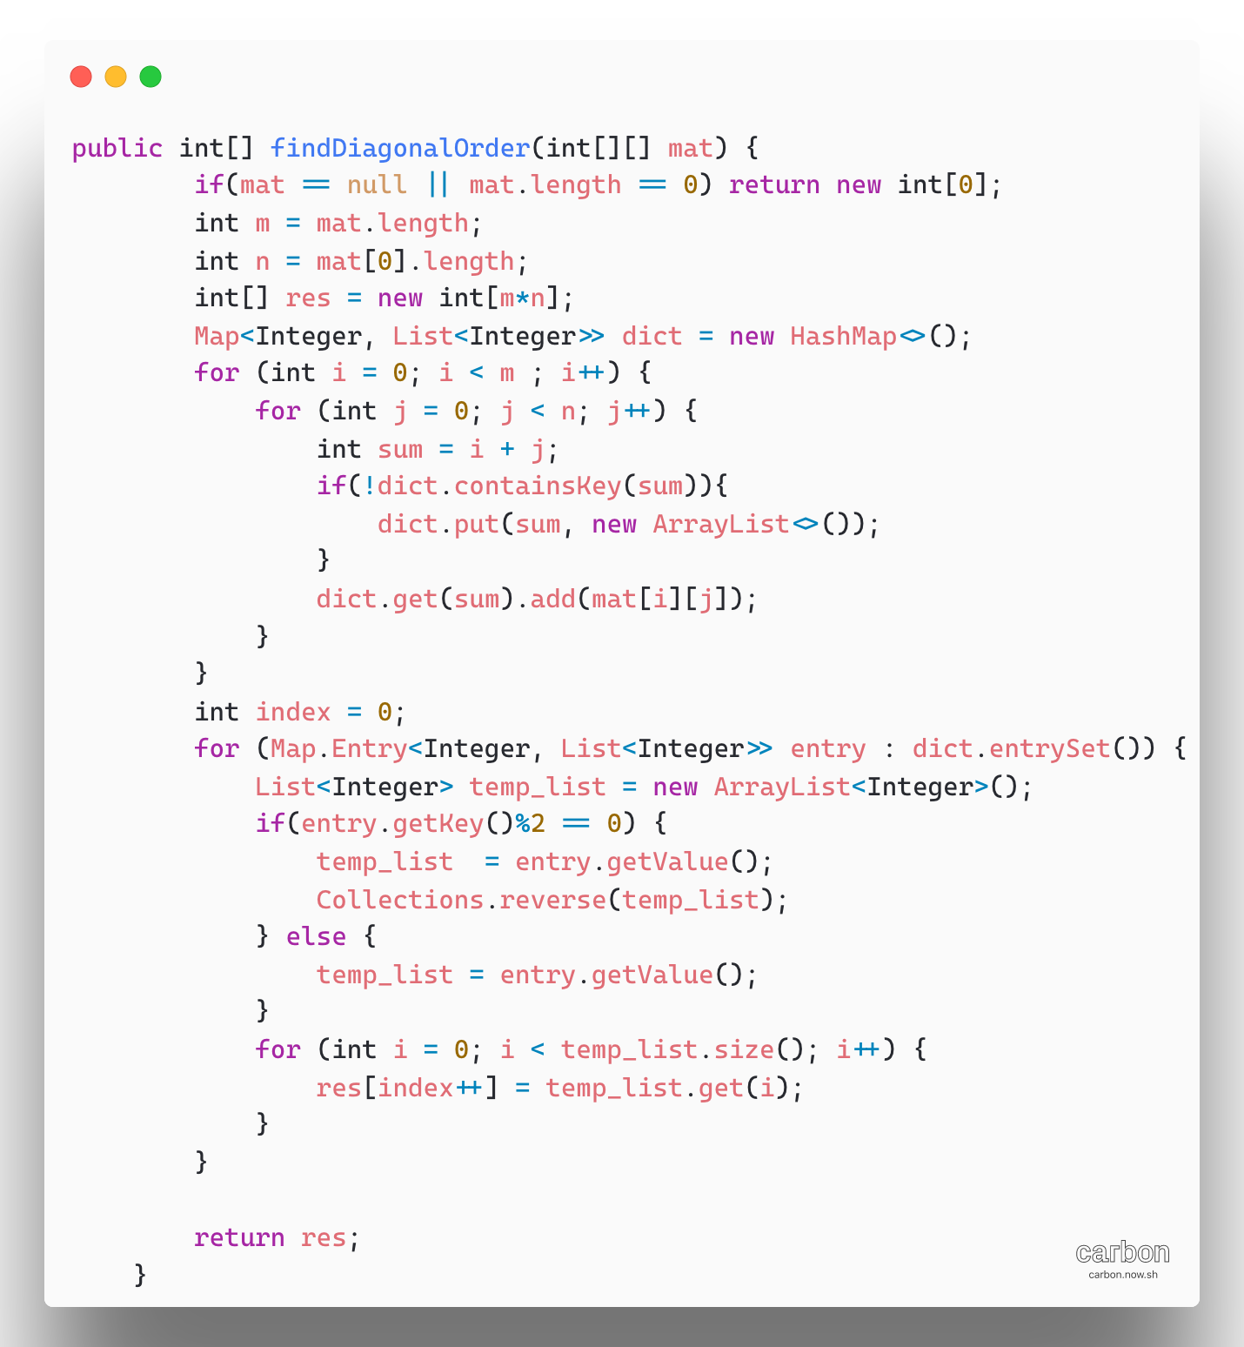

1. [Lemonade Change](https://leetcode.com/problems/lemonade-change/)

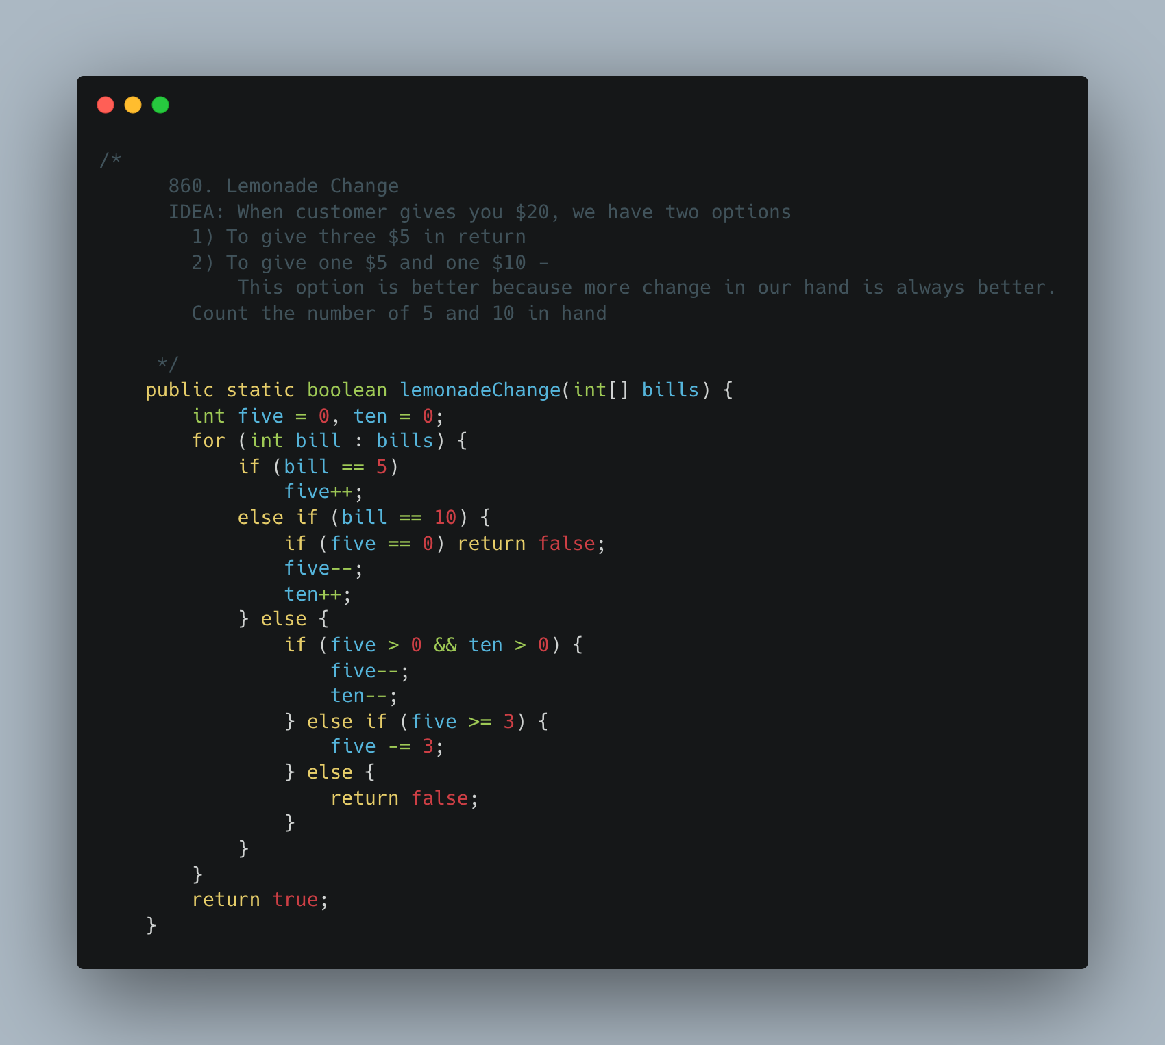

1. [Keys and Rooms](https://leetcode.com/problems/keys-and-rooms/)

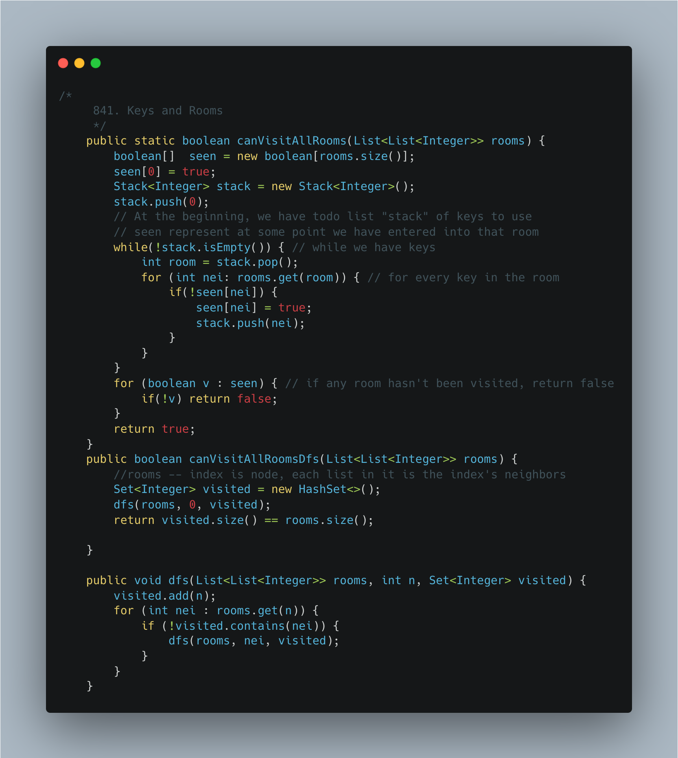

1. [Largest Rectangle](https://leetcode.com/problems/largest-rectangle-in-histogram/)

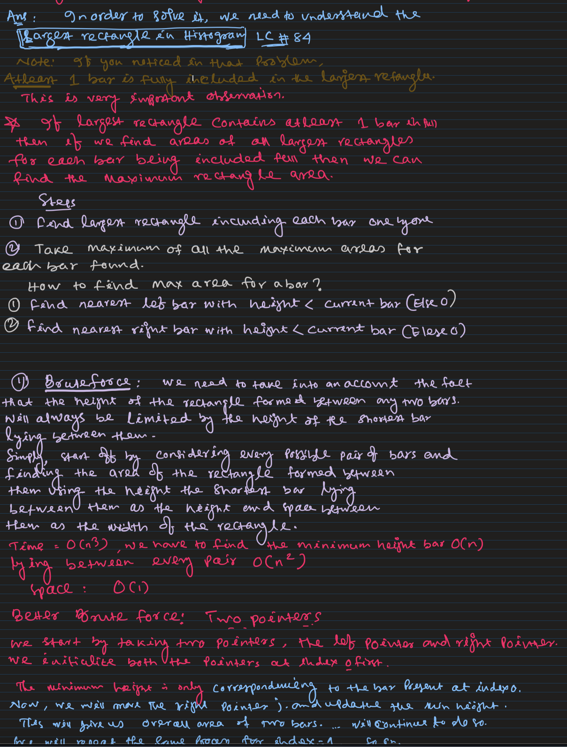

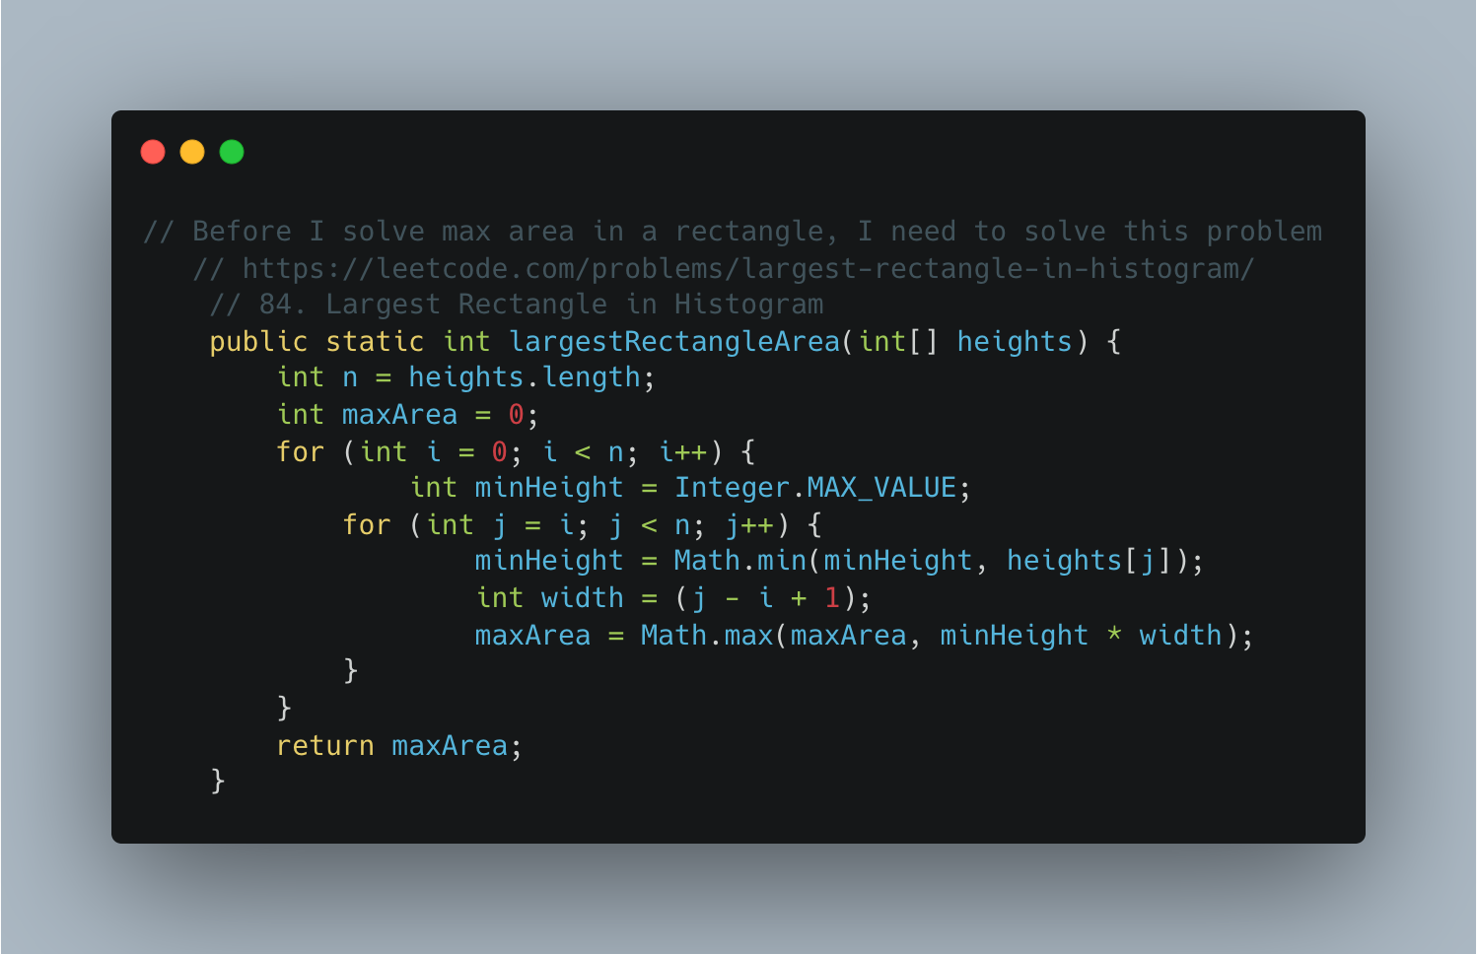

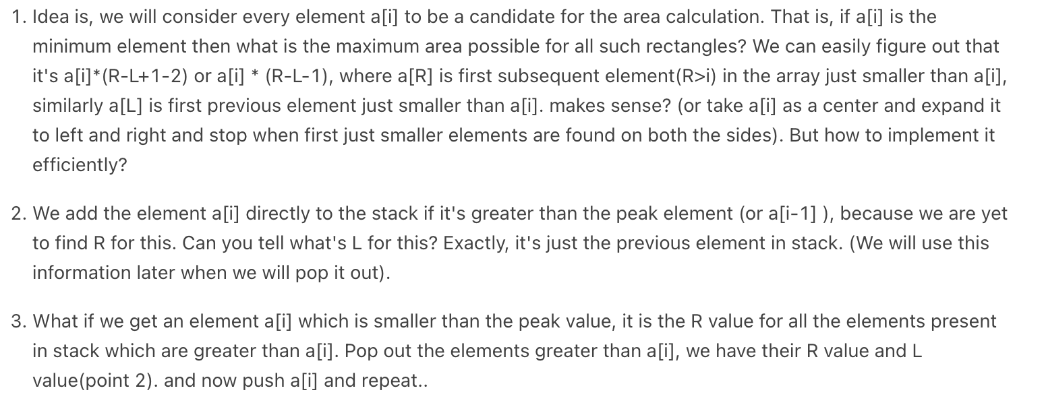

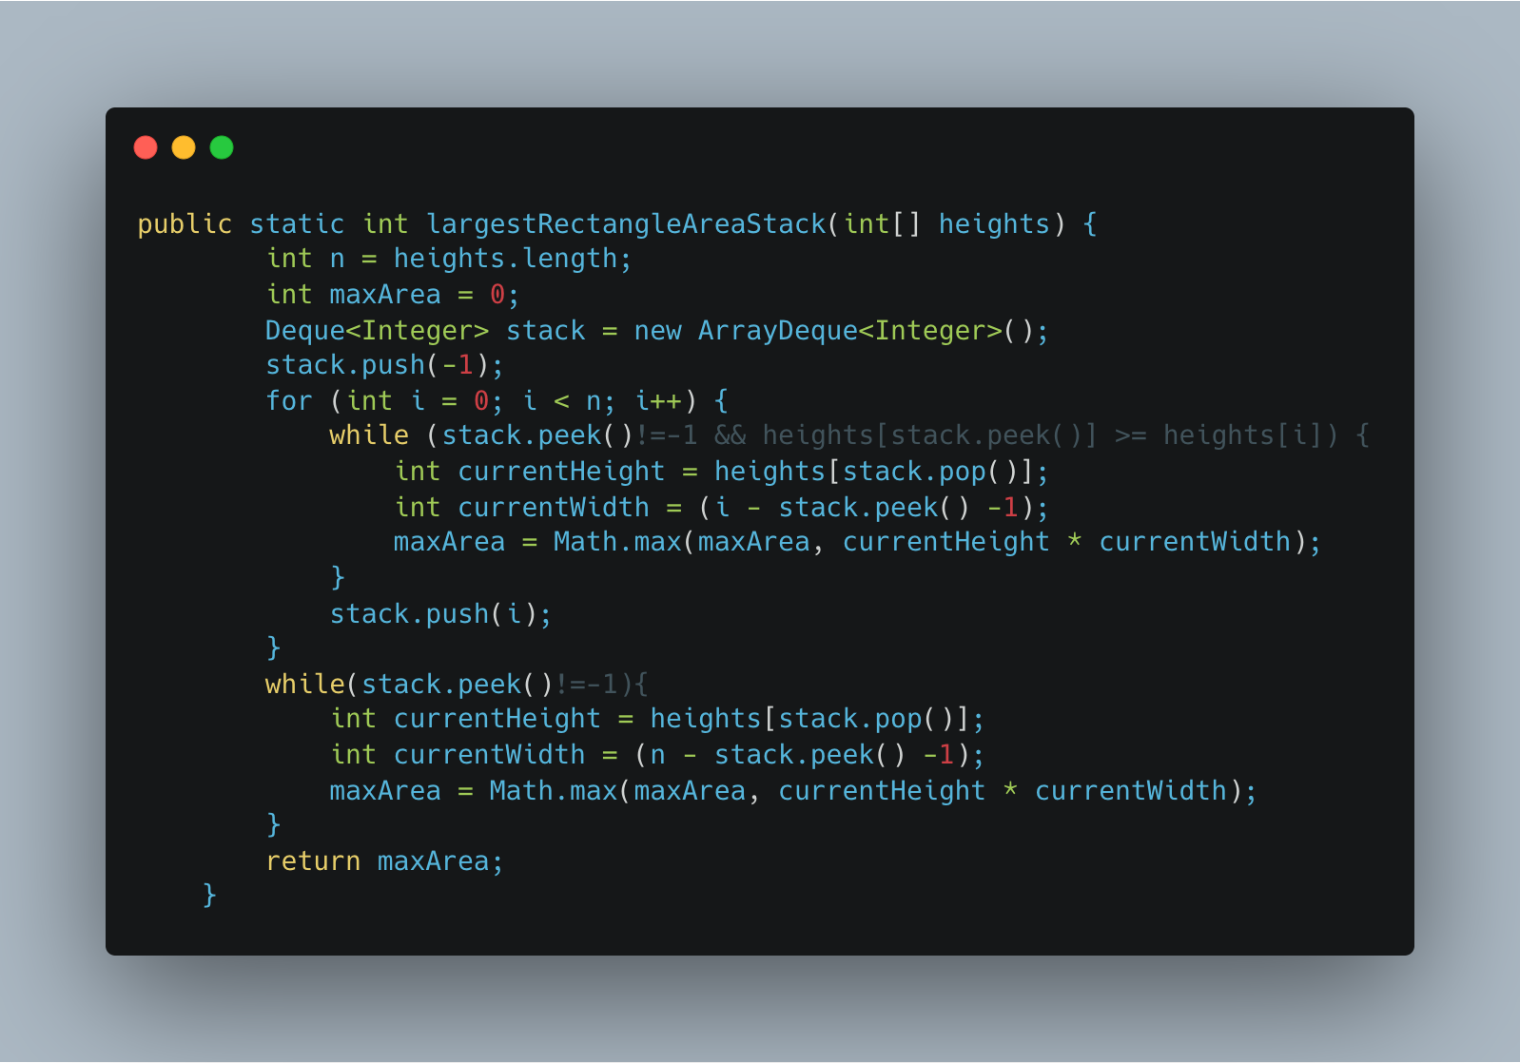

1. [Max Rectangle](https://practice.geeksforgeeks.org/problems/max-rectangle/1)

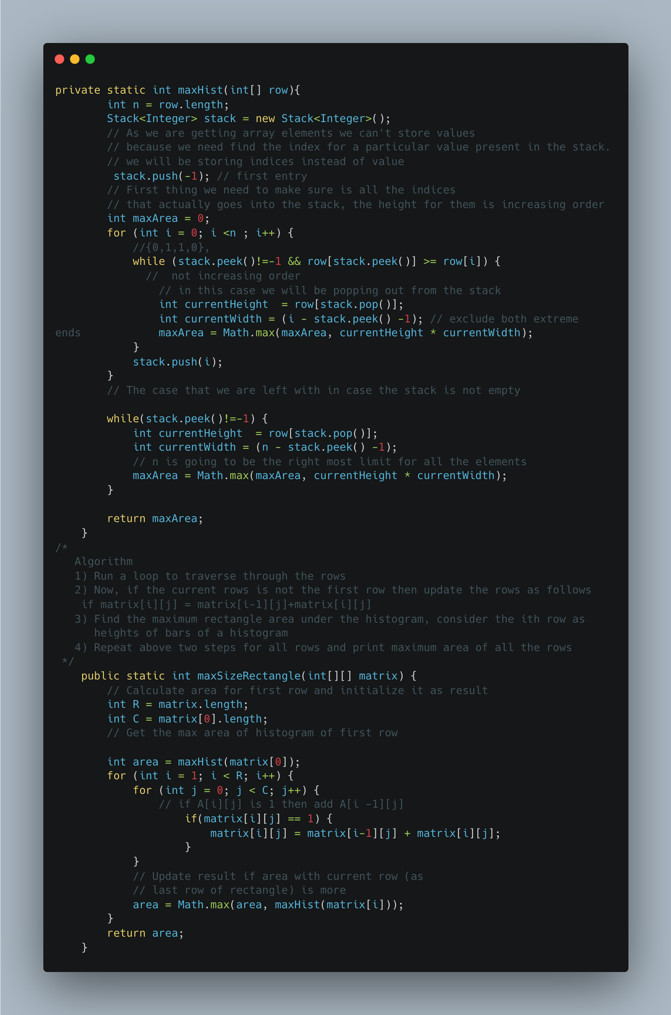

1. Find Median of row wise sorted matrix

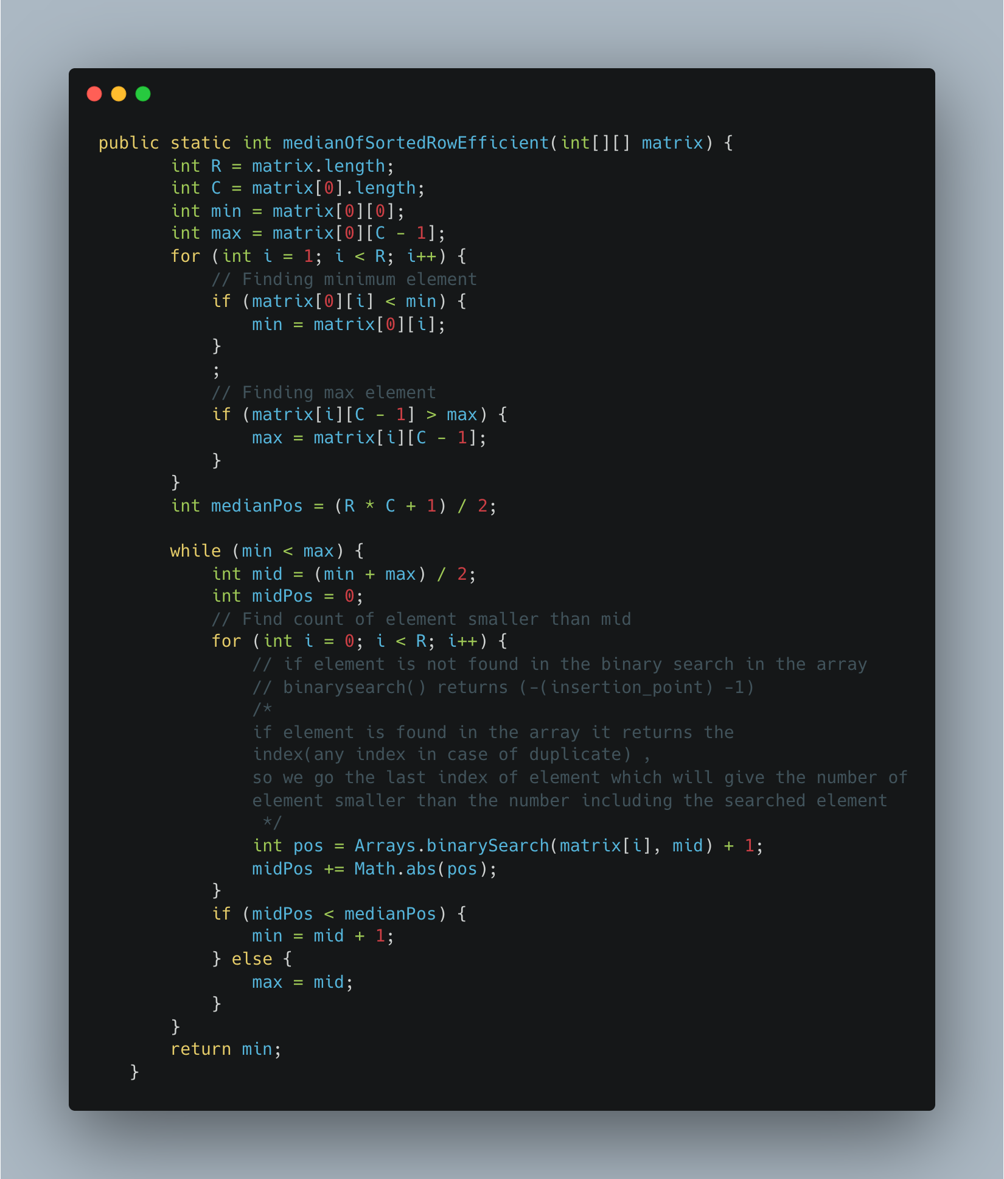

1. Find a subarray with given sum

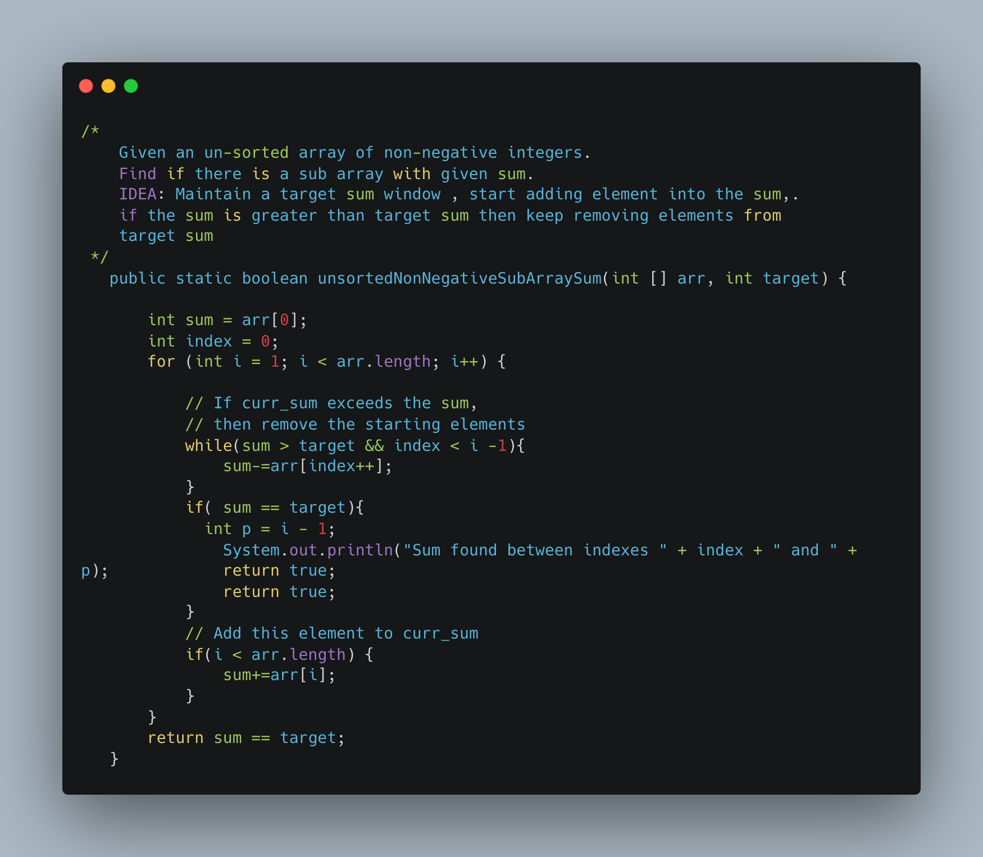

1. [Find Valid Matrix Given Row and Column Sums](https://leetcode.com/problems/find-valid-matrix-given-row-and-column-sums/)

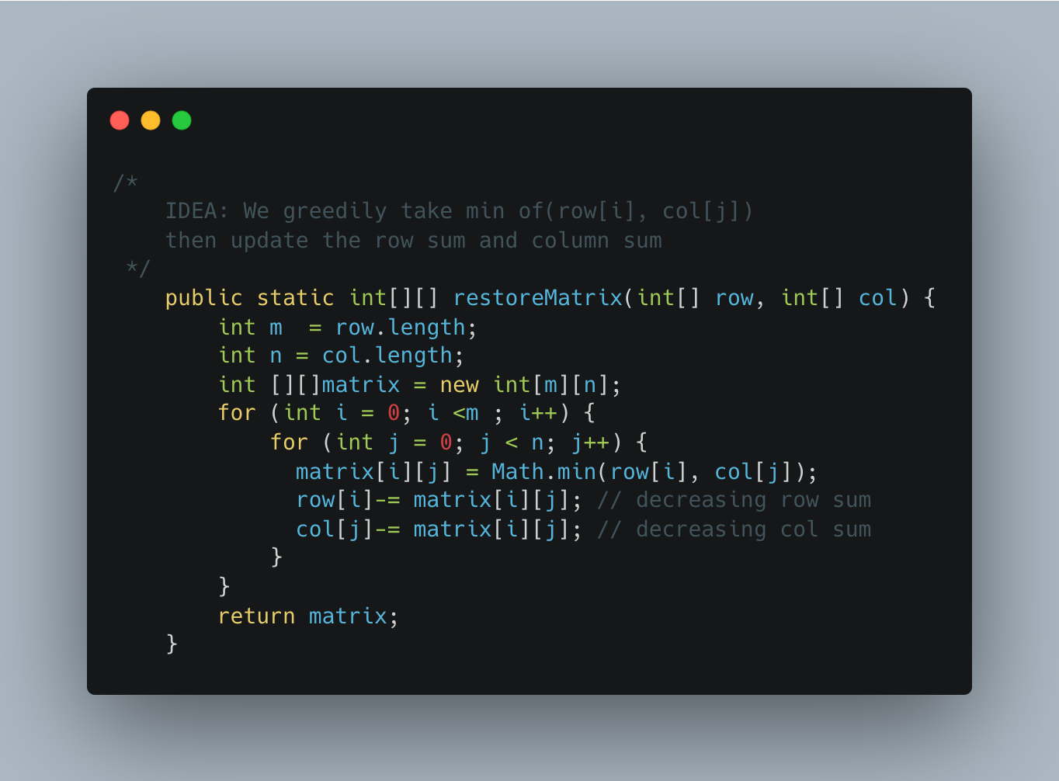

1. [Reorder Data in log Files](https://leetcode.com/problems/reorder-data-in-log-files/)

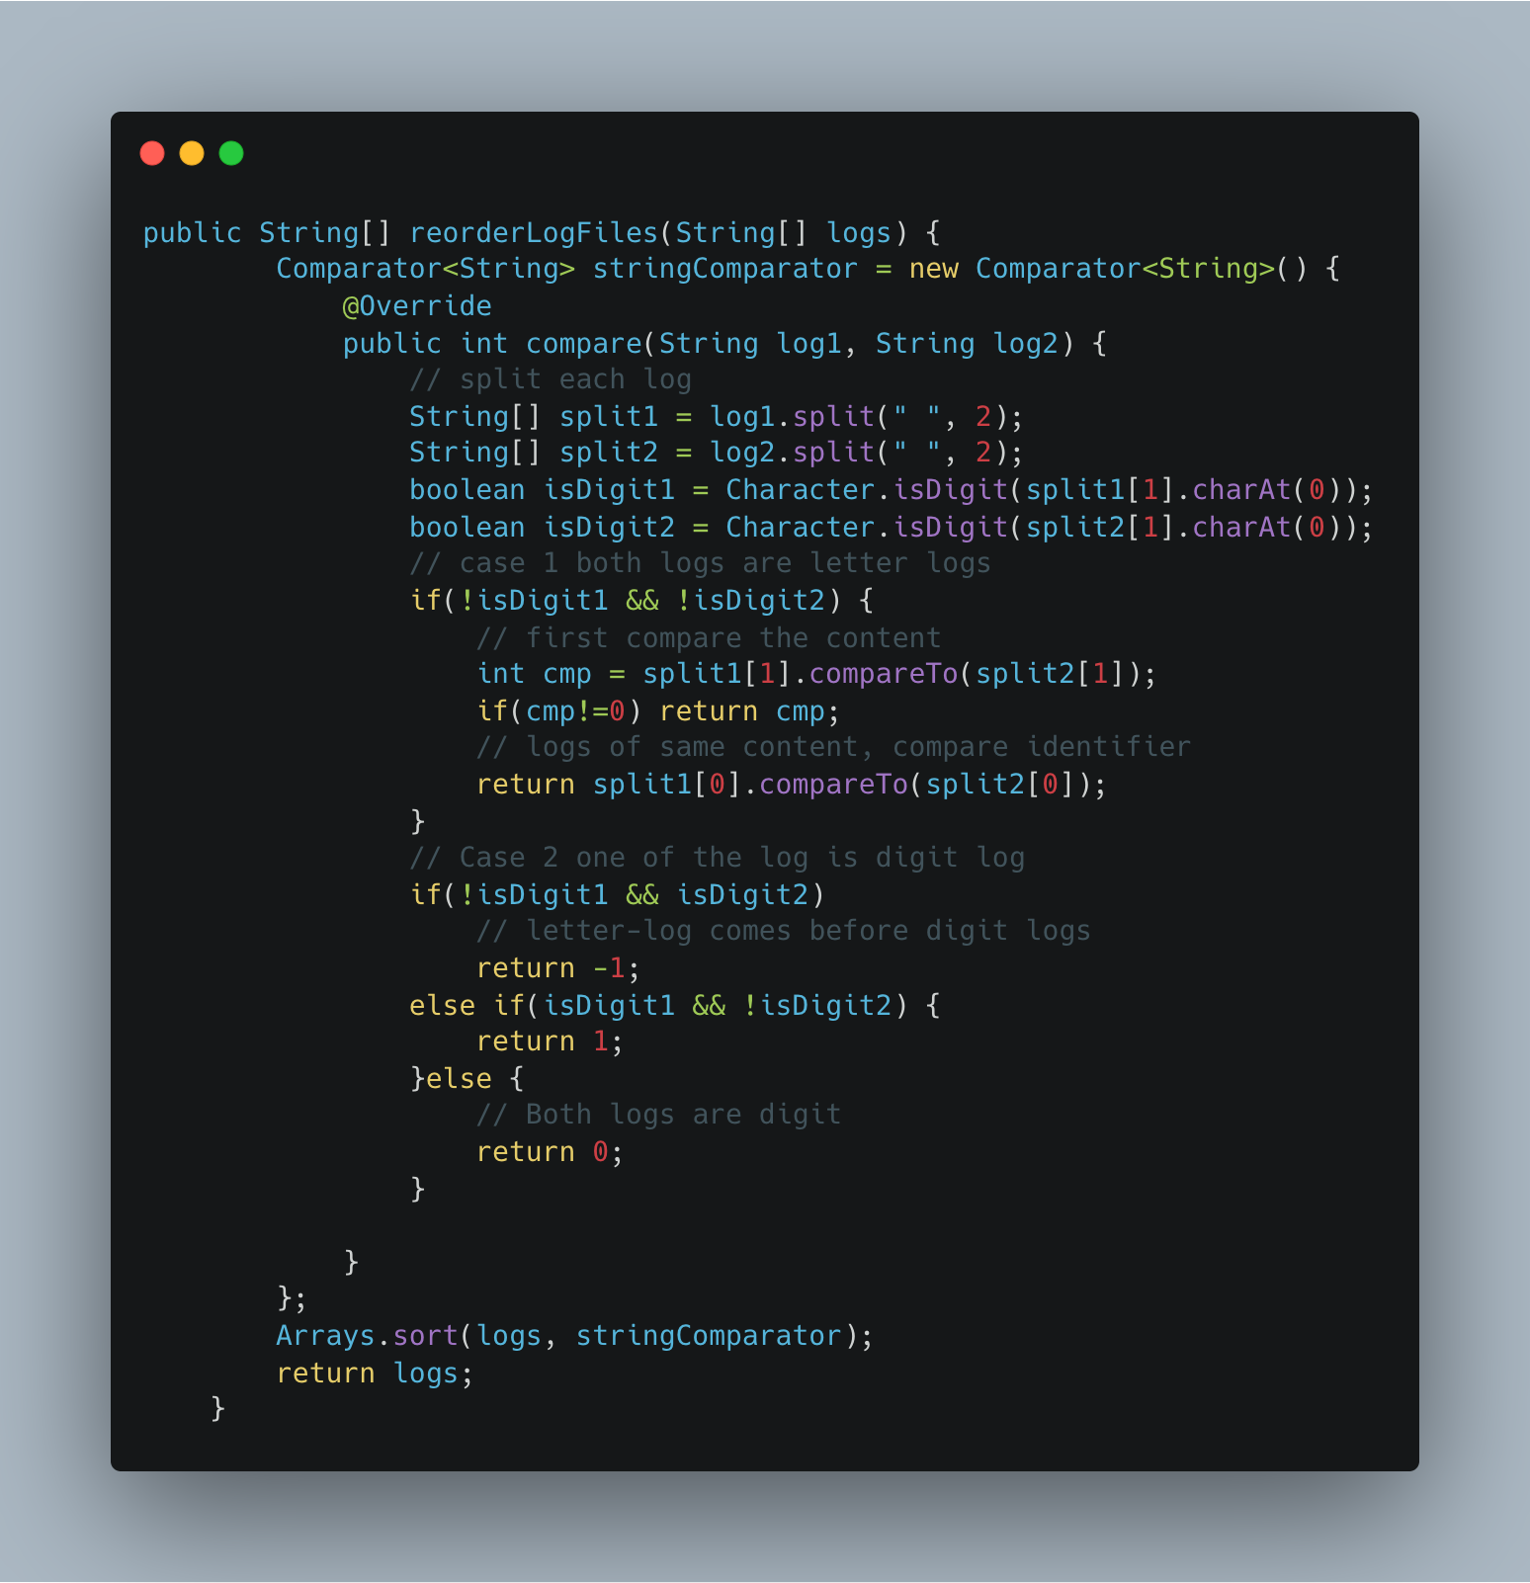

1. [Capacity to Ship Packages Within D Days](https://leetcode.com/problems/capacity-to-ship-packages-within-d-days/)

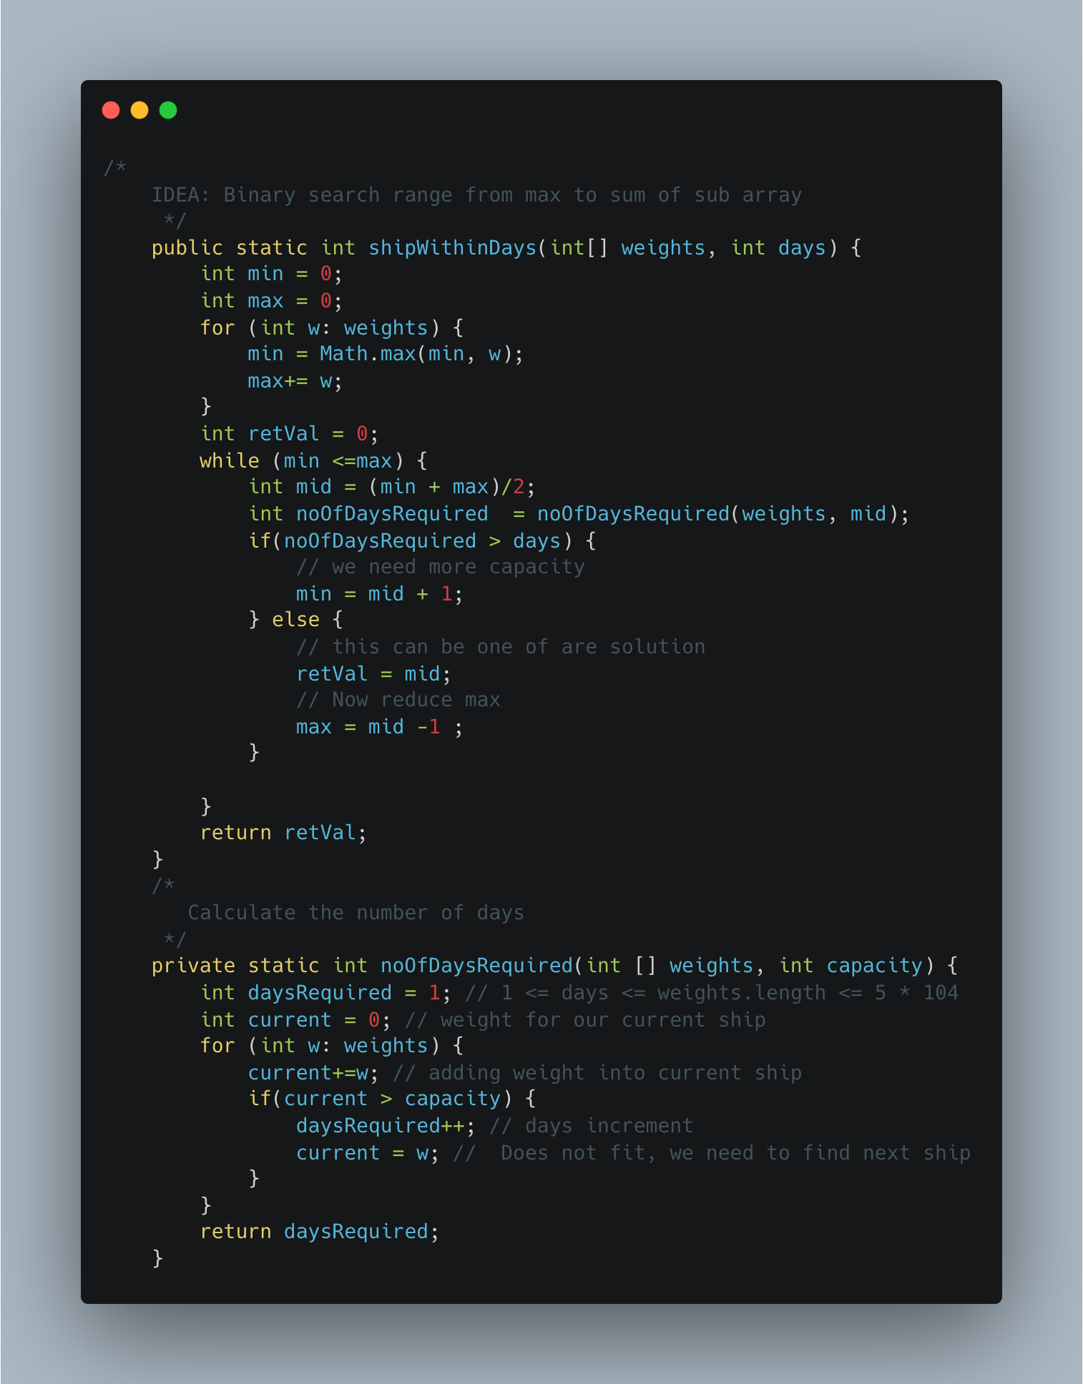

**STRINGS**

1. [1189. Maximum Number of Balloons](https://leetcode.com/problems/maximum-number-of-balloons/)

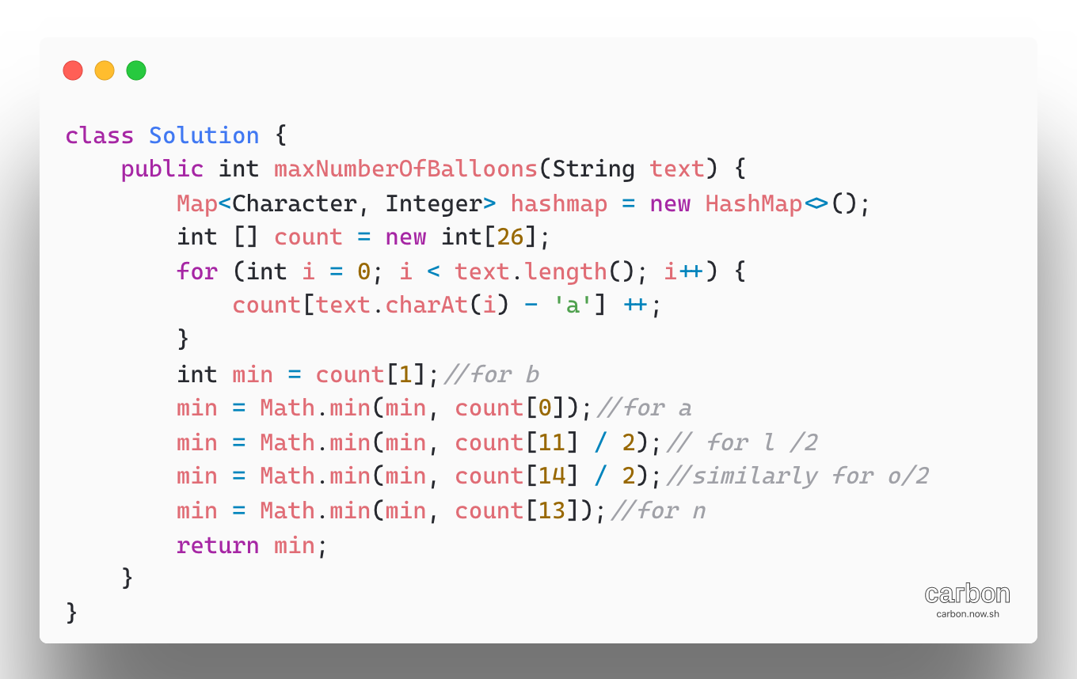

**STACK**

1. [**Longest Valid Parentheses**](https://leetcode.com/problems/longest-valid-parentheses/)

Approach 1:

Instead of finding every possible string and checking its validity, we can use of a stack while scanning the given string to:

* Our stack holds Integer index instead of character
* Check if the string is scanned so far is valid
* Find the length of longest valid string

To do so, we start by pushing -1 onto the stack.

For every ‘(‘ encountered we push the its index into the stack

For every ‘)’ encountered, we pop the topmost element. Then, the length of the currently encountered valid string of parentheses will be the between the current element’s index and the top element of the stack.

If, while popping the element, the stack becomes empty, we will push the current elements’ index onto the stack. In this way, we can continue to calculate the length of the valid substrings and return the length of the longest valid string at the end

Complexity:

Time: O(n)

Space: O(n)

Approach 2:

Algorithm, in this approach, two traversals of the string we make use of two pointers left and right.

First, we traverse the string from left to towards the right and for every ‘(‘encountered

We increment the left counter and for every ‘)’ encountered, we increment the right counter.

* If left and right counters become equal, we calculate the length of the valid string and keep track of maximum length substring found so far.

Max(ans, right*2);

* Else If right greater than left, we reset left = right = 0

Before traversing from right to left, reset left = right = 0

Above logic will be remain same

Left >= right reset

Max( ans, left*2)

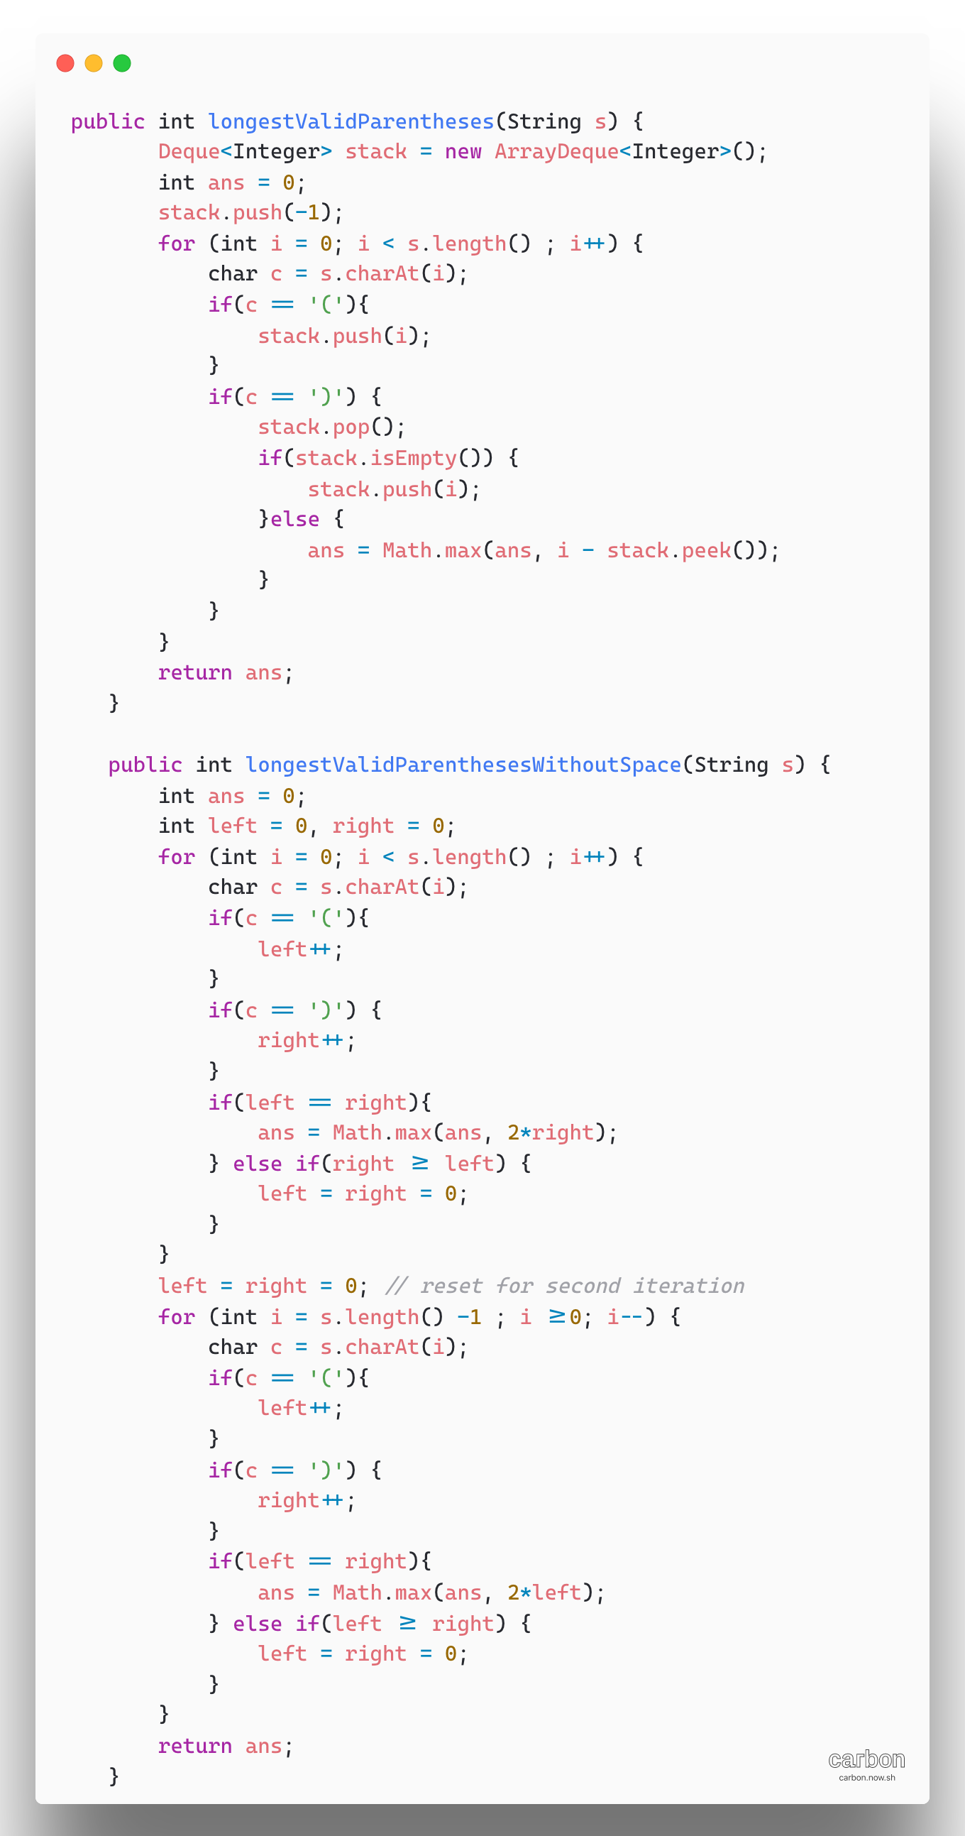

**LINKED LIST**

1. [Add Two Numbers](https://leetcode.com/problems/add-two-numbers/)

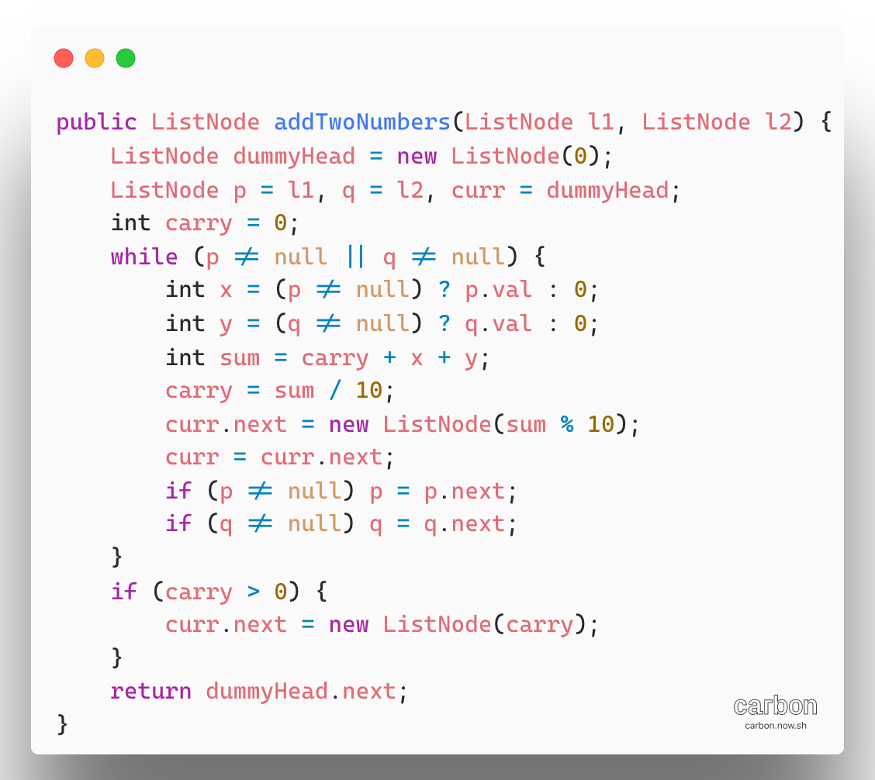

**--Two Pointers--**

1. [Intersection of Two Linked List](https://leetcode.com/problems/intersection-of-two-linked-lists/)

The brute force solution, for each node in list A, traverse over list B and check whether or not the node is present in the list B.

Note: We’ are comparing objects of type Node. We don’t want to compare the values within the nodes, because two difference nodes have the same value.

Complexity: O(NxM)

Space: O(1)

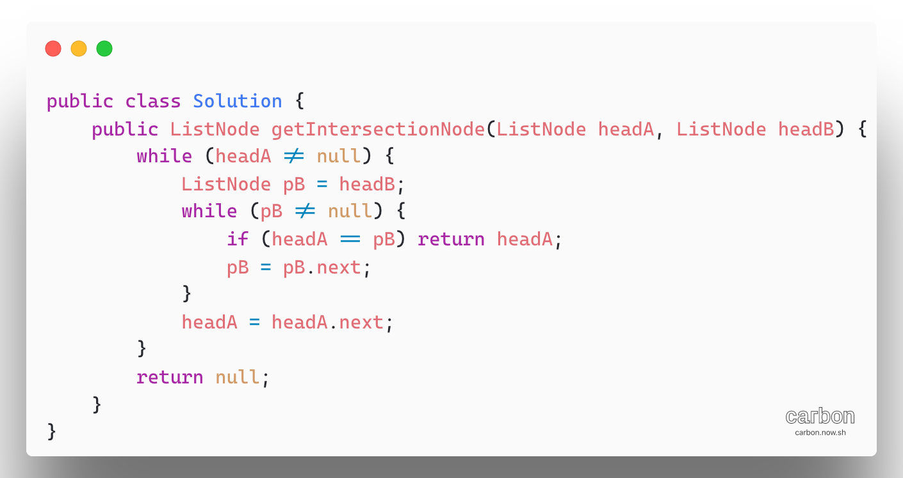

**Approach 2(HashSet):**  Traverse list and store the address/reference of each node in hash table, then for each node in list A, check whether or not that node exists in the hash table. If it does, return it.

**Note:** we are comparing objects of type Node.

**Complexity:** O (M +N)

**Space complexity:** O(M)

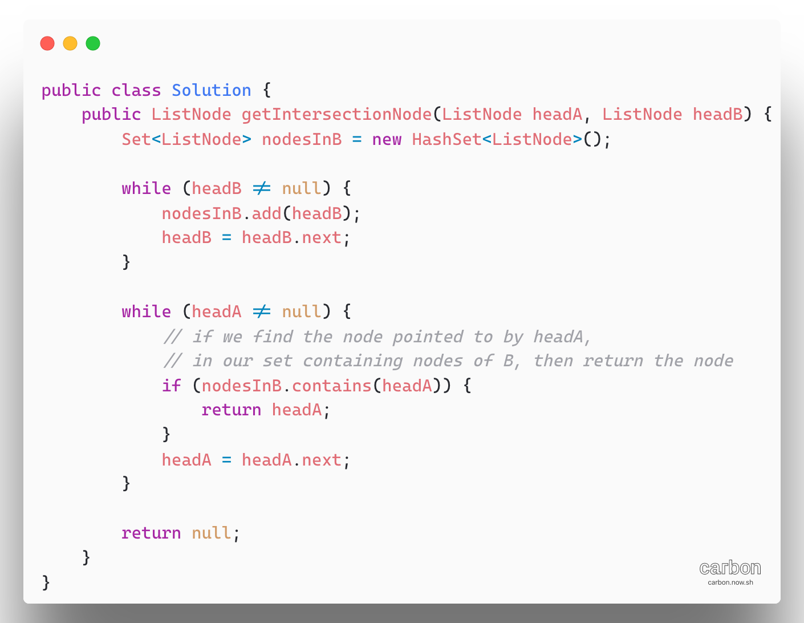

**Approach 3 (Two Pointers): Complexity O(MXN) and O(1)**



